Computer Science Project – Pixel Quest

Table of Contents

Analysis 4

Thinking Procedurally 4

Thinking Abstractly 4

Heuristics 4

Stakeholders 5

Existing solutions for the problem 5

The Legend of Zelda: Spirit Tracks 5

Features of: The Legend of Zelda: Spirit Tracks 5

UI analysis of: The Legend of Zelda: Spirit Tracks 6

Freshly*-Picked Tingle's Rosy Rupeeland* 7

Features of: Freshly-Picked Tingle's Rosy Rupeeland 7

UI analysis of: Freshly-Picked Tingle's Rosy Rupeeland 8

Stardew Valley 9

Features of: Stardew Valley 9

UI Analysis of: Stardew Valley 10

Key features of solution 11

Key features of my solution 11

Limitations of solution 11

Main limitations of my solution 11

Requirements of solution 12

Success Criteria 13

In-game Success Criteria 13

Design 15

Overall Flowchart of the solution 16

Main loading screen Flowchart 17

Scene/level loading Flowchart 17

Saving system Flowchart 18

Game over/ Death Flowchart 19

AI Logic Flowchart 20

Variables to be used throughout Development 21

Player 21

Enemy 21

Saving and Loading 22

Levels 22

Functions/Procedures to be used throughout Development 23

Player 23

Enemies 23

Main Menu 23

Camera 23

Level Changer 23

Saving/Loading 23

Start of development process 25

Progress on 11/01/2019 25

Iteration 1: Creation of main menu system 25

Progress on 18/01/2019 28

Progress on 26/01/2019 33

Iteration 2: Creation of the House (Interior) 33

Progress on 30/01/2019 36

Iteration 3: Creation of the character + movement 36

Iteration 4: Testing Player Movement 39

Progress on 31/01/2019 40

Progress on 04/02/2019 42

Iteration 5: Creation of the outside of the house 42

Iteration 6: Creation of the save UI and controlling it 44

Progress on 10/02/2019 47

Iteration 7: Tracking the player with the camera 47

Progress on 11/02/2019 49

Iteration 8: Creating dialog to guide the player 49

Progress on 21/02/2019 53

Iteration 9: Creating Player Stats 53

Progress on 01/03/19 57

Iteration 10: Player Animation 57

Progress on 01/03/19 59

Iteration 11: Creation of the Chest 59

Progress on 22/03/2019 64

Iteration 12: Creating the combat system 64

Progress on 25/03/2019 71

Iteration 13: Creating Enemy Slime 71

Progress on 30/03/2019 76

Iteration 14: Creating the saving System 76

Progress on 05/04/2019 80

Iteration 15: Implementing the Saving and Loading system into the game 80

Progress on 10/04/2019 84

Iteration 16: Creating the Combat System with values 84

Progress on 22/04/2019 94

Iteration 17: Creation of the First Level 94

Evaluation 99

Player Testing 99

Final Testing 102

Player Movement 102

Enemy Movement 104

Scene Loading 104

Saving 104

Main Menu 105

Overview against Success Criteria 106

Overview against In-game Success Criteria 107

Limitations of Solution 109

Player Combat System 109

Game’s Progression 109

Transition between Scenes 109

Game did not include Puzzles as originally planned 109

Maintenance 110

Adding additional levels 110

Fixing minor issues 110

Bibliography 111

# Analysis

## Thinking Procedurally

Thinking procedurally is a computational method when a programmer is trying to solve a program and they break down the problem so that they can create a clear order in which the program needs to run. Like abstraction, there is a heavy emphasis on the core elements of the program and by mapping out how the different elements should join this will lead to more effective programming.

One way I will use procedural thinking is when designing the save system within the game; I know that it is important and also a very complicated feature. By thinking procedurally, I will be able to plan the data management within the saving/loading process as I will be able to map out the specific times when it is required that the game accesses the player’s storage and as a result it should reduce the complexity and also unnecessary stutter.

## Thinking Abstractly

Thinking abstractly is a computational method where the programmer tries to eliminate all information that isn’t necessary so that they cut down the work load. An example of how this can be used is when designing simulators; simulators often focus on creating the main object (such as a car) and use abstraction to remove the workload (removing scenery).

One way I have used abstraction in my project is by choosing less demanding graphics; I have decided to use a top-down view in my game to reduce the amount of time needed to create the graphics. This will also reduce the time required for coding because I know that by only having 2-dimensional movement I will be able to limit the workload is the animation process and interaction will be reduced. Another form of abstraction I will likely use in my game is abstraction when creating the RPG-style character progression, I have decided that instead of having an inventory with items which have a level progression; I will just edit the player’s stats based on level(such as health and damage). This will result in a lower workload as I won’t need to program an inventory system or design the graphics for the different items/weapons although depending on time I may change how the player’s character looks depending on level so that it adds elements of an RPG.

## Heuristics

Heuristics in programming, is when a programmer will pick a solution which is fit for its purpose although it isn’t made to the best of the ability which is usually down to either time or money. In my project I will likely use Heuristics, this is because as one of my biggest limitations will be time; I have decided that Heuristics will be used for my graphics because from my research I have found out that working code is seen as a necessity whereas high-quality graphics aren’t demanded as much. This means that by using Heuristics I am able to focus more on my code; it also helps to meet one of my requirements for low-hardware requirements as I will focus on making the code efficient as possible and the graphics are 16x16 pixels which mean that it is easy for computers to process, including integrated chips.

Heuristics could also be used when trying to program complex features; this is because for one of my main features (the saving system) I would like to be able to keep track of secondary objectives; this would involve needing to design a method to keep track of the progression and to be able to load the relevant quest. However, I may use Heuristics for this as I would be able to simplify this so the save feature would only keep track of the player stats etc. This would be much easier to program as it would be only one piece of data and as a result it would save time.

# Stakeholders

Although my game will have cartoonish/childish graphics I want my stakeholders to be above 13; I have decided on this age because I think that these players won’t need to be lead along in the game and as the game will have various puzzles it will not be suitable for younger audiences as they may not understand what is required and as a result will not be able to progress(this was shown when carrying out my research as the average player age for these games was much higher than the age rating – likely due to their difficulty and complex puzzles). However, it doesn’t entirely depend on age, as I have decided on a levelled-progression system, this means that this game wouldn’t be suitable for an audience who don’t want to invest time into the game and play for extended periods of time.

As the game will likely be converted into an .exe file; this means that the game will be more accessible for stakeholders as it will not require additional software to be able to play. This will also meet one of my requirements for my solution as there won’t be any paywalls or additional requirements to play the game. I will also develop the game to use mouse and keyboard which means that it isn’t hardware restrictive as there won’t be any need for a controller etc. (also meeting part of my success criteria for no hardware restrictions).

# Image result for zelda spirit tracksExisting solutions for the problem

## The Legend of Zelda: Spirit Tracks

### Features of: The Legend of Zelda: Spirit Tracks

* Single-player
* No multiplayer
* Low hardware requirements
* Basic graphics/UI
* Player-tracking/map
* Inventory system
* Save/checkpoint system
* Free-roaming
* Age rating – 10+

The legend of Zelda: Spirit Tracks is a single-player game which relies on the player going through different areas(levels) to complete the end game goal(the purpose of this game is to restore the spirit tracks). I like this concept because it means that although the game is free-roaming there is an end-goal which completes the game; this would be good for my game as if there is an end-goal there is a purpose of playing it and as a result it should maintain the player’s interest.

The Legend of Zelda: Spirit Tracks was developed for Nintendo DS’s; this meant that it had to run on very basic hardware and as a result the graphics were basic although they didn’t look too bad. I’ve decided for my project to also use a basic-pixelated art-style, as not only does this mean that the game will require less hardware(meets one of my aims to not be heavily hardware-intensive) but it also meant that the game will be much easier to design as less time will need to be spent creating the graphics. Another key feature of The legend of Zelda: Spirit Tracks is that there is a map that is constantly giving the player’s location; although this is a good feature I don’t think it would be suitable for my game as the different areas will be too small to need a map.

The Legend of Zelda: Spirit Tracks has a very basic inventory system; this suits the style of game because it means that the game can add a difficulty as items may be required to complete puzzles without the game prompting the player to find/use these items. I like the concept of having an inventory as it can make the player more engaged with the game and it adds to the complexity of the game.

The save and checkpoint system in the game is also a good idea as it means that the player is able to quit the game whenever they want without losing progress; although I think that this is a good idea I think it would be much harder to manage as you would need to manage not only the personal stats but also the level and location and also any items the player currently has which would take a lot of management and as a result it might not be appropriate for my game.

The free-roaming in The Legend of Zelda: Spirit Tracks is very limited in the sense that although you have the ability to move around there isn’t really a reason to do it unless you’re restocking your inventory. In my game I have planned to add a level-system into the game which means that there is a purpose of free-roaming to be able to level up your character (I want the game to last a while so I think that level-grinding is a good idea). The only difference I will likely have with my game is that I don’t want to enable saving anywhere in the map; this is because it will be harder to manage and program.

### UI analysis of: The Legend of Zelda: Spirit Tracks

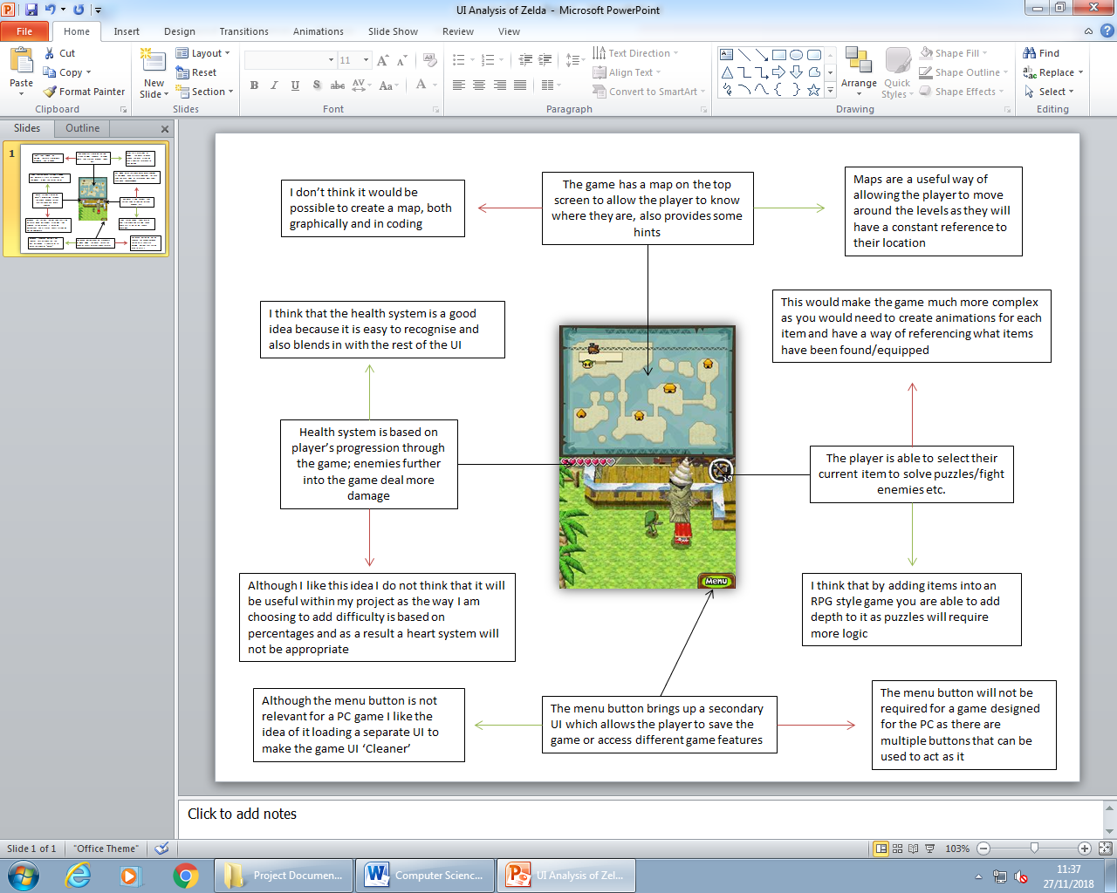

## Freshly*-Picked Tingle's Rosy Rupeeland*

### Features of: Freshly-Picked Tingle's Rosy Rupeeland

* Single-player
* 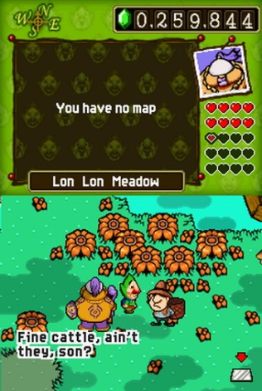No multiplayer
* Low hardware requirements
* Basic graphics/UI
* Player-tracking/map
* Collectables
* Save/checkpoint system
* Free-roaming
* Age rating – 12+

Freshly-Picked Tingle's Rosy Rupeeland is a single-player game which relies on the player collecting rupees (the in-game currency) to progress through the different areas in the game. I like the idea of it being a single-player game because this means that there is a definite end-goal whereas if it was a multiplayer game is wouldn’t have the same structure. As well as this the health system in the game might not be suitable for multiplayer as the purpose of progression is to carry more rupees in the higher levels and as a result a multiplayer game might not suit this format. I like the idea of locking the questline behind a level which is why I am using this feature and this is also why multiplayer will not be suitable for my game.

Like The Legend of Zelda: Spirit Tracks, Freshly-Picked Tingle's Rosy Rupeeland was developed for the Nintendo DS which as a result meant that the hardware capabilities were very limited. This resulted in the game having basic graphics but also a basic UI which was easy to follow and understand. I like this concept and think it would be good for my game because it would suit my target audience of teens+ but also it would take less time to design which means having the ability to spend more time on programming. Another key feature of Freshly-Picked Tingle's Rosy Rupeeland is that there is a map that is constantly giving the player’s location; although this is a good feature I don’t think it would be suitable for my game as the different areas will be too small to need a map but also this may limit the area the player play is likely to explore.

One of the key features of Freshly-Picked Tingle's Rosy Rupeeland is that the player is able to collect multiple items (collectables). Although I think that this is a good idea, I do not think I will add it to my game because this would then need a way of viewing the items and also this isn’t a common feature in most games which likely means that the audience isn’t too engaged into finding collectables. However, I would like to add an inventory system to allow the user to pick up some items; this is because as my game will have a couple of puzzles I want to have an ability to limit progression by having a need to collect items.

Freshly-Picked Tingle's Rosy Rupeeland has a unique saving system compared to most games; this is because in order to save the game you have to return to the starting location (your house) and access your TV to save the game. I will likely implement this concept into my game because I think that it will be much easier to program but also, it may be more appropriate for my younger target audience as they might not be able to load a recent checkpoint and remember what needs to be done. On the other hand, as I want my game to have lengthy playtimes this system might not be suitable for my stakeholders as death could lead to massive progression loss.

The free-roaming system in Freshly-Picked Tingle's Rosy Rupeeland is very basic in the sense that there is a limited amount of alternatives to the main quest line; however one of the key components of Freshly-Picked Tingle's Rosy Rupeeland is the constant grinding of finding ingredients (to be able to brew potions etc.) . This was a good idea for Freshly-Picked Tingle's Rosy Rupeeland because it meant that the length of the game was much longer; combined with the fact that your health was also the game currency meant that not preparing for the quests often resulted in your character dying. I think that this is a concept I would be able to use in my game however, I have chosen to focus on the grinding of player level because it would require less management from the programming whereas keeping track of all items between the different saves would be difficult.

### UI analysis of: Freshly-Picked Tingle's Rosy Rupeeland

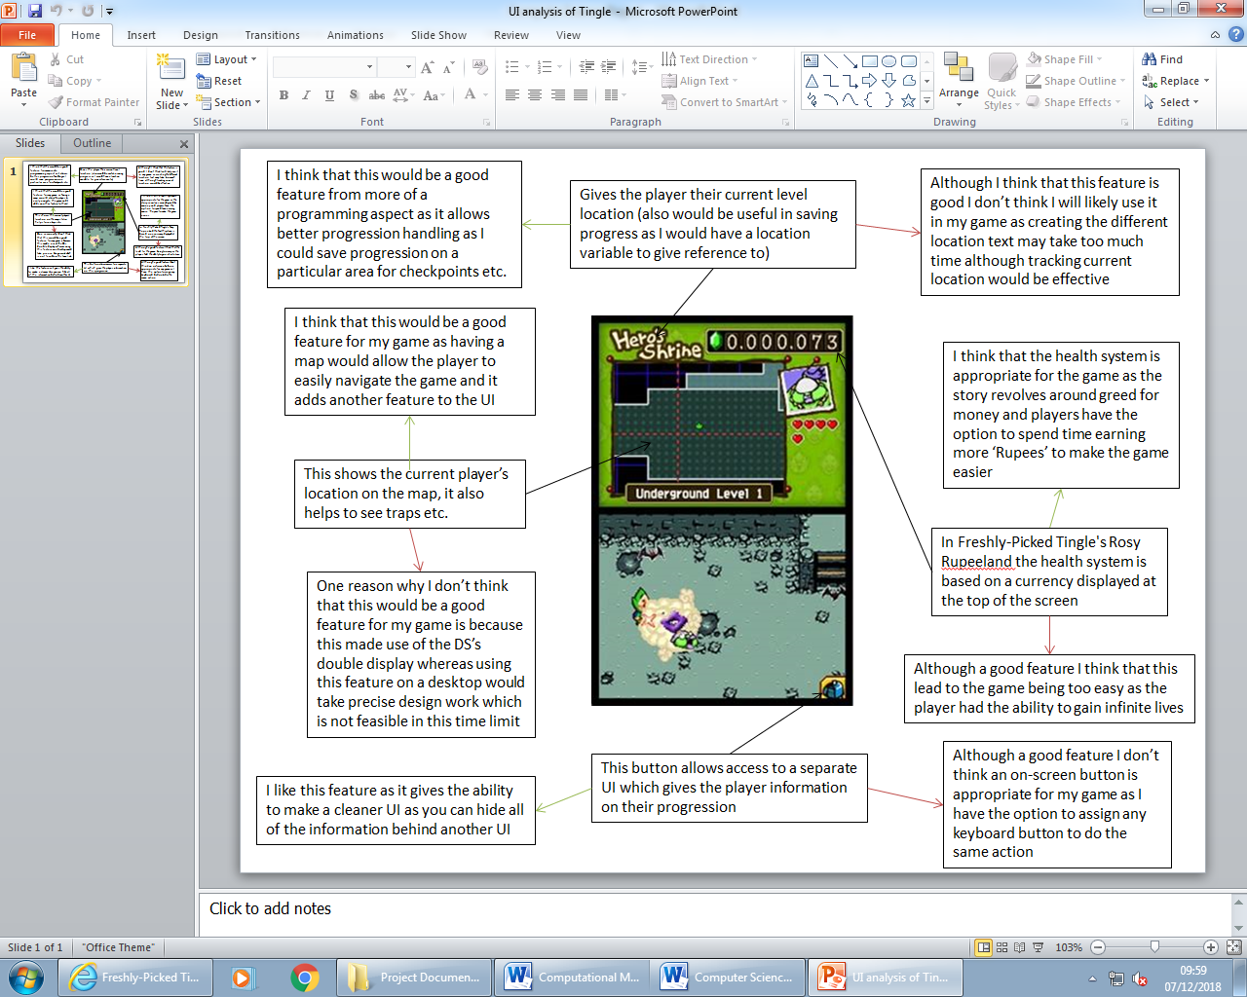­­

## Stardew Valley

### [Image result for stardew valley](https://www.google.co.uk/url?sa=i&rct=j&q=&esrc=s&source=images&cd=&cad=rja&uact=8&ved=2ahUKEwjhzc-2j7rdAhVSiRoKHahWApAQjRx6BAgBEAU&url=https://store.playstation.com/en-gb/product/EP2319-CUSA06829_00-STARDEW00000SIEE&psig=AOvVaw3XJ7jPx-oxuB9AduW_4l3V&ust=1537001634108577)Features of: Stardew Valley

* Single-player/Multiplayer
* Low hardware requirements
* Basic graphics/UI
* Player-tracking/map
* Inventory System
* Save/checkpoint system
* Free-roaming
* Age rating – 7+

Stardew Valley is a single-player game which has recently added the ability for multiplayer; although multiplayer is suitable for Stardew Valley (it doesn’t change any core features of the game) I don’t think that this would be a good feature for my game as my game relies on the player level to be able to progress which would not work, especially in splitscreen-multiplayer as this would then mean that players would not be able to go into the same area if there was a level difference which would cause various issues. However, this feature works on Stardew Valley as it allows the game to run on separate devices and as a result, players can be in the same game but in different areas of the map.

Although Stardew Valley runs on a different device compared to the other existing solutions, the hardware requirements for this game are also very low; this is due to the fact that not only does it have pixelated graphics but also there isn’t an intensive load on the processor (basic AI etc.). I think that out of the 3 solutions I have researched this is the most appropriate for my game because it will be designed for the same device; the reason behind choosing a desktop to design my game for is that although hardware varies in desktops most will be able to handle my game whereas mobile hardware can have a massive variance.

Like the other solutions, Stardew Valley has very basic pixelated graphics; I think that this is a good concept for my game because it also means that it has low hardware requirements (which is part of my success criteria as I don’t want the game to run poorly). On the other hand, Stardew Valley’s UI can be seen as being very complex as it has multiple indicators on the screen at once; this feature is not something I would like to use as I want the UI to be as basic as possible to allow the user to see more of the screen and to make it easier to understand.

Stardew Valley’s inventory system is too complex for what I want in my game; this is because not only does the player have usable items in their inventory, but the game also contains ‘placeables’. I think this combined with a save system will be harder to program because you would need to save the items but also where you have placed them in the map, although one good feature of Stardew Valley’s inventory system is the toolbar at the bottom of the screen. I think this would be good for my game as players would be able to keep track of potions etc. and it would add a bit of complexity to the game. The use of the toolbar in Stardew Valley is to be able to quickly change tools as Stardew Valley combines a farming game with a combat system and as a result it makes the gameplay smoother.

One of the other key features of Stardew Valley is that it has a very basic save system (you sleep to save and skip time), I think that this is a good feature because it means that players can easily continue their game as when they reload a save they will know where they are; I like this feature although I will likely not introduce time-skipping into my game as I don’t think it requires a day-night cycle although the way the player can leave the game is quite a good idea.

As with the other games on my list Stardew Valley is a free-roaming game where the player is allowed to explore the world by themselves; I like this because it means that progression isn’t locked behind a set of missions. However, progress is locked in Stardew Valley as you have to complete certain objectives to access other areas of the map. I think that this is a good feature and that I’ll likely add it to my game because it means that you can increase playtime without needing to add additional content.

### UI Analysis of: Stardew Valley

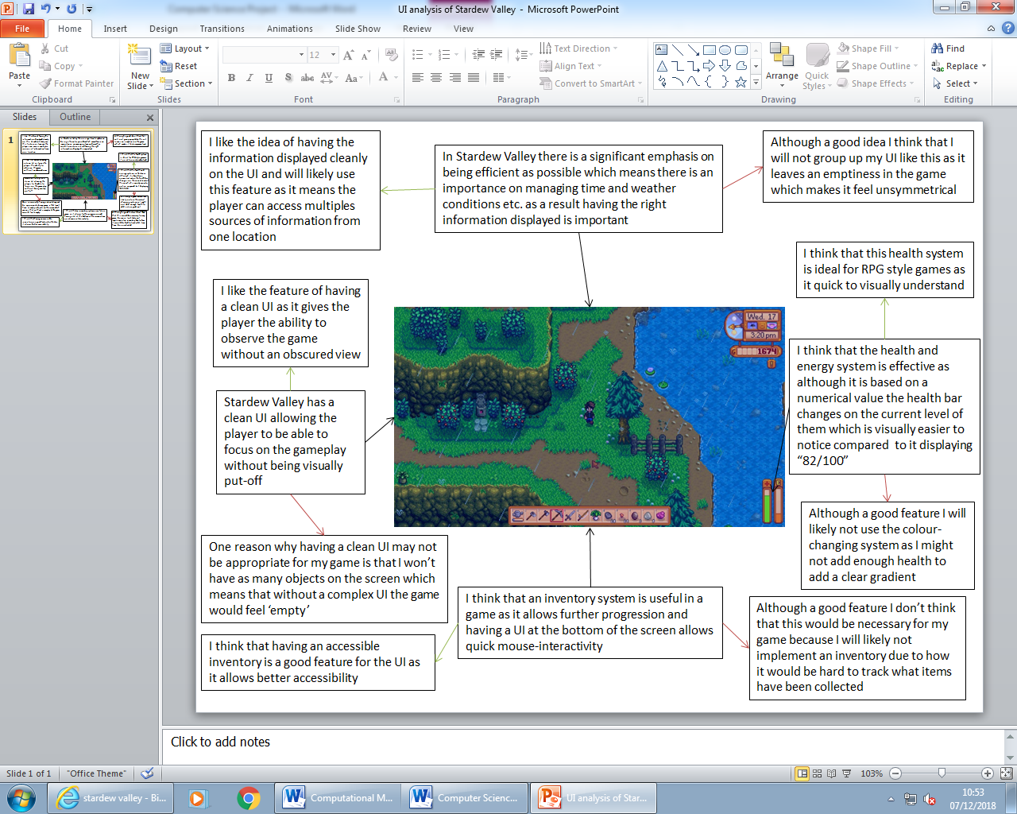

# Key features of solution

## Key features of my solution

* There shouldn’t be an end-goal, the game just continues (gives an option to add further levels in future development)
* The solution must be enjoyable for an extended period of time, this is the reason why I am creating my solution
* Suitable for teens and up (although the game won’t feature gore etc. I want to challenge players with puzzles which is why it won’t be suitable for younger audiences)
* There is a character level progression which is meant to be more entertaining for the player
* Basic combat system within the game (no armour/shields etc.)
* A save/checkpoint system
* Free-roaming (although there are some levels, the player can free-roam to increase player level)

# Limitations of solution

## Main limitations of my solution

* There won’t be a usable inventory system
  + In most games like my solution, there is a heavy emphasis on how the player will collect better items to be able to complete higher levels. However, due to my time limitation I will likely not be able to add an inventory system which could be a negative for stakeholders as the game won’t have much depth.
* The player will only be able to save the game from one location
  + As my game will have multiple different scenes/levels it would be much harder to add a save system onto each area; as a result I have decided that the player will only be able to save the game at a certain location in the game so that it is easier to manage; however, this approach may not be suitable for some players as it means that it cannot be played for brief periods of time as the player wouldn’t have the time to retrace their steps.
* The game will not have player tracking, which means there won’t be a map
  + I believe that it will be too difficult to implement player-tracking into my game (both graphically and in terms of programming) which means that the game won’t have a map to tell the player where they are. I think that this might limit the enjoyment of my solution because new players may not know where to go which could lead to a lack in interest for the game.
* The game will be single-player only as the concept won’t suit multiplayer
  + As my game will rely on the player’s level for progression I don’t think that it would suit multiplayer as this wouldn’t allow players to progress together; however, I don’t think this limitation will affect my game severely because from my research I found out that most games like mine, do not offer multiplayer.
* Although it has features of an RPG there will be no item progression etc.(swords/damage may change based on level)
  + As referenced before, there won’t be an inventory system which means that my game will not include the common elements of an RPG; I think this this may be bad for my game as it will mean that there won’t be much depth (players have no reason to explore the different areas); this may poorly effect stakeholders’ opinions as they may quickly find the game boring and repetitive.
* The game will require an XML file to keep track of progression which means players could edit it to skip parts of the game, although an XML file is much harder to edit(this is due to how the player level will open different areas)
  + One of the limitations of having progression saved to the user’s storage is that they have the option to be able to edit it; this will be bad for my game as it will result in the player being able to ‘cheat’ by editing the file which would dramatically reduce the length of the game as the main progress-blocking strategy is level progression.
* One of the biggest limitations will be time; the length of the game will solely depend on how many different scenes can be created
  + As I am creating my solution with a limited amount of time, the length of the game will solely depend on how many different levels can be created; I think that this will still be good for the stakeholders however, as the way I am designing my game is so that the different levels are self-contained which means that I don’t need to rush to make a complete game because as far as the stakeholders are concerned they will not recognised if something is missing.
* The game will have limited objectives; side quests may only be added if they’re basic, so it is easy to keep track of the progression on them as they will need a way of being saved
  + When creating my game, I think that it is important that all progression is saved to allow the player to freely play the game without needing to fully complete quests. As a result, when adding additional quests, it is important that they are basic (such as a kill counter) so that the information can easily be written into storage and loaded back. This could however, be bad for the stakeholders as they may find that the quests aren’t enjoyable or too alike/repetitive.
* The game may not be challenging enough if a formula cannot be created which modifies enemies based on the player level.
  + One of the biggest limitations of the game will likely be the difficulty; this is because the damage from enemies will need to be based on player level; to add a challenging factor and add enjoyment. However, this would mean that the game may be too difficult at the beginning as the game balances out or the game will be too difficult near the end. To try and counter this, I will need to get multiple opinions in the testing stage although these opinions could vary due to the style of game it is as some testers may find it more difficult than others.

# Requirements of solution

As my game is being created for the PC, the player will require a windows desktop, as other OS’s run on different code it will only be available for Windows. It will also only require basic hardware to run as I didn’t want high-quality graphics; it was also one of my goals to make sure that stakeholders are not hardware restricted on the game (throughout my research I found out that games developed for computers are usually hardware restrictive; consoles are created equally so there aren’t hardware restrictions when designing a game)

Another requirement for the game is that it requires permission to access and edit storage; this is because once the player exits the game, in order for the progression to be saved, the software will need to create a text file which will store the player stats and when the game is resumed it should be able to find the stats and give the player the correct information; this also will bring up an issue of the player being able to ‘cheat’ the game as they would be able to find the XML and edit the stats. However, an XML file is usually much harder to edit than a text file due to the format type, so this may allow less people to be able to cheat the game.

Players will need the ability to run an exe. File which may mean that they need to be granted administrative permissions to be able to run them. As I am developing the game within school I might not have the option to send out my .exe as most users are blocked from running them due to security reasons.

# Success Criteria

* The game must have a menu/title page which gives the player the option to start a game; have a help page for controls etc. and an option to be able to quit the application.
  + I think that it is important for the game to load into a menu because it allows
* In-game there must be a way of saving/quitting the game(saving will only be available at a certain point within the map)
* Players must be able to save the game; leave and then resume their progress and they should keep all stats etc.(puzzles/interactions in the game will likely reset)
* Game must have a way of notifying players of achievements, such as defeating a particular enemy (depending on how AI programming goes there might be statues etc. telling players which enemies they’ve killed(this will depend on if more difficult enemies can be created by programming the AI differently))
* Although in the early stages there will probably be a level cap, I would like the game to contain infinite Player levels; this would depend on if you could create a relationship between the player level and AI health etc.
* The game will have different areas which as a result mean that the player must be able to smoothly move from one location to the next (smooth camera transition etc.)
* A health system is essential in the game as this will add the difficulty to it
* Enemies will need to spawn automatically based on when that area is loaded up(allows the player to grind for XP if wanted)
* There shouldn’t be any game-breaking bugs as this will lead to players losing their progression which could stop them from wanting to play the game.

# In-game Success Criteria

|  |  |  |  |  |
| --- | --- | --- | --- | --- |
| Criteria | Description | Reason for criteria | Achieved: Yes/No | Explanation |
| Starting screen menu | There should be a menu which is loaded up straight away when the game loads which gives the player multiple options; such as New game, Load game and Exit game etc. | There is a need for a main menu as this is a clean way of the player being able to start a game; without a starting screen the UI would be much more complex. | Yes | There is a main menu screen that is loaded when the games starts; this then links to the “House” scene |
| Player needs to be able to load their saved game | Once the player has finished the game they must be able to return after a period of time and load their save. | Without giving players the option to save/load their game this means that the game wouldn’t be suitable for most players. | Yes | If an xml file is available, the “Load Game” option is set to active |
| Needs to have a guide/tutorial | Players must have the ability to be able to see how to play the game; either through a written guide or in-game tips. | Without giving players tips they may struggle to play the game; not all stakeholders will be gamers who have general knowledge E.g. WASD controls | Yes | Although there isn’t a tutorial in the game there is a help screen on the main menu and when in the game they player can read tips |
| In-game menu | Once the player is in the game they should have the ability to load up a menu which gives options to save their game etc. | Without having a menu in the game this would mean that the player wouldn’t be able to save the game, so a menu is needed, also gives the ability to add different interactions in the game. | Partial | Although there is a save menu I decided not to include an in-game menu as I decided that the player would only have the option to save and leave the game from one area, so I don’t need to attempt to keep track of the player’s location |
| Enemies should level up proportionally to the player | When the player levels up the enemies should also level up to make sure that the game is still challenging | If enemies didn’t level up this would lead to boredom as the player would easily be able to skip past them without fearing being killed. | Yes | As I have designed that game so that the Player will always have a level, enemies will have their stats changed based on the Player’s level. |
| There must be a clean transition between different areas | When the player is moving between the different levels it is important that the transition is smooth(the player should not notice that a new area has been loaded along with the player) | If the transition wasn’t smooth between levels, this may be off-putting and as well as this it is important that the player’s stats are carried over which would require reading and writing of the data (health will likely be regenerated to full) | No | Due to a lack of knowledge on how to serialize a Vector 3 I was not able to add in smooth transitions between scenes. |
| The game should have the option to pause(if the player is reading a tip the game should pause) | It is important that the game can be paused as when the player may interact with objects (signposts etc.) it would be good if the game paused so that the player can better understand what they are reading. | I may include random puzzles in the game such as the player needing to collide with objects in a certain order and as a result it is better if they can read the instructions without being attacked and also a pause feature in the game allows for better player-experience. | Yes | When the player presses the “P” key the timescale = 0 which will pause the game. When the player is also interacting with any UI elements, menus etc. the game pauses to make sure that the player isn’t attacked |

# Design

## Overall Flowchart of the solution

This is the general overview of how my software will run and how it will access and modify the data which is required for the player to be able to save their progression.

Due to the difficulty of trying to program a saving function that can track the player’s location I have decided that to make it easier I will only allow the level to be loaded up from the starting point (the house) and if the player chooses to load their previous game the game will just copy the information across from an XML file but start the game as if it was the first time; this would then require scaling to the player level to always make sure that enemies are challenging.

When the player wants to leave the game, the game will require them to return to the house to be able to save their game; I think that this is a good idea as it means that I won’t need to program saving and loading their current location and it also means that players will likely complete an area before quitting which means I don’t need to aim to save their current progression such as if they’ve completed a certain puzzle.

The saving function will require me to be able to monitor the player’s current progression and then be able to automatically document it onto an XML file so that it can be loaded up again. I think that to do this I will give each level a different collectable and then add a simple true/false statement which will display if that area has been completed and also it would allow the player to easily know where they have been.

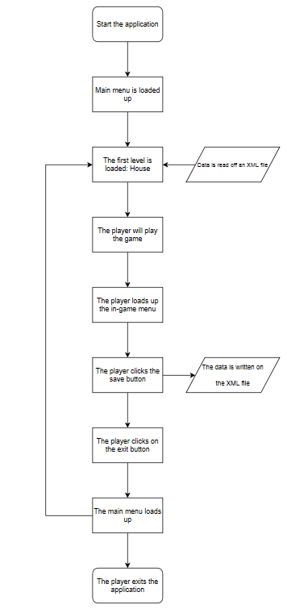

## Main loading screen Flowchart

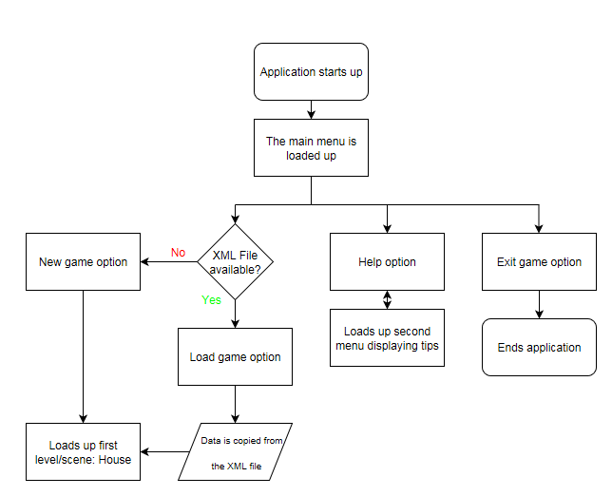

I think that it is useful to create a flowchart for the menu system as it allows me to visualise the flow of the program and how the code would run and in what order.

The menu will require at least 4 different buttons which would be able to load up other screens. I think it is important to keep the menu system basic as it only needs to serve the purpose of loading the game instead of the player loading straight into the game and as a result, it will likely be part of the first iteration as it is a core component.

## Scene/level loading Flowchart

As the main focus of my game is on the player’s current level I think that it is important that the games progression is artificially halted; one way of doing this is to add in level requirements into the different areas so that the player is required to “Farm” to increase their level. The way the game works is that once an area is loaded the enemies are also loaded onto that level so the player is required to leave that area for the process to loop. I decided to use this method as it means that players are more likely to explore the different areas instead of just trying to make enemies respawn to progress.

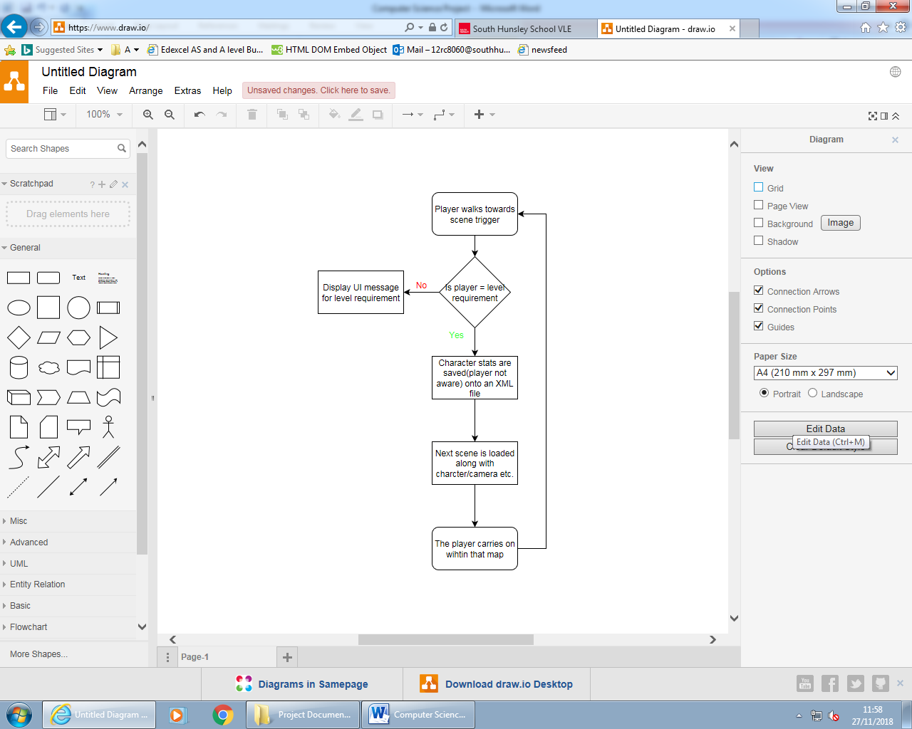

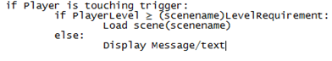

This is example Pseudocode of how my program will function; although the variable names have not been completed yet. Variables such as “Trigger” will likely reference an invisible object within the level that the player is able to collide with as the code will need a reference point and the save function will also need to be implemented into this section of code. This will require a way of being able to store selected information into a file and a way to for the game to be able to find and receive this information.

By pushing the logic into a flowchart this has shown me that a decision needs to be made for the player to progress; this will require two variables which will need to be compared and then if the player level matches or exceeds the required level an outcome will become true; this will load up the next scene whereas if it is returned false a message will pop up on the screen notifying the player of the requirement.

## Saving system Flowchart

The saving object will be a bed which means that when the player walks into it, it will run the script attached to it which should display the saving menu UI and pause the game.

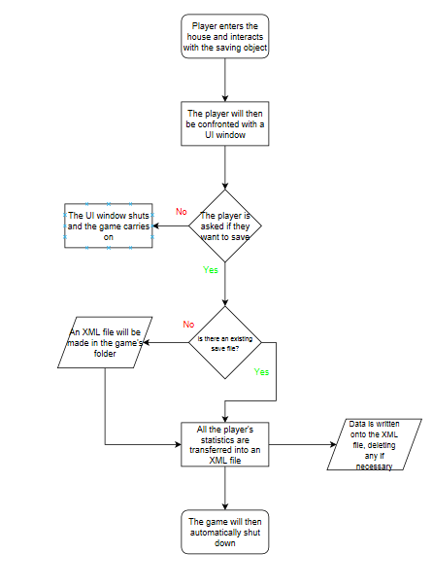

The saving process will need to involve copying all the player’s stats onto an XML file so that the procedure can easily be reversed when loading the game. Although there would be options to encrypt the data when it is written to the file I have decided to write it straight into the file as I feel like this method would be too complicated and although testers(Computer Science students) will have knowledge of how to modify the file I don’t think it will have an impact.

I think that it is important that the game checks whether the file exists as otherwise it might show an error or just not save and the game requires saving to be able to switch between scenes.

There will likely be multiple options on the UI, for example if they clicked on the “Quit” button the game would leave whereas in the flowchart this is determined as “No”.

## Game over/ Death Flowchart

I decided that loading up a death UI would be an important stage in this process as this would allow the user to choose if they wanted to carry on or quit. Having the two options would be important as this would then give me an option to add a saving function so that when one of the buttons is clicked the game will save; this is important because when the game starts again the original scene (“House”) is loaded so it needs to load with any information that the player died with (XP) although the health will reset

This is the general structure of how the information should flow during the player’s death, for this to work there needs to be a variable (named “PlayerHealth”) which when it equals 0 another function will run

## AI Logic Flowchart

This will be the basic logic behind most enemies in the game, as most of the enemies are going to be variants of slime they will likely behave the same. However, I will likely input more difficult enemies into the game such as enemies who will have a specific movement path which means that they would have a different flow of logic as you would need to prioritise the movement over trying to attack.

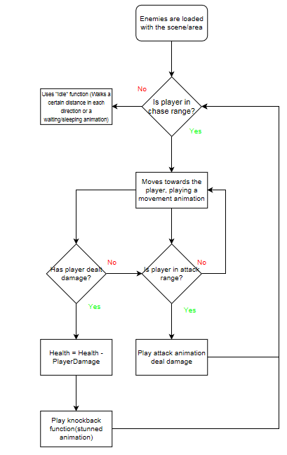

I think that it is important that enemies have certain conditions to meet before they can move as it means that I am able to better control where they will be in the level; this is because if they had the ability to walk straight up to the player this could result in the game being much harder as each level will likely have about 8 enemies which the player shouldn’t be able to fight at once due to the progression system without being killed.

One problem that I may encounter when creating my game is that enemies may deal too much damage to the player; this is because without interrupting them they have the ability to keep attacking. I think that when developing the game I will likely notice that once in range of an enemy the health will likely just plummet as there is no reason for the attack function to stop/slow down. I think that a way around this will be to add an attack delay into the game so that enemies wait a certain duration before dealing damage; this will require a lot of testing to try and fine-tune the exact delay.

## Variables to be used throughout Development

### Player

|  |  |  |
| --- | --- | --- |
| Name | Type of variable | Reason |
| Health | Integer | The reason for “Health” is to add difficulty to the game as it means that the Player needs to act carefully |
| Max Health | Integer | The reason for “Max Health” is so that the Player’s health can be set at the start of the level without them being invincible |
| Player Level | Integer | “Player Level” is needed to show the Player’s progression throughout the game |
| Exp | Integer | The reason for “Exp” is so that the Player has something within the game to aim for and it also controls the difficulty |
| Required Exp | Integer | “Required Exp” would be needed to allow the Player to level up; the fact that it is also a separate integer means that I would be able to display it in a different area of the screen |
| Speed | Integer | “Speed” will likely be needed to allow the Player to move at a set speed |
| Damage | Integer | The reason for “Damage” is so that the Player can attack the Players and allows me to add a health system |
| Is Alive | Bool | “Is Alive” would be a bool used to decided when the Player has been killed or not |

### Enemy

|  |  |  |
| --- | --- | --- |
| Name | Type of variable | Reason |
| Health | Integer | The reason for “Health” is to allow the Player to attack the enemy; like in games that I have researched |
| Max Health | Integer | It is important that the enemies have “Max Health” so that there is a value that their current health can be set to |
| Reward | Integer | “Reward” is needed so that the Player is able to level up after earning enough “Exp” |
| Speed | Integer | “Speed” will need to be used to control how fast the enemy is able to move |
| Range | Float | Like in many of the games I have researched it is quite common to include a “Range” which determines whether the Enemy is able to start moving or if they are in an idle state |

### Saving and Loading

|  |  |  |
| --- | --- | --- |
| Name | Type of variable | Reason |
| Player Level | Integer | It is important that “Player Level” can be saved as without this the Player’s progression wouldn’t be tracked |
| Exp | Integer | “Exp” will be needed so that no progression is lost as at higher levels the amount of “Exp” required will be a significant amount |
| Changed Scenes | Bool | This Bool would be used to decide whether the Player’s position needed to be saved |
| Player’s Position | 3 Integers | “Player’s Position” would be used to save the Player’s last position so that when the level is loaded again the Player is in the right spot |
| Chest Status | Bool | “Chest Status” would be used to decide if a Player had used a chest and then stop them from using it again after quitting the game and reloading it |

### Levels

|  |  |  |
| --- | --- | --- |
| Name | Type of variable | Reason |
| Statues | 4 Bools | As part of 1 of my levels I have decided to create a puzzle in which the Player will have to interact with the Statues in a certain order to open a door to progress through the level; the purpose of the bools would be to determine if the correct order was used |
| Slime Counter | Integer | In another Level, I want to create multiple rooms which the Player must progress through to finish the level; each door would only open when the “Slime Counter” was the correct amount which also means that the Player cannot easily skip the game |
| Level Complete | Bool | This Bool would be needed to determine if the Player had finished the level; this variable would then need to be saved in case it is used to enable another level. |

## Functions/Procedures to be used throughout Development

### Player

|  |  |
| --- | --- |
| Name | Reason |
| Player Movement | The reason for “Player Movement” is so that the Player can control their character throughout the level, will likely be set to WASD keys |
| Player Attacking | This function will be needed to allow the Player to attack enemies within the game |
| Player Interaction | The reason for “Player Interaction” is so that the Player will be able to interact with objects around them (chests, doors, signposts etc.) |
| Take Damage | Due to how I am going to use multiple scripts it is important that each character has a function which allows them to take damage which is triggered in another Objects scripts |

### Enemies

|  |  |
| --- | --- |
| Name | Reason |
| Enemy Movement | When the condition for movement is met it is important that the enemy can move throughout the level |
| Enemy Attacking | This function will be used to allow the enemy to deal damage to the Player |
| Death | Once the Enemy’s health is equal to 0 it is important that a function is run which destroys the enemy object and rewards the Player with Exp |
| Take Damage | It is important that the enemies have this function attached to them as this is likely the only way that I will be able to deal damage |

### Main Menu

|  |  |
| --- | --- |
| Name | Reason |
| New Game | This function will be used to load up the game without accessing the Player’s storage to access their stats |
| Load Game | This function will allow the game to access any local saved files on the device so the Player is able to resume their progress |
| Help | This function will be needed to load up a separate UI which will be used to give the Player help on how to play the game |
| Quit Game | This function will be needed so that the Player is able to exit the game |
| Main Menu | As I am planning on having different UI screens within the Main Menu I wanted to make sure that there was always a way to get straight back to the main menu |

### Camera

|  |  |
| --- | --- |
| Name | Reason |
| Camera Movement | The purpose of this function is so that the Camera is able to follow the Player as they move around the game as this then means that I don’t need to drastically zoom out to fit everything in |

### Level Changer

|  |  |
| --- | --- |
| Name | Reason |
| Position Saver | The purpose of this function is so that before the level is changed the Player’s location is saved |
| Position loader | Once the old level has been loaded it is important that the Player’s previous location is loaded on return to that scene to make it seem like a smooth transition |
| Saving | When the Player is about to change scenes, I need to make sure that any progression is saved so that it can be loaded, along with the next scene |
| Scene changer | This function will be responsible for changing what scene is currently being displayed; I will also try to add level requirements into this function so that I can slow down the Player’s progression |

### Saving/Loading

|  |  |
| --- | --- |
| Name | Reason |
| Saving | This function will take any of the variables within the script and then write them out to an XML file; depending on time I may use a binary formatter which means that Players would not be able to modify the data |
| Loading | This function will be used to retrieve any information from the XML file and then assign it to the correct variables so that it functions as required |

# Start of development process

## Progress on 11/01/2019

### Iteration 1: Creation of main menu system

#### New objects within Iteration

|  |  |  |
| --- | --- | --- |
| Name | Type of object | Reason |
| Main camera | Camera | It was automatically added to the scene so that when the game runs you are able to see what has been added to the scene. |
| MainMenu | Scene | The purpose of having multiple scenes is so that instead of loading everything at once I am able to section the different stages. |
| Canvas | Canvas | This is automatically added when adding UI objects into the editor |
| Main Menu | Empty Object | When trying to create a help menu I found out that trying to hide multiple objects individually took a large amount of code. To fix this I embedded the different objects within the empty object that meant that I only needed to reference the Empty Object to control the others. |
| Title | Text | At the moment it is just plain text which was created for test purposes; later on, it will be pixel-art style. |
| NewGameOption | Button | This button will be linked to a function that will load the next scene. |
| LoadGameOption | Button | This button will be linked to a function that loads the next scene while also loading any information which has been previously saved. |
| HelpOption | Button | This button will link to a function that hides the “Main Menu” empty object and display the “Help Menu” empty object. |
| QuitOption | Button | This button will link to a function that exits the game. |
| Help Menu | Empty Object | This is an empty object which has the “BackOption” embedded into it so it can easily be referenced throughout the editor. |
| BackOption | Button | This button is linked to a function that will hide the “Help Menu” empty object and display the “Main Menu” empty object. |
| EventSystem | EventSystem | This is automatically added when referencing buttons using different functions. |
| Main Menu Controller | Script | Creates the multiple functions used within the MainMenu scene. |

#### Class Diagram of the Main menu

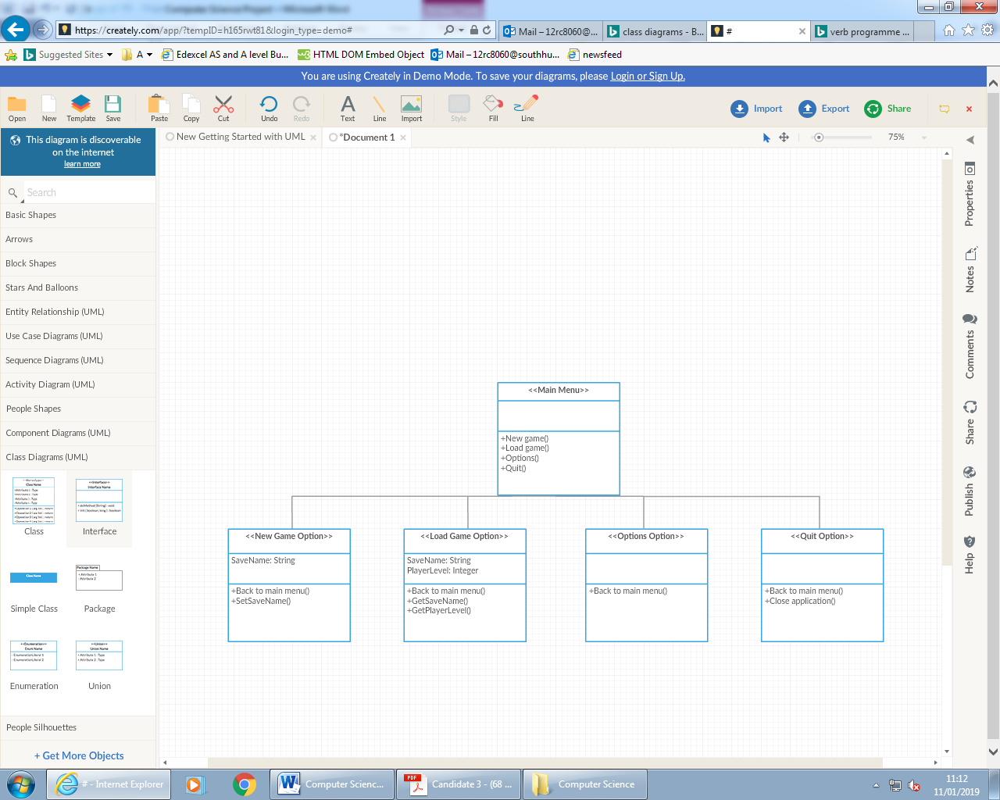

This is a class diagram of how the different UI screens in the menu scene should be able to interact with each other. As this is the menu system for the game it will only have a limited number of variables as it is used for better user-experience rather than functionality which is a focus for this solution. By breaking down the problem using visualisation this will allow me to see how the code will need to flow throughout the solution. I found out that the game will likely need a main menu to be able to join the UI options together, as this allows the player to easily navigate to their desired choice without making the UI crammed with information which will make it look un-professional but also harder to understand.

#### Example Pseudocode of Main Menu

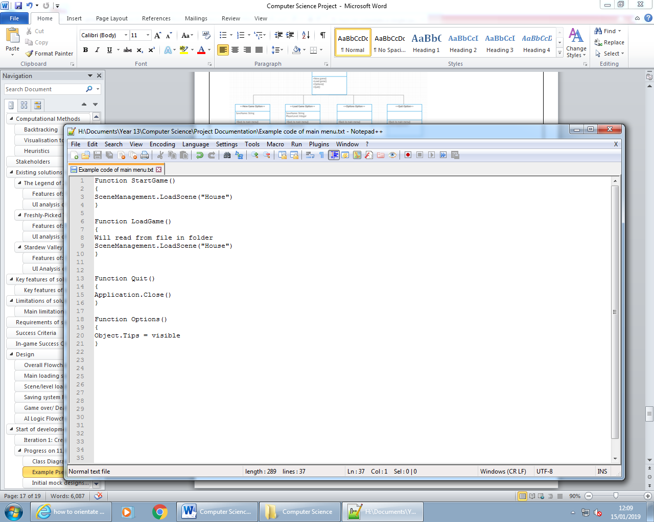To be able to interact with the multiple buttons on the menu, the UI manager will need to be used which is built into unity; this means that you can use the command OnClick() which if it is linked to an object is able to run that part of the script. By doing this I won’t need to produce a way of being able to navigate the menu as it is already built into the software which is a good time-saver. For this to work the OnClick() would need to be able to run the functions which would then load the appropriate scene(level) which will use the scene manager which is built into unity, for this to work unity would also need to be able to reference the buttons as objects so it knows which one the user has interacted with.

#### Initial mock designs of Main Men

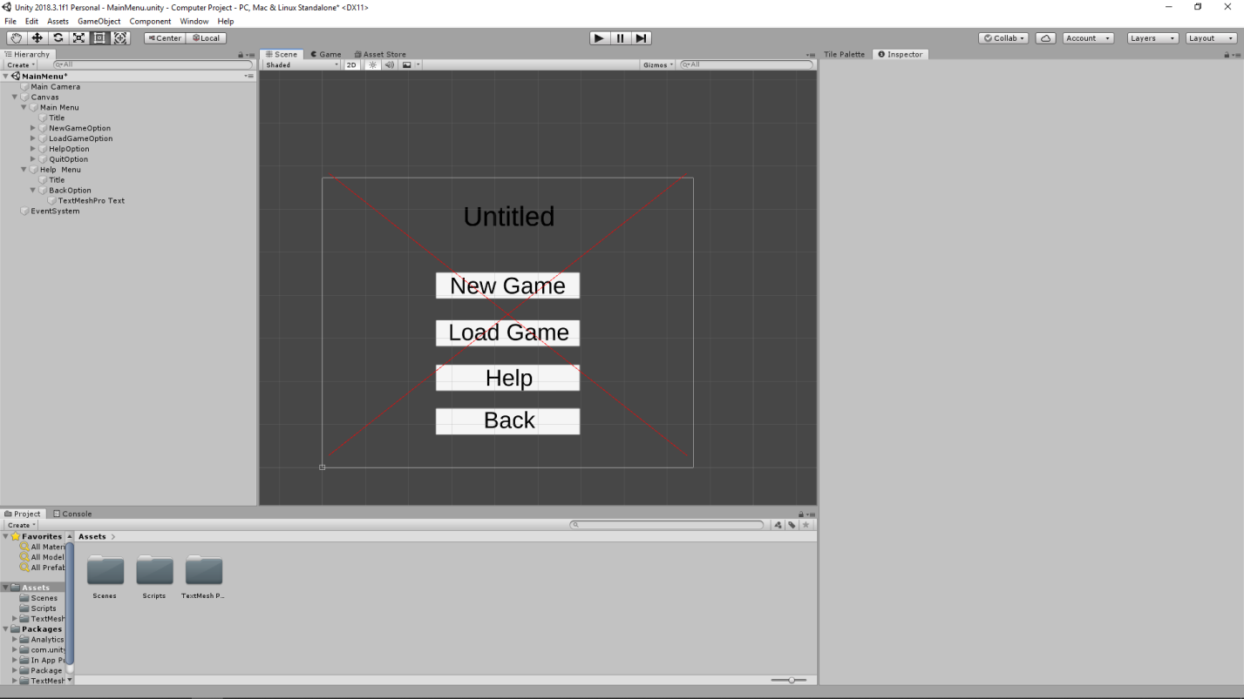

## Progress on 18/01/2019

#### First Design of Main Menu

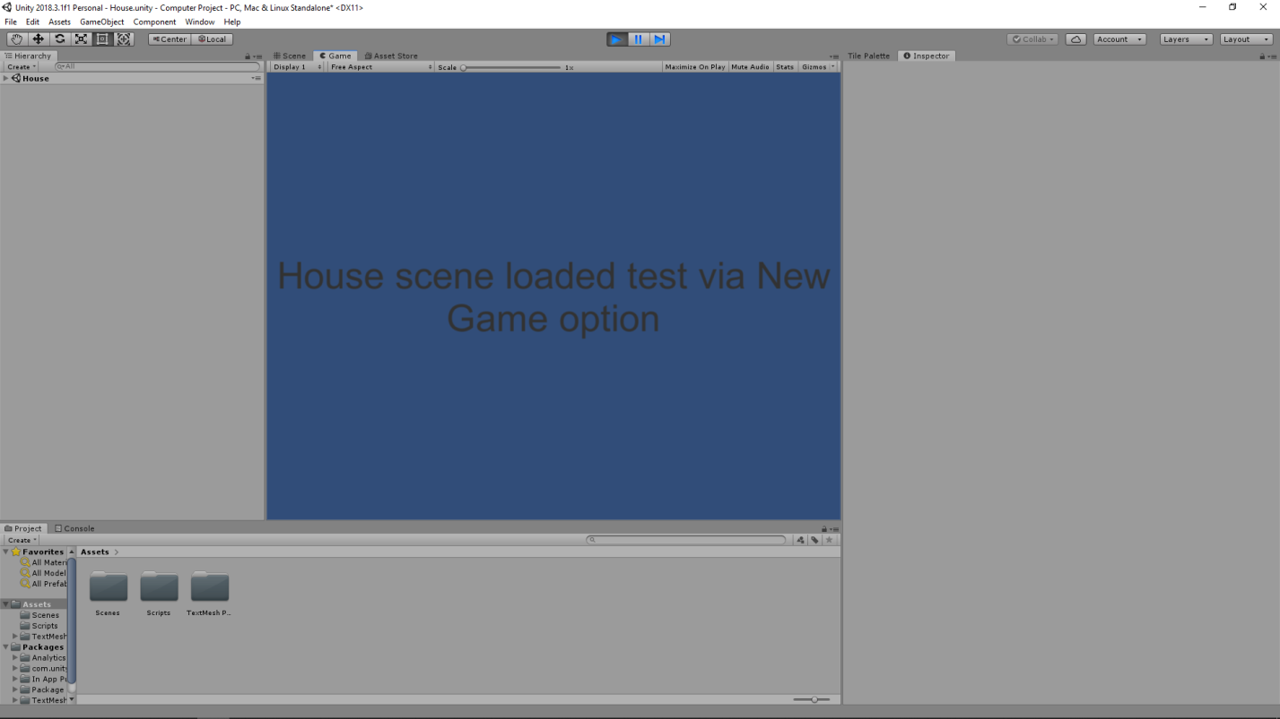This is my first design of my main menu for my project, as stated in my class diagrams I wanted to have 4 different options; these options were: New game, Load game, help and quit(this is hidden in the screenshot because of the “Help” UI being rendered on top). I have decided to make a temporary menu page because I wanted to test the functionality in the early stages of development and as a result I have decided that it isn’t a focus to create the graphical components of the menu system yet.

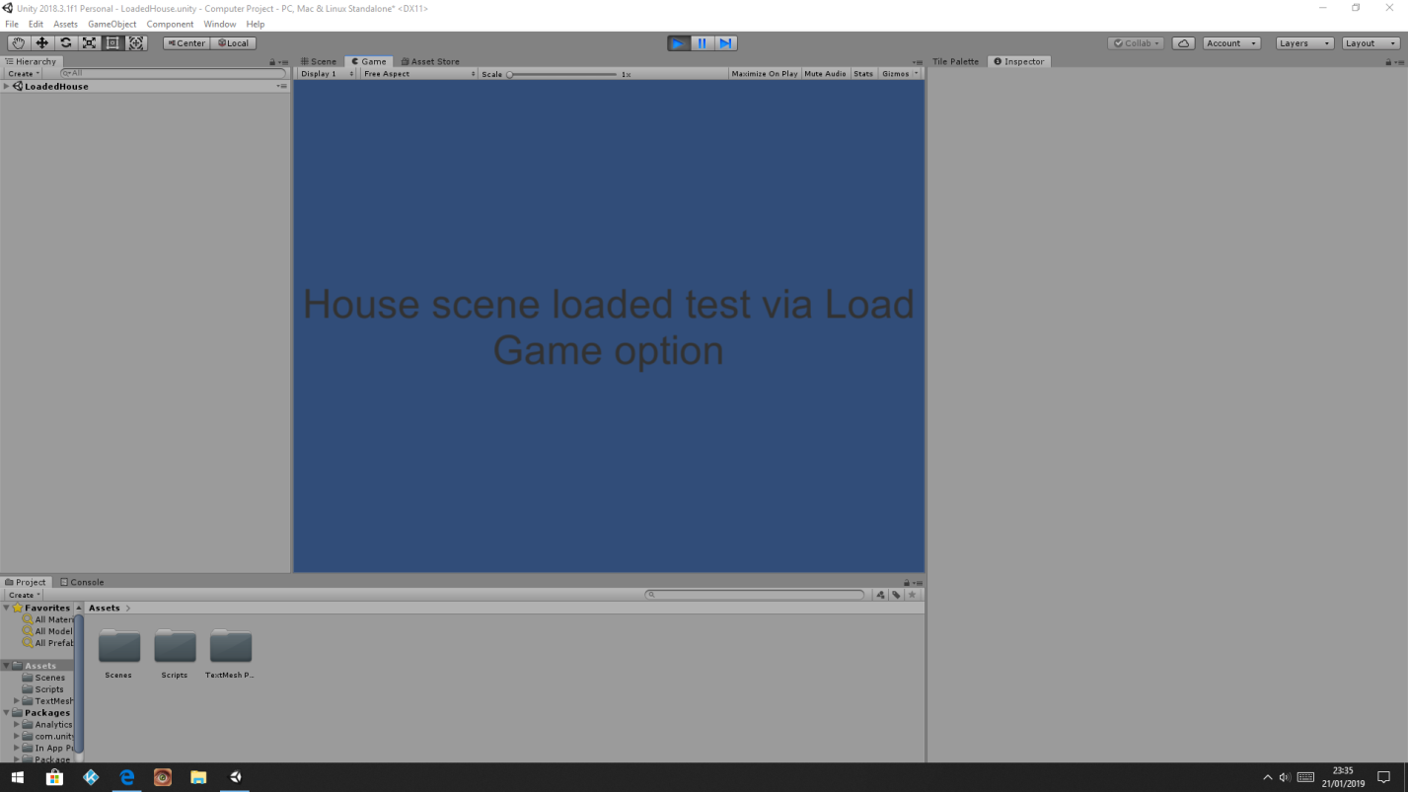This was one of my tests to see if the “New Game” option would work the way it was intended to. I wanted to make sure that the “New Game” and “Load Game” buttons had a different function which I could produce; this would then allow me to alter the loading function so that it would be able to read from a file which was not needed in the “New Game” button. When the house scene is actually created the Main Menu will be load into the game instead of a demo scene like this.

The “Load Game” button currently loads up this scene; I decided that when testing the functionality of the main menu I would create a separate scene to the “House” scene to make sure that the different functions worked as intended and as a result created a scene called “LoadedHouse” that will be deleted once the “House” scene is fully functional

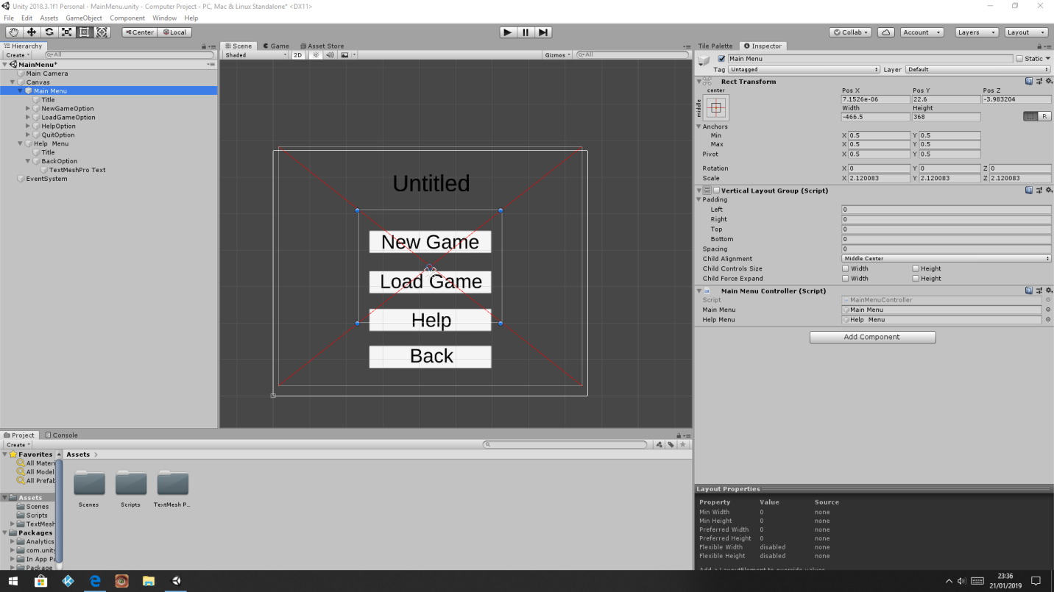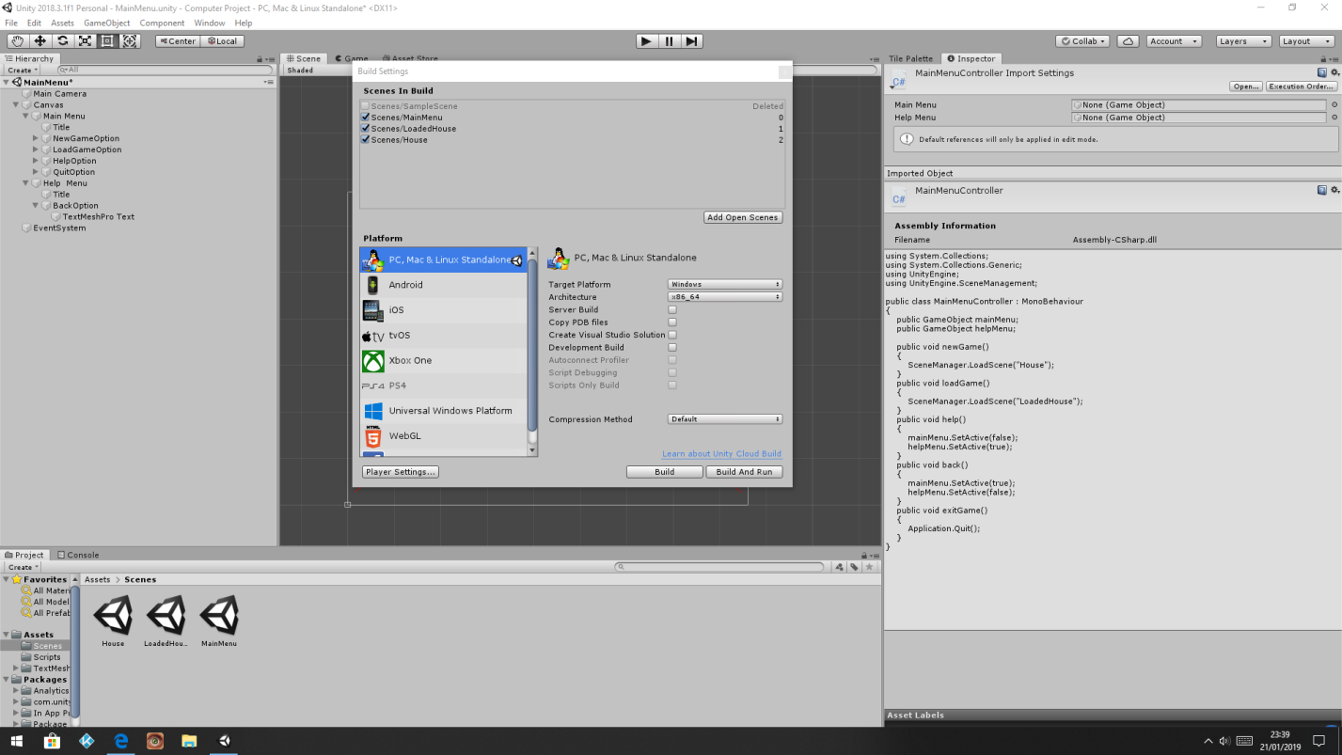This is the build settings within the Unity Editor; without linking the different scenes together with this they are unable to reference each other; this was one of my problems that I met when trying to create and test the main menu as I was unable to find the solution straight away and without this I would have to make sure that each scene contains the other scenes which would cause issues if I forgot.

The Main Menu and Help Menu are both empty objects that allowed me to group up the UI (text and buttons) so that it was easier to reference to in the “Main Menu Controller”. By using the hierarchy system this also allowed me to organise objects which may be useful further on in development when each level will have lots of objects

This was a part of the script that controls the menu (shown on page below) the two boxes are used to reference the Main Menu and Help Menu objects so that I was able to control the visibility of the UI

#### Analysis of Main Menu Script

#### Testing within Iteration

|  |  |  |  |
| --- | --- | --- | --- |
| Test | Criteria | Reason | Pass/Fail + Explanation |
| Testing “New Game” function | When you click on the button it needs to load another scene (scene has text saying what it is) | It is important that a button can link to a specific scene as for the saving system I will need to decide whether to load a stat file or create one which is the purpose of the different buttons | Fail – When the “New Game” button is clicked an error about the build shows up  Solution – The scenes weren’t added to the build, so Unity couldn’t access them |
| Testing “New Game” function | When you click on the button it needs to load another scene (scene has text saying what it is) | It is important that a button can link to a specific scene as for the saving system I will need to decide whether to load a stat file or create one which is the purpose of the different buttons | Pass – When the “New Game” button is clicked a new scene is loaded up |
| Testing “Load Game” function | When you click on the button it needs to load another scene (scene has text saying what it is) | It is important that two different buttons can load the same scene as this then allows me to differentiate the function to fit the purpose required | Pass – When the “Load Game” button is clicked the “House” scene is loaded with the log showing it has been loaded (I used Debug. Log(”Loaded”) to see if all lines of the function ran) |
| Testing the “Help” function | When you click on the button it needs to hide all the buttons and display a “Back” button and vice versa | This is to show that a separate UI window has been shown and then hidden which allows me to present information in a cleaner style | Pass – When the “Help” button is clicked the other buttons are hidden and then a new button is displayed at the bottom and you can click this button to load up the rest of the buttons |
| Testing the “Quit” function | When you click on the “Quit” button the application should close (the executable) | Without having a way of being able to quit the user would need to alt + F4 or try to close the window which is unnecessary | Pass – When you click on the quit button the application closes which is what was needed |

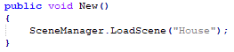

During the testing of the “New Game” function I tried to load up an empty scene named “House”, to check that the function would work as required. One issue I had when testing the function was that a build error showed up and the scene did not load up; the solution was to add the scenes to the build so that they were able to access each other.

#### Validation within Iteration

|  |  |  |
| --- | --- | --- |
| Test/Data | Criteria | Outcome |
| New Game | Button Click | Scene changes |
| Load Game | Button Click | Scene changes |
| Quit Game | Button Click | Nothing |
| Help | Button Click | UI visibly changes |

#### Evaluation of Iteration

Due to using the designs that I had created; this iteration was quite successful as I was easily able to duplicate the code for the different buttons and then slightly modify them. When I later come back to edit the Menu in later iterations I will focus on making the aesthetics for the Main menu, this is because as of now I am unable of how to implement the saving into it and this may require more buttons. As part of my Success criteria it was critical that this feature was added.

## Progress on 26/01/2019

### Iteration 2: Creation of the House (Interior)

#### New objects within Iteration

|  |  |  |
| --- | --- | --- |
| Name | Type | Reason |
| House | Scene | To make sure that the game only loads what is necessary I have separated the different areas onto different scenes. |
| Main Camera | Camera | Automatically created so that when testing the game, you are able to see something. |
| Grid | Grid | Automatically created when creating a tilemap so you have better control of it. (All tilemaps are embedded). |
| First Layer | Tilemap | This is the first layer of the game, so it is designed to show the floor |
| Objects | Tilemap | Objects are on a different layer from the floor, so a tile collider can be added; adds collision with the player. |
| Walls | Tilemap | Although there is no difference from the “Objects” tilemap I used this so that I made it clear what tiles were the walls. |
| Player | Object | This is the object that will be able to be controlled later on by adding a script to it. |

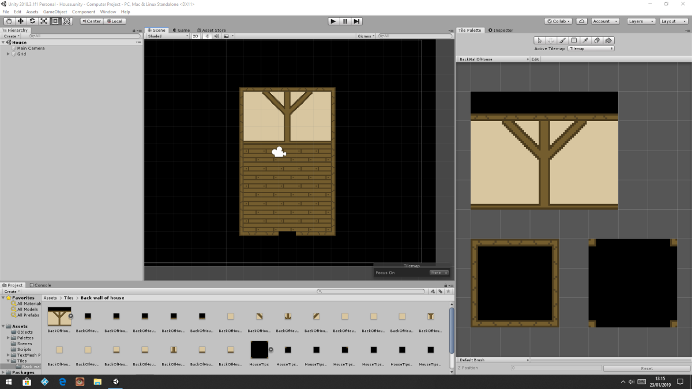This is the basic layer of the house which should be the first level that the player loads on to when they start the game. For now, I have focussed on the basic elements of the house as I don’t think it is important that it looks appealing when trying to test the functionality. When creating this I used a tile palette as this allowed me to easily piece the different components together which I created in Photoshop. To be able to use the tile palette I needed to make sure that my game included a tile map and when creating this I decided that each tile would have a size of 16px*16px; this was important because it means that all tiles from now will need to be created to that size and if they aren’t this will lead to the game looking bad as it could result in black lines appearing between the tiles where they don’t piece together as planned.

The floor is on another tile palette named “Tiles” so that I am easily able to find it if I need to use it in other scenes.

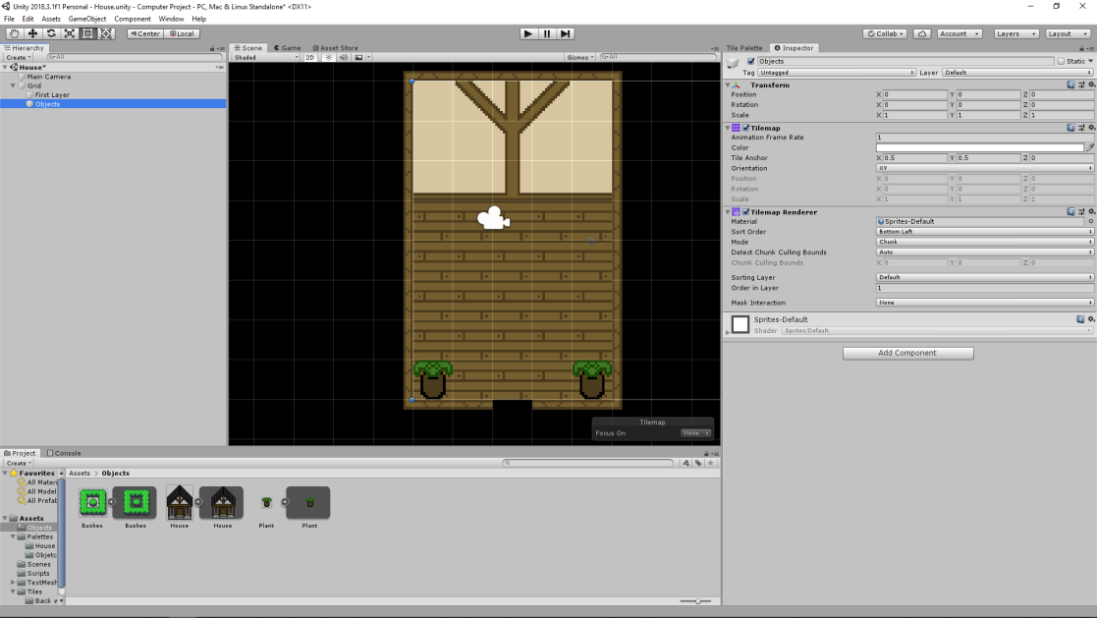When creating the “House” scene I realised that it was important that the walls of the house would be able to have a collision box which would mean that the player would not be able to walk through them. For this to work I needed to add another Tilemap on top of the “First Layer” Tilemap so that I could make specific changes to the Tilemap on top such as collision boxes.

When creating this it was also important that the “Objects” layer was rendered above the “First Layer” layer so that the objects are not hidden behind the layer below; this will also be important when creating the player as they will need to be on the same layer as the objects to be able to interact with them and also so that the player’s movement is blocked by these objects.

#### Testing within Iteration

|  |  |  |  |
| --- | --- | --- | --- |
| Test | Criteria | Reason | Pass/Fail + Explanation |
| Test to see if all the tiles are aligned | Once the game is in play I want there to be a smooth transition between tiles (no gaps) | If there are gaps between the tiles due to a sizing issue it will look bad and it instantly draws your attention | Pass – As I remained consistent with the tile sizes there wasn’t any issues of the tiles being different sizes and leaving gaps |
| Testing full screen view | Once the game is running in full screen it is important that the black tiles cover the full space of the camera | If there are empty spaces not covered by tiles in full screen it will appear as blue | Fail – The editor window is a different size to the full screen window so there was an issue of blue appearing |
| Testing full screen view | Once the game is running in full screen it is important that the black tiles cover the full space of the camera | If there are empty spaces not covered by tiles in full screen it will appear as blue | Pass – When I added more black tiles around the house the blue was no longer visible in full screen |

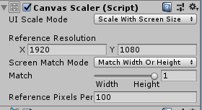This is an image of one of the components of the canvas; the issue behind the game displaying incorrectly was due to the fact that it was originally set to “Constant Pixel Size” which means that on screens bigger than the editor window it doesn’t stretch which means that the camera sees further than intended which made the blue background visible.

#### Evaluation of Iteration

As no scripts were created within this iteration I did not have any issues/bugs, as I followed guides from the internet I also didn’t have any issues when it came to being able to correctly import assets into Unity as I made sure that I remained consistent with the sizing. The only issue within this Iteration was that it took longer than planned to create the assets which may be an issue when it comes to developing levels in the game it may restrict how many different levels I can create due to timing.

## Progress on 30/01/2019

### Iteration 3: Creation of the character + movement

#### New objects within Iteration

|  |  |  |
| --- | --- | --- |
| Name | Type | Reason |
| PlayerMovement | Script | The purpose of the script is to be able to control the “Player” object within the game. |
| Player | Object | This is the object that will be able to be controlled by the “PlayerMovement” script once it is attached. |

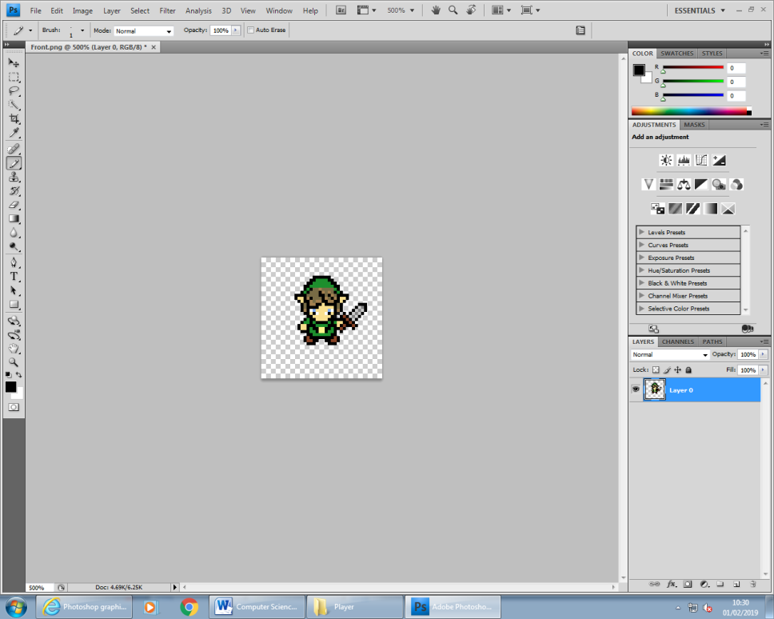

I decided to use the Zelda games as an inspiration for the design of my character; I like this style because it is minimalistic so it is easier to design although I have only designed the front of the character for this iteration because I wanted to be able to focus on the player interacting with the previous scene that I had created (“House”) which has now been made larger to be able to add in camera controls later on.

#### Pseudocode of Character Movement

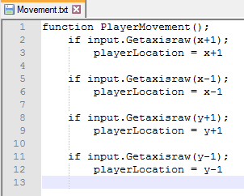This is a brief example of how the player movement should work in the game; the Unity Engine already provides standard controls which can be used. The “input.Getaxisraw” was a piece of code that was on the Unity forums which means that the value returned is always going to be a 1 or 0 which is important when using movement as you don’t want the speed to progress the longer the key is held down.

When using the movement script in the game I will also need to make sure that I can reference the player in the script; this is important because without being able to reference the player, using the controls will just result in nothing happening visually.

#### Analysis of Player Movement Script

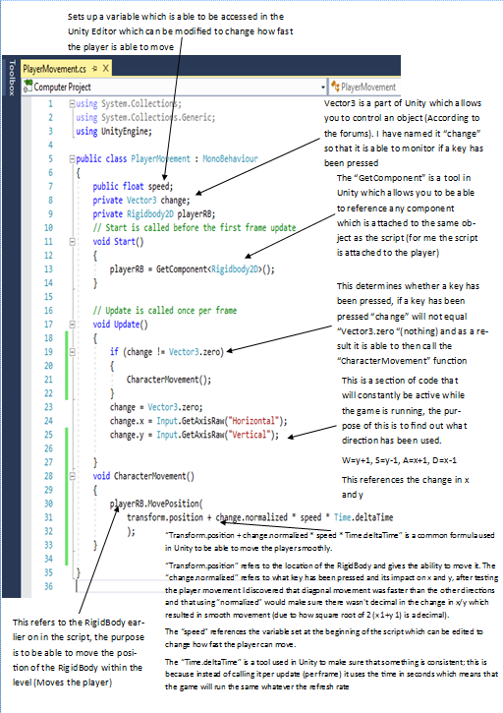

#### Testing within Iteration

Due to the amount of changes that were made during the testing I dedicated another Iteration to it

#### Evaluation of Iteration

This iteration relied heavily on using the Unity forums for suitable code to be able control the character; originally, I intended on having 4 “If” statements to determine if a directional key had been pressed although I later found out that the way that I have used now is more efficient. I will need to modify the value for Speed after I have created the “Walking” animation so that the Player moves appropriately because currently the movement looks too fast.

### Iteration 4: Testing Player Movement

#### New objects within iteration

|  |  |  |
| --- | --- | --- |
| Name | Type | Reason |
| Tilemap Collider | Tilemap Collider | I previously attached a box collider to the Tilemap like I did with the player although this means that the player was forced off it as the game recognised the full area as one object instead of just the edges. |
| Objects | Tilemap | Like I did with the walls I wanted to have specific objects that would collide with the player and as a result another Tilemap was needed. |
| Composite Collider | Composite Collider | The composite collider is used with the Tilemap collider to create one collision box instead of having multiple collision boxes; this was recommended on the forums as it stops the game stuttering as you move between the different collision boxes |
| Scene Manger | Empty Object | The “Scene Manager” was an empty object that I created so that I could create a collision trigger so that there was a way of being able to move between scenes |

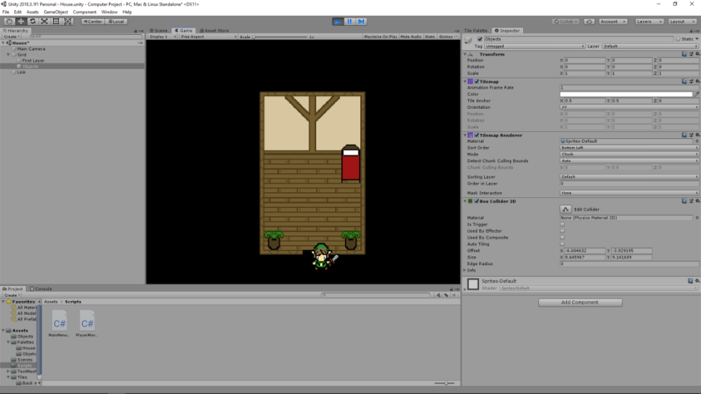

When testing the player movement, I found out that the player was able to walk out of the level, even though I added another Tilemap thinking that this would stop this from happening. After this I then added a collision box like I did with the player although this then brought up other issues where the player was being pushed out of the room onto the background which I did not attach a collision box to as I was using it for more aesthetic purposes .

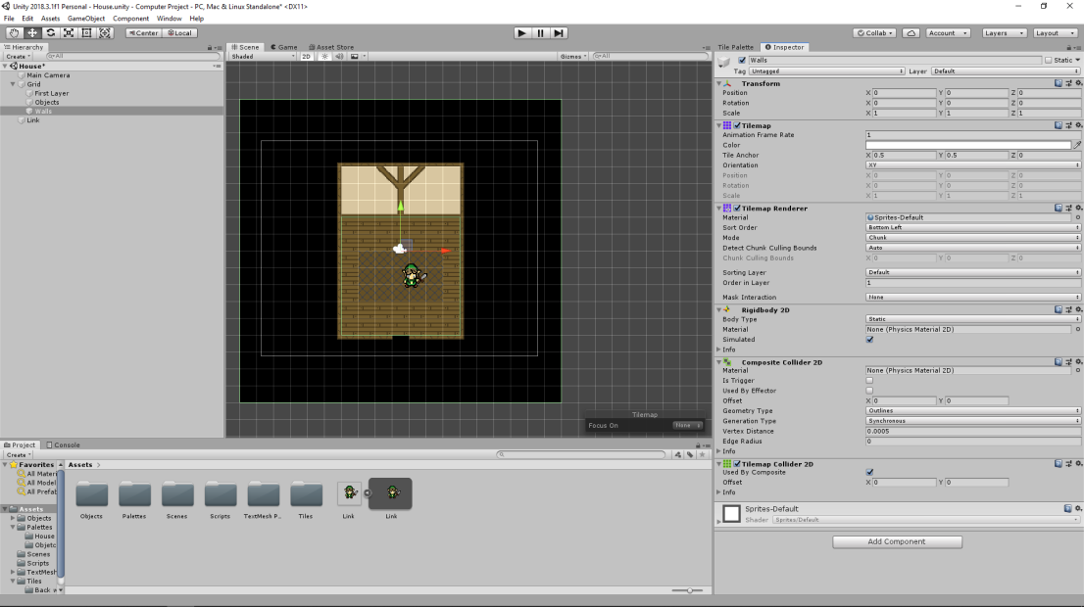After having issues with the box collider, forcing the player out of the house I decided to delete it and look on the Unity pages for help. The solution I found was to use a “Tilemap Collider” which instead of drawing a collision box around the whole Tilemap it does the individual objects instead which means that it doesn’t push the player out which is what I intended. After this I then tested the level and the player was unable to walk out and the walls also blocked the player which is what I wanted. After this I repeated the process for the “Objects” Tilemap so that I was able to add objects to the house. The bed, which will act as a saving point, will need to be modified as when it is part of a Tilemap it is more difficult to reference a specific object in a script which will be required when producing the saving function.

## Progress on 31/01/2019

#### Analysis of SceneMovement Script

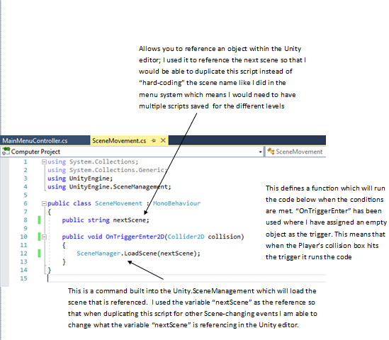

#### Testing within Iteration

|  |  |  |  |
| --- | --- | --- | --- |
| Test | Criteria | Reason | Pass/Fail + Explanation |
| Test to see if the Player is able to move through walls (wall tiles) | If the player walks up to the wall they should be stopped; they must be able to move in other directions though | It is important that I am able to block the Player as if they could move anywhere they wanted in later stages they would be able to skip the game | Pass – When the player walks into walls they can no longer move forward which is what was needed |
| Test to see whether assigned scene is loaded when the player hits the trigger | When the player walks into the trigger a mock scene should load up showing that it worked. | It is important that the player is able to trigger a function that loads a new scene as this is one of the requirements for the game | Pass – The blank scene is loaded which means the player triggered the function with the collider |

#### Validation within Iteration

|  |  |  |
| --- | --- | --- |
| Test/Data | Criteria | Outcome |
| Movement upwards | W/UP arrow key | W key – Player moves  Up Arrow Key – Player moves |
| Movement downwards | S/Down arrow key | S key – Player moves  Down Arrow Key – Player moves |
| Movement left | A/UP arrow key | A key – Player moves  Left Arrow Key – Player moves |
| Movement right | D/UP arrow key | D key – Player moves  Right Arrow Key – Player moves |
|  |  |  |
|  |  |  |

#### Evaluation of Iteration

Due to the amount of problems that I found within Iteration 3, I decided that it would be a good idea to create a separate iteration to address all the issues that I had; this iteration had a focus on testing how the Player interacted with the environment as I wanted to make sure that visually the game looked 3D. The way I have done this is by trying to create walls which are colliders; this means that the Players can’t walk on it but when against it they appear on top.

## Progress on 04/02/2019

### Iteration 5: Creation of the outside of the house

#### New objects in Iteration

|  |  |  |
| --- | --- | --- |
| Name | Type | Reason |
| Main Camera | Camera | This is automatically added onto the scene so when you go into game view you can see things. |
| Grid | Grid | This is automatically added to keep track of the different tilemaps which are embedded into it. |
| First Layer | Tilemap | This is the ground tiles for the game which is what the player can be seen walking on top of. |
| Objects | Tilemap | This is the second tilemap which has a tilemap collider attached to it which blocks movement of the player. |
| Player(Prefab) | Object | This is the object that when the “PlayerMovement” script is attached to it is able to move around the level. |
| Scene Manager | Empty Object | The “Scene Manager” was an empty object that I created so that I could create a collision trigger so that there was a way of being able to move between scenes |

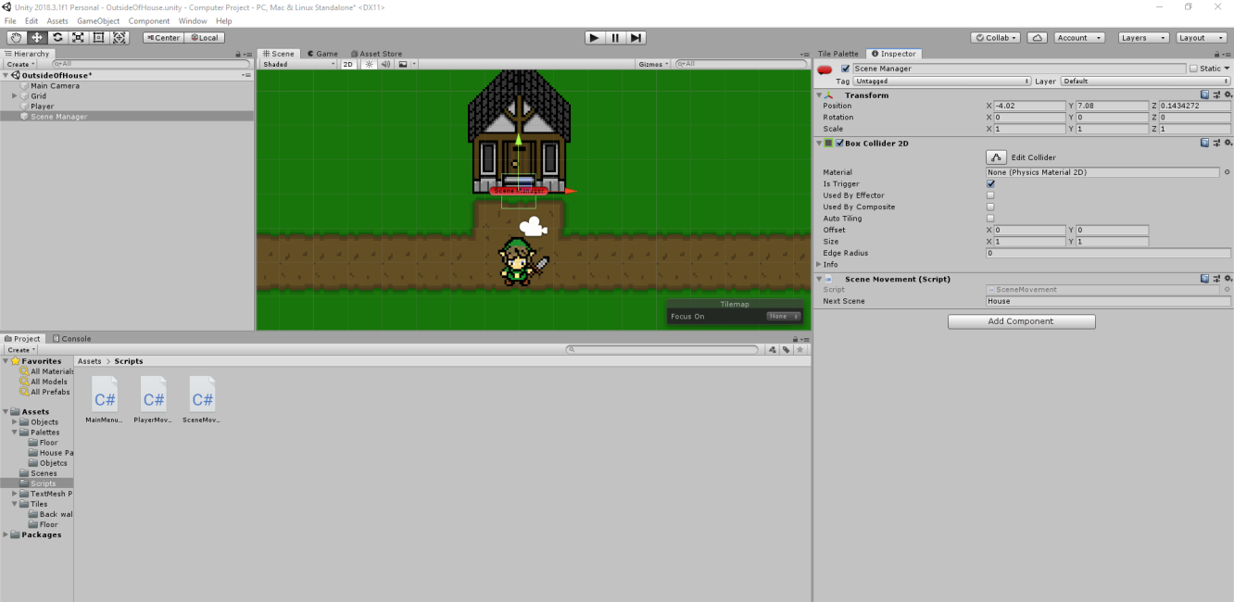

As I did in the house scene I added an empty object called “Scene Management” onto this scene so that when the player walks to the door of the house the scene is changed and you are able to control the player from within the house; eventually, when I have created a level system the information will need to be saved when switching between scenes because when moving between levels the player is not copied, instead a new one is created. This will also allow me to control the exact position of the player as I could save the previous location and then load it when the scene is loaded again.

This is a screenshot to show the transition between the house and the outside while testing the game; one problem that I have noticed is that when the player walks into the house the player sprite is facing the wrong way. To fix this I will make the player look into the room so that is looks like a smooth transition. This has brought up some issues that might occur however, as when it gets to the point of moving between different scenes the player spawn will need to change depending on the location of the previous scene.

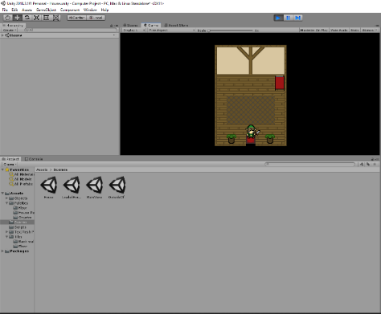

The lack of assets shows the scene has been loaded from the previous one

#### Testing within Iteration

|  |  |  |  |
| --- | --- | --- | --- |
| Test | Criteria | Reason | Pass/Fail + Explanation |
| Testing the SceneMovement triggers between the scenes | When the Player moves towards the House door the “House” scene should be loaded up and then when they walk towards the rug the “OutsideOfHouse” should be loaded up | It is important that scenes can be loaded multiple times as in one session the Player may go into the House multiple times | Fail – The player is able to enter the House through the trigger although the other trigger doesn’t work  Solution – From testing in the previous iteration I didn’t assign the new “OutsideOfHouse” scene to the “Scene Manager object” and as a scene was already assigned no errors showed up |
| Testing SceneMovement | Same as above | Same as above | Pass – With the fix of assigning the correct scene the Player is able to move between the two scenes multiple times |

#### Evaluation of Iteration

As part of my success criteria I planned to make sure that there was a smooth transition between the different scenes, this is because if the transition between scenes is not smooth the quick image change can be off-putting. This Iteration did have an issue where the “SceneMovement” didn’t work; as discussed in testing the actual reason was because the scene wasn’t added to the build, when testing the game this was shown in the console log.

### Iteration 6: Creation of the save UI and controlling it

#### New objects in Iteration

|  |  |  |
| --- | --- | --- |
| Name | Type | Reason |
| Canvas | Canvas | Automatically created when creating UI objects. |
| SaveGameOption | Button | This is a button that is linked to a function that will save the game when clicked. |
| QuitGameOption | Button | This is a button that is linked to a function that will quit the game when clicked. |
| ResumeGameOption | Button | This is a button that is linked to a function that will un-pause the game and closes the UI window. |
| Bed | Object | This is an object in the game which is separate from the tilemap so that I am able to individually reference it. |
| HouseSavingSystem | Empty Object | This has the different UI options embedded into it so that I am able to reference them as a group instead of individually. |
| EventManager | EventManager | Automatically added when using functions with the UI and the purpose of it is to track mouse inputs etc. |
| LoadingUpSavingUI | Script | This script will be attached to the bed object in the house and the purpose of this is to be able to display and control the Saving UI when the player walks towards the bed. |

#### Analysis of Saving UI Collision

The purpose of this script is so that the player is able to load up the Saving UI without needing to have a button on the UI which will likely be too visible. The way I have intended for the saving system to work is that the player will walk back to their house before leaving the game to quit; as a result there won’t be a need to keep track of the player’s location for saving purposes as the game will only be able to start in one place. However, due to the movement between the different scenes the game will need to save the player’s stats so that no progression is lost. I have decided to not tell the player this feature as I think that this will mean that players are more likely to quit whenever they want rather than needing to complete a level before returning which makes sure that it isn’t repetitive as they won’t have to go through an area again just to complete it.

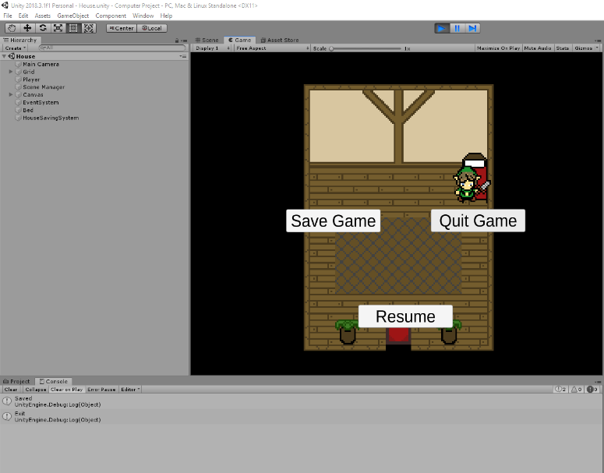Although I have nothing to save, I thought that it would be important that a save feature was made early on so that it is in place when creating the player’s stats. To test that the functions worked I used “Debug.Log()” and then inputted text inside; as shown on the picture it logs both of the functions that are linked to the two buttons “Save Game” and “Quit Game”. I have left out the “Resume” function as the purpose of this is to make the “SavingUI” invisible and to un-pause the game.

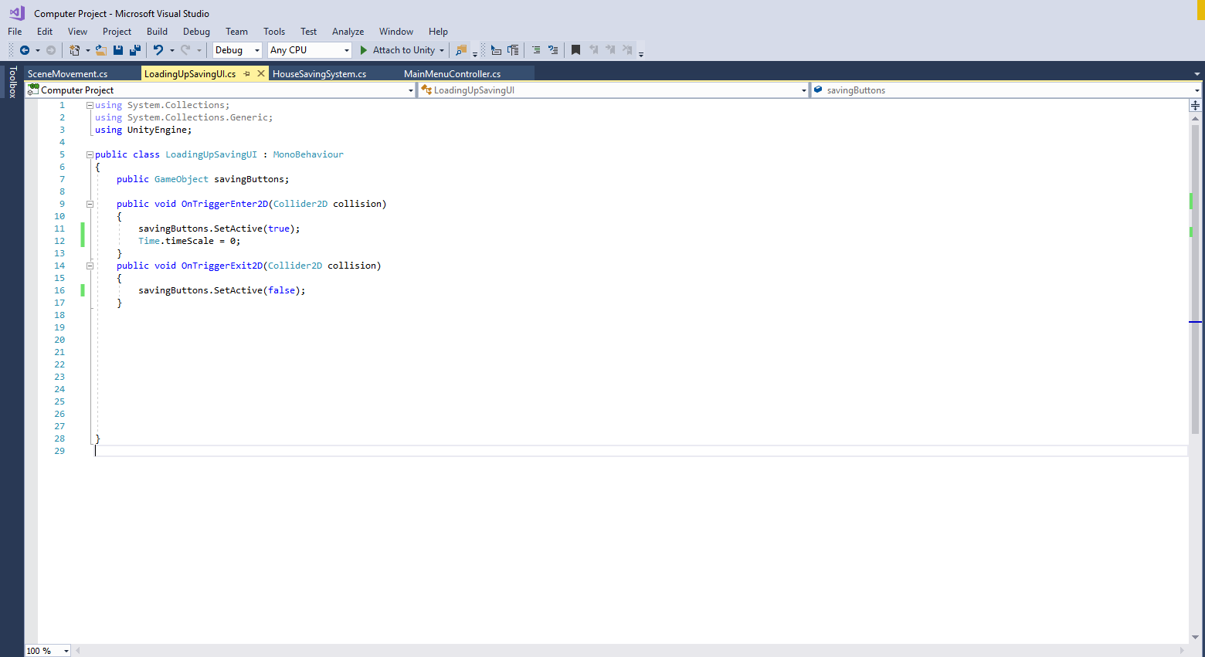This is part of Saving UI script from above; I have decided to add a pause feature into it so that the player cannot accidentally move while trying to pick an option. “Time.timeScale = 0;” will control the game meaning that it does not run until the time is equal to 1; this lead to an issue where I was not able to change the timescale back to 1 as the movement is based on the update system which only functions when the timescale is >0. As a result, I was unable to use the “OnTriggerExit2D” to alter the time which then needed a fix within the UI section and I decided to alter the “Resume” function.

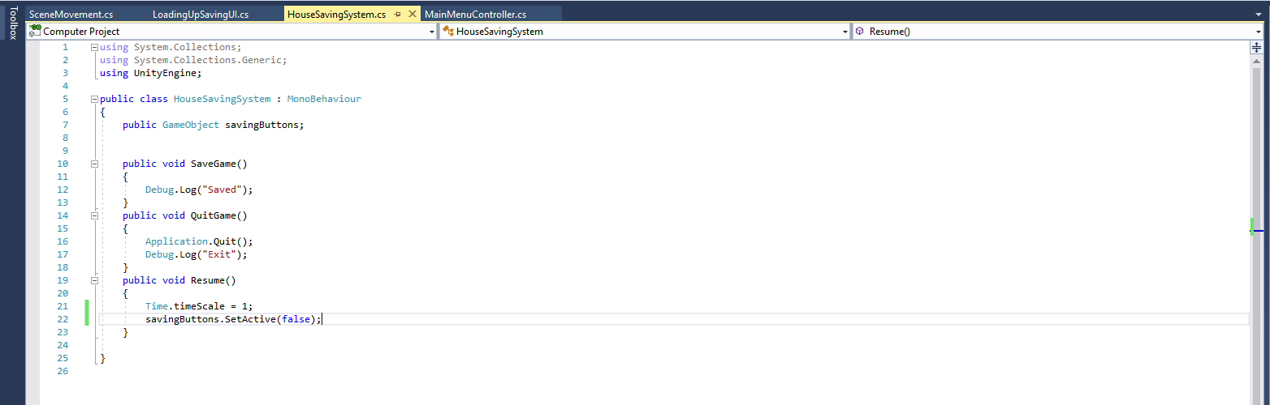When programming the script for the saving system I decided to add a pause function into it for a better user-experience. The problem that I encountered was that I had no way of being able to un-pause the game with the Player’s character as movement was disabled when the game was paused. As a result, I decided that on the resume function (which is linked to the “Resume” button) the timescale would be altered to = 1. This fixed the issue as the player was then able to move again which meant that the saving UI became hidden.

#### Testing within Iteration

|  |  |  |  |
| --- | --- | --- | --- |
| Test | Criteria | Reason | Pass/Fail + Reason |
| Testing “Save Game” button | When the Player clicks on the “Save Game” button, the log should show that the function has run | The reason behind having the Log show that the function has run is because I have not added a saving system yet and as a result there is no way of showing that it works | Pass – When the “Save Game” button was clicked the log showed “Saved” which shows that the function ran entirely |
| Testing “Quit Game” button | When the Player clicks on the “Quit Game” button the application should close | It is important that the Player has a way of being able to quit; I decided on having this feature only available in the house. | Fail – When tested the quit function runs, as shown by log although the application doesn’t close  Solution – “Appliaction.Quit” only works on the executable |
| Testing the “Resume” button | When the Player clicks on the “Resume” button the UI should become hidden and the Player should be able to move | It is important that the player is able to close the UI via a mouse click as when the UI is visible the game becomes paused which means that you can’t un-pause it by moving out of the trigger zone | Pass - When the Player clicks on the resume function they are then able to move |
| Test to see if the collision function loops | When the game is resumed I will move the character further into the bed object to see if the “Pausing” function loops | It is important that the function doesn’t loop because this means that the Player would be stuck | Pass – When you click on the “Resume” button you are able to move the player further onto the bed without the UI popping up again which means that the player is unable to get stuck |



This is an image of the console log after clicking all of the buttons as part of the Saving UI; as I have not yet added a saving system into the game it was important that I test the different functions so that when I am able to create a saving system I can easily add it into the pre-existing function.

#### Validation within Iteration

|  |  |  |
| --- | --- | --- |
| Test/Data | Criteria | Outcome |
| Save Game | Button Click | UI closes |
| Quit Game | Button Click | Nothing (works on executable) |
| Resume | Button Click | UI closes |

#### Evaluation of Iteration

The purpose behind this Iteration was to meet one of the requirements in my success criteria which was to have an in-game menu that allowed the Player to save their game(as of this iteration that has not been included) . As with the Main Menu I decided to prioritize the function rather than the designs; when I later implement the saving System I will change the way that the buttons are set out, so it looks more professional then it does currently.

## Progress on 10/02/2019

### Iteration 7: Tracking the player with the camera

#### New objects in Iteration

|  |  |  |
| --- | --- | --- |
| Name | Type | Reason |
| CameraControl Script | Script | This is attached to the camera which allows it to be controlled like the player; however, it functions on the movement of the player instead of the input (in case the player walks into an object, so the player remains centred even when using the movement controls) |

#### Analysis of Camera Controller Script

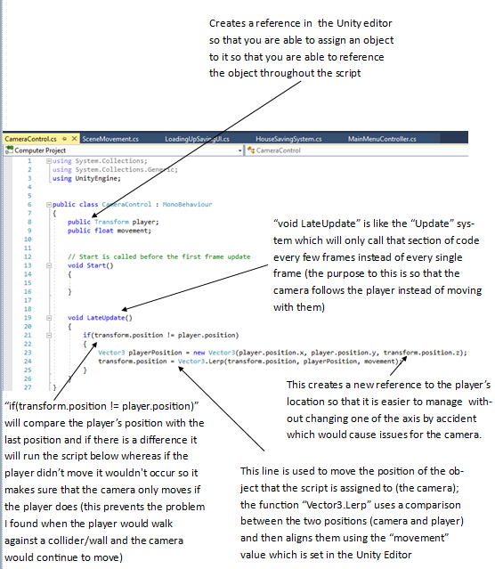

#### Testing within Iteration

|  |  |  |  |
| --- | --- | --- | --- |
| Test | Criteria | Reason | Pass/Fail + Reason |
| Testing the camera movement | In each direction the camera should follow the Player as the player moves | The full purpose of the camera is to focus on the Player; I have decided to make a camera that follows the Player as my maps are likely going to be large | Pass – When the Player begins to move the camera moves with them (follows them) which is what was intended |
| Changing the “movement” variable | Testing the “movement” variable at different values | The purpose of the movement variable is to change the camera position every “LateUpdate” which essentially follows the Player as they move (lower values look smooth) | Pass – I changed the value of “Movement” and this changed the way the camera moved. A value of 8 meant the camera moved with the Player whereas lower values caused a following effect |
| Testing “House” camera boundaries | When the Player moves against the edges of the level they should not be able to see blue which the default background colour is | The reason I don’t want the background colour to be visible is because it is off-putting | Pass - I walked along the edges of the scene and the camera did not reveal the blue background |
| Testing “OutsideOfHouse” camera boundaries | When the Player moves against the edges of the level they should not be able to see blue which the default background colour is | The reason I don’t want the background colour to be visible is because it is off-putting | Fail – When I walked along the edges of the scene (the bushes) I was able to see the blue background at some points |
| Testing “OutsideOfHouse” camera boundaries | When the Player moves against the edges of the level they should not be able to see blue which the default background colour is | The reason I don’t want the background colour to be visible is because it is off-putting | Pass – With the addition of some tiles at the top of the screen I was able to remove the blue background |

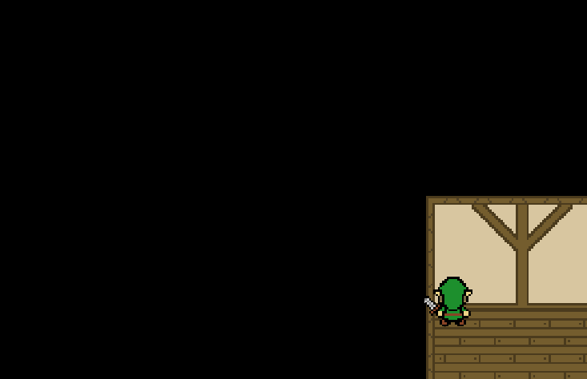

This image was taken during one of my tests when I was trying to detect the boundaries of the camera; it was important that the blue Editor background was not visible because this was visually unappealing.

#### Evaluation of Iteration

As part of my success criteria I wanted to make sure that scene transition was smooth, but I also wanted to make sure that the camera moved smoothly; as quite common in the games that I researched the camera follows the Player rather than the camera moving with the Player. When creating the “CameraController” script I looked on the forums for example code to use; this was because originally, I copied the “PlayerMovement” script, although this worked when the Player moved against a collision the camera continued moving which would be an issue.

## Progress on 11/02/2019

### Iteration 8: Creating dialog to guide the player

#### New objects in iteration

|  |  |  |
| --- | --- | --- |
| Name | Type | Reason |
| Button | Empty Object | As with the “House” Saving System I wanted to be able to the trigger UI and as a result the Empty Object contains the image and text which |

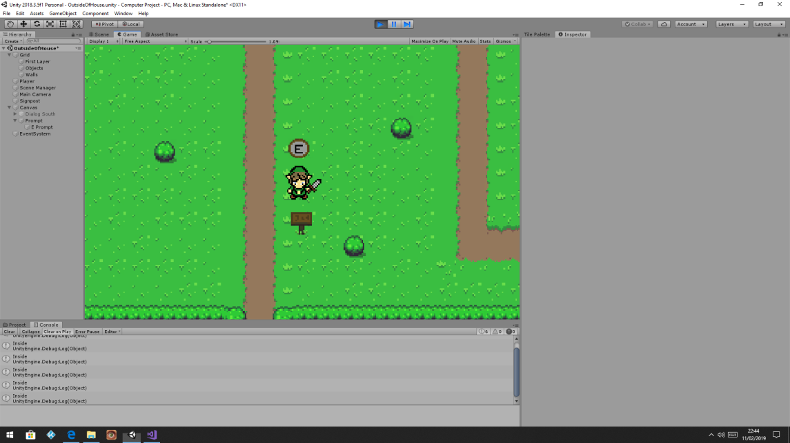

I thought that it would be important to create a specific design for the dialog boxes as when testing it with a white box I thought that it didn’t blend in with the game and it looked like a white error box had appeared on the screen instead of a text box. When creating the dialog box, I used a 48x48 sprite where the middle section was able to be stretched so that it would fit the desired size of the screen and the other 8 blocks just fit onto the edges of it.

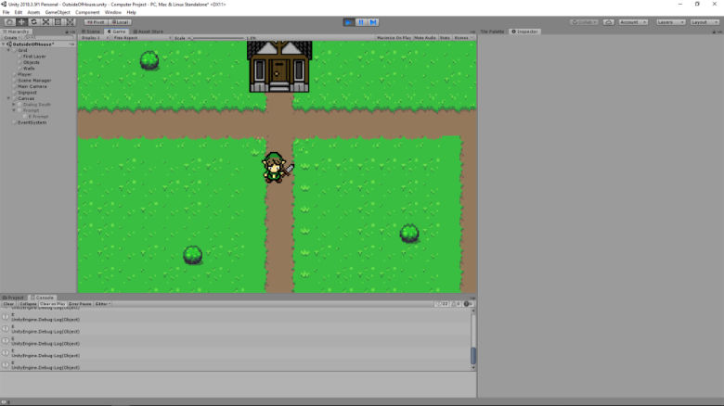This was a small bug that I found when testing the game where the dialog box would flicker on and off as the game registered the E key as being pressed multiple times; to fix this issue I changed “GetKey” to “GetkeyDown” which means that the game only registers it once. This will be useful in later iterations when I start the combat programming as it means that attacks won’t occur multiple times from one key press, it could also be useful if I was trying to find out if the key has been pressed rather than held as it would return multiple values instead of 1.

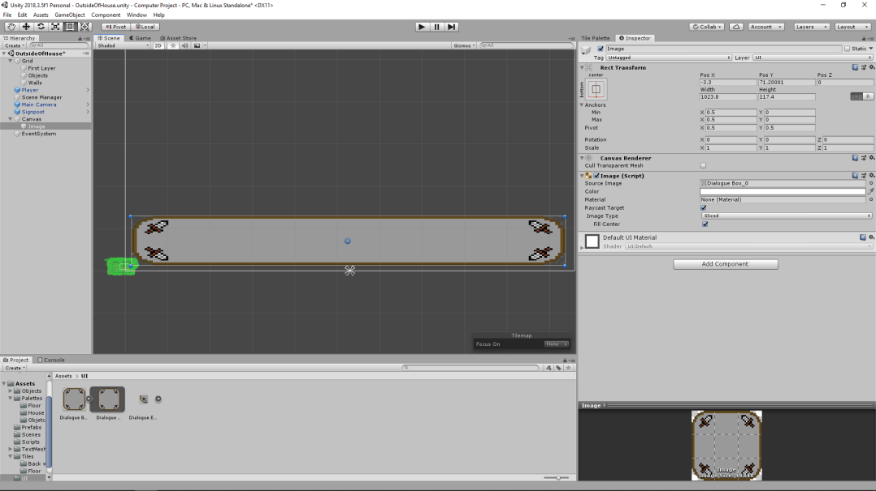Another feature I wanted in the game was that the player was prompted if they were in range of an intractable object. For this to work I designed a small circle with an “E” in the centre which should prompt the player that they can interact with an object. To make sure that this works for multiple objects I decided that the prompt would always be in the game and that the different objects would need to be able to directly access it by assigning the prompt as a GameObject.

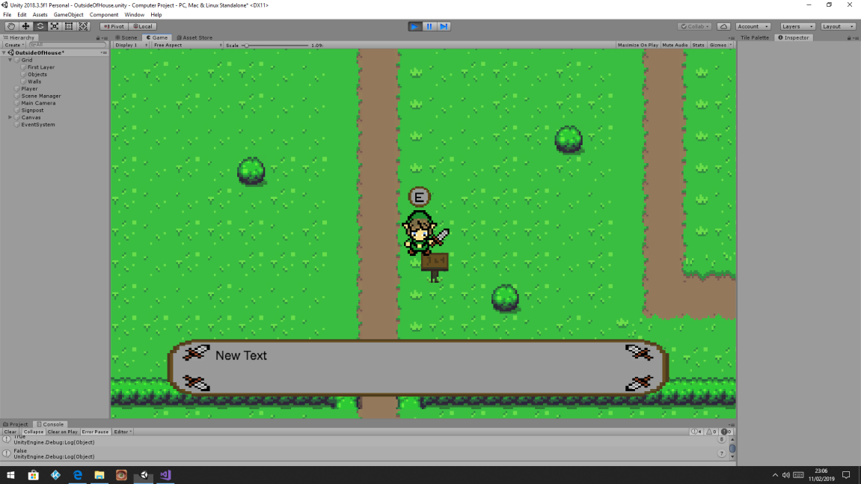

This is currently what the UI looks like when the player has moved within range of the object and pressed the “E” key; I will be able to duplicate the signpost and dialog box so that I am able to change the text for the specific circumstance. Although in later iterations I may remove the prompt when the Dialog box is active as the “E” prompt is not necessary.

#### Testing within Iteration

|  |  |  |  |
| --- | --- | --- | --- |
| Test | Criteria | Reason | Pass/Fail + Reason |
| Test to see if “E prompt” becomes visible once in trigger area | When the Player walks towards the signpost the “E prompt” should become visible | It is quite common for games to indicate that something can be interacted with; instead of visually changing the object (this requires more time) I have decided to create a prompt that pops up when the player is able to interact with something | Pass – When the player walks into the collision trigger the “E prompt” becomes visible which should hopefully indicate that the Player should press the “E” key |
| Test to see if “E” key can display the dialog box from outside of trigger | A test to see if the Player is able to display the dialog box from anywhere | The reason for the test is because logically following the code shows that by pressing the “E” key the dialog box should be displayed | Fail – The player is able to press the “E” key anywhere and the dialog box is displayed  Solution – Adding additional criteria to cancel this (a Bool that is true on trigger collision) |
| Test to see if Bool can be controlled based on collision | When the Player walks into the trigger of the signpost the bool status should become “True”; shown in the console using “Debug.Log(dialogStatus)” | The reason behind having this Bool statement is to make sure that the dialog box cannot be triggered outside of the collision box | Pass – When the player walks into the collision box the Bool status became True (shown in the console) |
| Testing the line of code “if(Input.GetKeyDown(KeyCode.E) && dialogStatus)  ” | Testing the “&&” which was shown on the forums as an “And” function | The reason for wanting an “And” statement is to try and make sure that the Player was in range of the signpost and that they also wanted to interact with it | Pass – The Player was unable to be able to press the “E” key and display the dialog box outside of the signpost’s trigger |
| Testing the dialog box on the executable | When the Player walks towards the signpost I want to make sure that everything displays right as the editor screen is small | When I tested the Camera script on the executable I found that the view was much larger than in the editor which lead me to needing to add more tiles around the edge of the house | Fail – As predicted, on the executable the “E prompt” and the dialog box where not in the right position  Solution – On the canvas settings I changed it from “Constant Pixel Size” to “Scale With Screen Size” |
| Testing the dialog box on the executable | Retesting the UI to see where it is located | From the previous test I found out that the “E prompt” was not in-line with the player and the dialog box was also not located at the bottom-centre of the screen like it was in the editor | Pass – With the rearrangement of the two images they are now in the right place on both the executable and the Unity Editor |
| Testing new font style in dialog box (Credit to OpenGameArt.org) | Making sure that the text fits into the dialog box | I want to make sure that the text is not too big compared to the dialog box and that it is readable | Pass – The text is readable and fits within the corners of the dialog box |

After testing from the executable, I realised that the “E” prompt was slightly off-centred compared to in the Editor, I found that the issue was because the canvas was set to “Constant Pixel Size” instead of “Scale with Screen Size”. After changing this I was then able to display the “E” prompt more precisely.

Originally the “E” prompt was an image that I made however, I realised that on a larger window the letter was hard to read without making the prompt too big; I then decided to include UI text for the Prompt although the standard font style used did not fit into the game so I then tried to download it from the internet (I learnt that you could import font to Unity when trying to find out how to create a Main Menu.)

#### Validation within Iteration

|  |  |  |
| --- | --- | --- |
| Test/Data | Criteria | Outcome |
| UI opens | “E” key press | UI becomes visible at bottom of the screen |
| Attacking signpost | “Space” key press | Nothing (checking that “E” key is always required) |
| UI closes | Move out of collider | UI closes |

#### Evaluation of Iteration

One of the requirements as part of my success criteria is that the game had a way of guiding the Player of what to do; instead of explaining how the Player can interact with Chests etc. in the “Help” section of the Main Menu, I decided that in-game prompts are more appropriate. Although in some of the games I researched prompts weren’t included I decided that I should use them as will be more appropriate for my target audience.

#### Analysis of Dialog Script

I thought that it would be important that there was dialog within the game because this means that it is easier for the player to understand what they need to do which is important for a game like this as without assistance, players will likely be confused and will likely not want to play the game which is one of the critical requirements for the game because if the testers don’t feel engaged the game will not be successful.

## Progress on 21/02/2019

### Iteration 9: Creating Player Stats

#### New Objects in Iteration

|  |  |  |
| --- | --- | --- |
| Name | Type | Reason |
| PlayerStats | Script | The “PlayerStats” script is a separate script from the “CameraController”. The point of attaching a second script to the Player is to make the saving process easier as I will be able to group the variables that need saving much easier. |

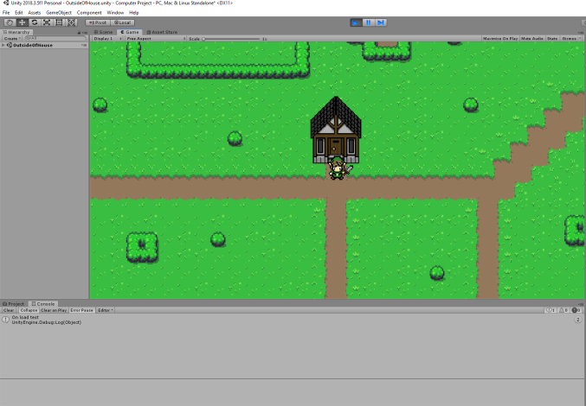

When creating the Player stats system, I was unsure of when the values would be set; as a result, I used “Debug. Log (“On load test”)” to test how many times the message would be displayed; I needed to make sure that the function only ran once as I needed to make sure that when the game loaded the health would equal the maximum health and when the player takes damage the function doesn’t run again which would cause the player to be invincible if it was within the “update” function.

#### Analysis of PlayerStats Script

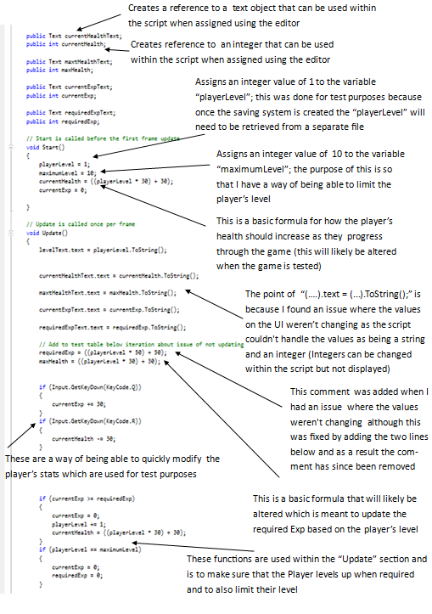

The purpose of this script is so that I am able to keep track of the player’s progression within the game; although the player already had the “CameraController” Script assigned to it; I decided to add another one as when creating the saving system I will need to be able to serialise the script and it will be easier to know what items need to be saved if they are in a separate script.

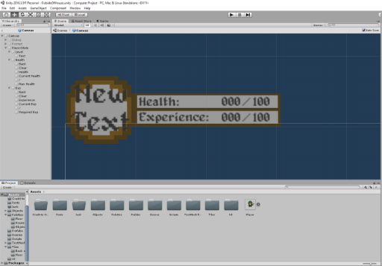This is the design of the UI which contains information about the player; including the Health, Experience and Level (where “New Text” is displayed). I initially wanted to be able to include a slide-bar for both the health and experience although I later realised that it was more challenging than anticipated as when the maximum values increase (because of the Player’s level ) it is difficult to be able to modify the values of the object whilst the game is in play. As well as this by setting the values as integers this allows me to better control the display of it as I know what the possible size is rather than a slide-bar which would increase in size as the value of the health and experience increases.

#### Testing within Iteration

|  |  |  |  |
| --- | --- | --- | --- |
| Test | Criteria | Reason | Pass/Fail + Reason |
| Test to see if the stats display correctly in the corner of the screen | When testing in the executable the stats should be visible in the left corner. They must be readable and not cut off by the screen | It is important that the stats correctly fit within the left corner of the screen as this means the Player is able to constantly monitor their progression | Pass – By changing the canvas settings in the previous iteration I have been able to fix the position of the UI |
| Testing the automated “LevelUp” function | For testing purposes, I added a function that increases Exp when the “E” key was pressed. When current Exp = the required Exp the level should increase | It is important that the level can increase by being based on the Exp as this then means it is done automatically | Pass – When the Exp equalled 100; the level, health and experience all changed as intended |
| Testing the max level | I have set it so that the Player’s level can reach 10 and then progression is locked; this is done by making sure that once the level equals 10 the Exp will always be 0 | The reason behind having Player level restrictions is so that I can easily test the difficulty and when I get stakeholders to test they can judge the difficulty and say if there is a constant increase in difficulty | Pass – When I set the Player’s level to 10 the Exp no longer increases indicating that they can’t level up any more |
| Testing the position of the Player level UI | I want the UI to fit in the top-left of the screen so that it is completely visible but with a minimum-sized gap | It is quite common for player statistics to be in one of the top corners of the screen and as a result I think that that is a suitable place for mine | Fail – In the executable (all UI tests are on the executable) the PlayerStats are not in the corner of the screen  Solution – As this was tested in a new scene the changes to the canvas scaling has not been made in this one which meant that it displayed it based on pixel amount rather than screen size |
| Testing the position of the Player level UI | Retest | Retest | Pass – With the changes made the UI is now displayed in the top-left corner as set in the Unity Editor |

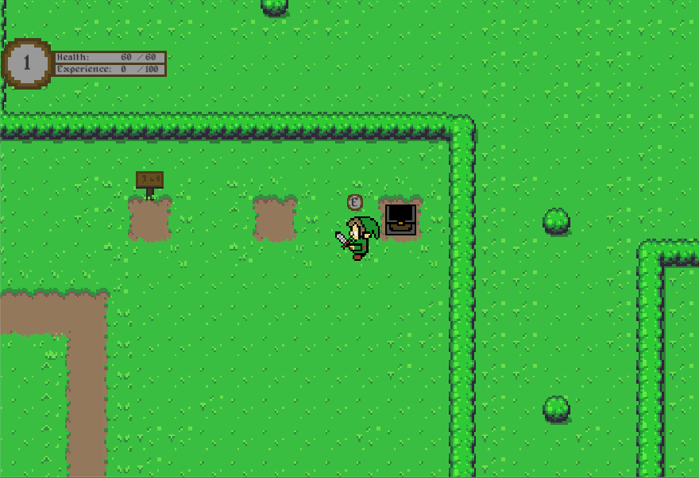One issue I keep having during the development of my game is that I am not able to correctly position the UI for the executable; this is an issue as it is important that the Player is fully able to see all stats. As seen in the image I also want to make sure that it is located directly in the top-corner as when it isn’t it looks unprofessional

#### Validation within Iteration

|  |  |  |
| --- | --- | --- |
| Test/Data | Criteria | Outcome |
| Player Level | Testing value of 1.5 | Error and value doesn’t show – only shows integers not floats |
| Max Level – which is set to 10 | Value of 9  Value of 10  Value of 11 | Displays 9  Displays 10  Displays 10 |
| Required Exp – currently 60 for Player Level | Value of 59  Value of 60  Value of 61 | Displays 59  Displays 0 – Player Level now 2  Displays 0 – Player level now 2 |

#### Evaluation of Iteration

As my game has a heavy focus on the Player levelling up to progress through the game I thought that it was important that the Player Stats were created during the early development of the game so that I can test the other components against it. Overall, this iteration was successful as I was able to meet the success criteria without having issues with the script, the issues from the UI scaling will be part of every UI element I create.

On the other hand, one issue I had within this iteration is the way that I wanted to display the Player’s Health. I intended on using a graphical representation to show the Player’s health as then this is easier to see, but as I intended that the Player’s health would increase with their level I did not have an appropriate way of creating this; any guides on forums that I looked for were all using a fixed health level and then changing the slider based on the percentage.

## Progress on 01/03/19

### Iteration 10: Player Animation

#### New objects in Iteration

|  |  |  |
| --- | --- | --- |
| Name | Type | Reason |
| Idle (4 ways) | Animation | The reason behind having 4 different idle animations is so that when the Player is not moving the player on screen is looking in the direction that they were last moving. |
| Walk (4 ways) | Animation | The reason behind having 4 different walking animations is so that in each direction the player faces there is an animation. I have decided to not include diagonal animations as when it comes to the combat system is will increase the time required which is very limited. |
| Animator | Animator | In-built into Unity this takes care of when the different animations should be ran based on whether or not the conditions are met E.g. When Y=1 play upwards animation |
| Blend Tree | Blend Tree | Used as part of the animator which is used to transition between the different animations. |

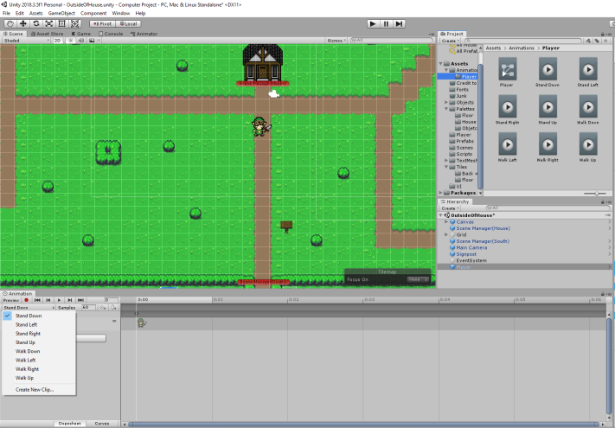This screenshot is to show how I have created two animations for every direction; this is important because I want the player to be able to move in four directions but also when they aren’t moving they face the direction that they were last moving in.

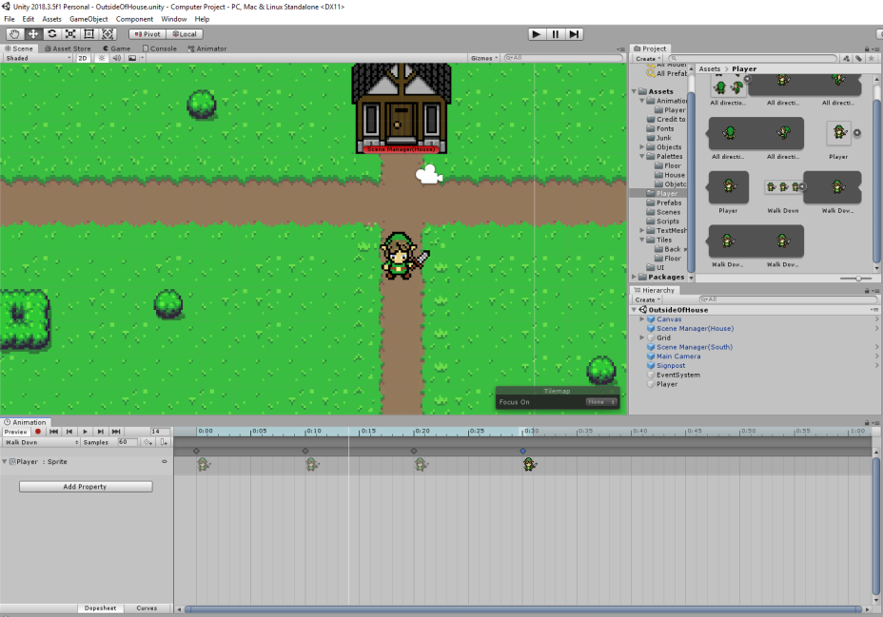One problem that I have found is that players are able to move diagonally and I have not created animations for diagonal movement; this is a minor graphical issue although I will likely not create diagonal animations as when it comes to the combat system I think by having diagonal animations; this will further add to the complexity as I would need to be able to monitor the direction the player is facing 8 times to make sure that they are attacking only in front of them. (Unless necessary, I will not include an area attack as I only want the Player to attack in the direction that their player/character is facing.)

This is an example view of how the animations were created; each moving animation consisted of 3 different sprites which were 2 movements and the idle sprite.

One issue I found out when testing was that without having an “Idle” sprite at the end (the 4th one) the player movement stutters as it loops. This is because it switches between two movement sprites. (1st and 3rd on the screenshot.)

#### Analysis of Animator Window

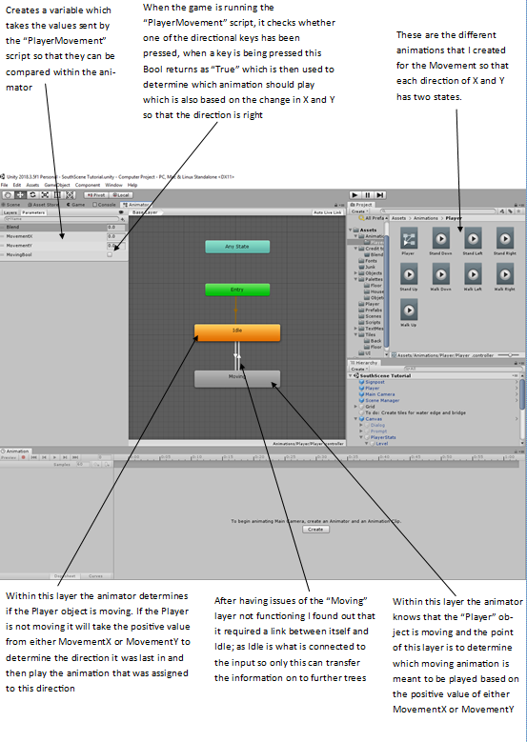

## Progress on 01/03/19

### Iteration 11: Creation of the Chest

#### New objects within Iteration

|  |  |  |
| --- | --- | --- |
| Name | Type | Reason |
| Chest Unused | Empty Object | The reason behind having an empty object is so that I can choose when I want the object attached to it to be displayed (although it is a single object I wanted to keep the style consistent throughout the project) |
| Chest Used | Empty Object | The reason behind having an empty object is so that I can choose when I want the object attached to it to be displayed |
| Chestused | Object | This is an object that looks like a chest which has been opened; the purpose of it is so that the Player is able to know that this object has already been interacted with |
| Chestunused | Object | This is an object that looks like a chest which has not been opened; the purpose of this is so that the Player knows that they can interact with the chest. |
| Box Collider | Box Collider | The purpose of having a box collider is so that it can be used as a trigger to decided when the Player is in range of the chest |
| Chest UI | Empty Object | The reason behind having an empty object is so that I can group up objects and not have to reference them individually within the scripts |
| ChestText | Text | This is text which is used to give information to the Player |
| ChestBox | Image | The purpose of having a UI image is so that the text is presented in a way that makes it easier to read but also so that it draws attention to the text |
| Back | Button | Used to run a function that closes the UI and un-pauses the game |
| ChestLine | Image | This is just a small rectangle used to separate the title from the text below it doesn’t have any other purpose than aesthetics |
| Title | Text | This is a brief message which alerts the Player to what has happened in the game. I think that this is important as it gives the Player the important details (“You earned…” etc.) |
| ChestHandler | Script | This is a script which monitors how a Player has interacted with a Chest object; it is also used to monitor if the Player has been rewarded as it is important a Player can’t take rewards from a chest multiple times. (At the moment as no saving system has been added having a reward system is not necessary) |

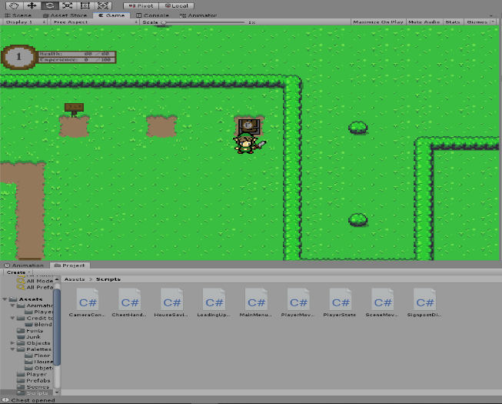

This was used to see if the “ChestInteraction” ran as within the “ChestInteraction” function was Debug.Log(“Chest opened”). This shows that when the player was in range of the trigger (set in front of the chest) and when they pressed the “E” key the function ran showing that they could use the chest. In the bottom-left of the screen it shows the most recent console message which is “Chest opened” showing that the test worked as intended.

This was the next phase of the iteration which focussed on me being able to display that the chest had been used (shown how the chest has changed from a shut one to an open one). Unlike in the screenshot I managed to fix the issue of the “E prompt” remaining active once the player has used the chest or that they have walked out of the range. I wanted to make sure that the prompt behaved differently to the one used for the signposts as I wasn’t able to use the collision to control it because this meant that even a used chest would still display the prompt which is logically wrong.

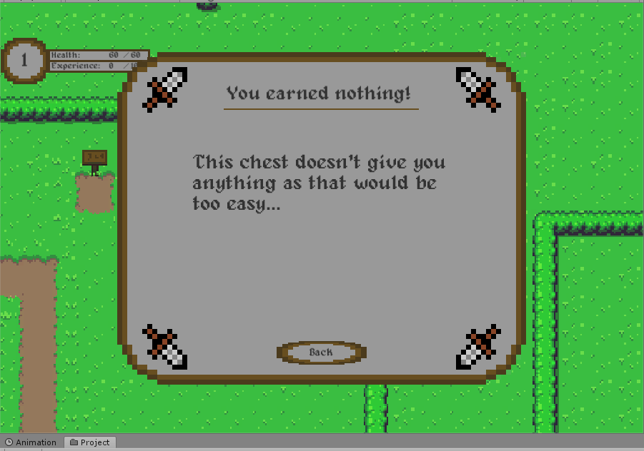

This is how the dialog box is shown once the Player has interacted with the Chest. The main reason behind having a large dialog window pop-up is because the transition between the two chest objects stuttered and it was noticeable, and I decided that increasing the size of the UI was an easy fix. When the player has read the text or just want to skip the message they are then able to click the “Back” button which will make the UI invisible and un-pause the game.

#### Analysis of ChestHandler Script

#### Testing within Iteration

|  |  |  |  |
| --- | --- | --- | --- |
| Test | Criteria | Reason | Pass/Fail – Reason |
| Testing whether the Player is able to interact with the chest (Testing “If” statement) | When the “E” key is pressed the console should show “Chest opened” to show that the function ran | It is important to test this function as it composes of several sections which have not been tested | Fail – Nothing happens when the “E” key was pressed, even took out other components which worked (Bool and collider)  Solution – Key presses can only be monitored during the “update” function so I moved the “ChestInteraction” function inside of this |
| Testing whether the Player is able to interact with the chest (Testing “If” statement) | Same as above | Same as above | Pass – After fixing the issue the console shows “Chest Opened” showing that the function ran as intended |
| Testing whether the UI displays as intended | When the Player interacts with the chest the UI message should pop up | The reason behind having the UI message is to give the Player information but also to hide the transition between chest states | Pass – When the Player Interacts with the chest the UI shows up and then closes when the Player walks out of the trigger |
| Testing the “Back” button | When the “Back” button is pressed the UI should go invisible and the Player should be able to move | After changing the script by adding a line which pauses the game it was necessary to have a way of un-pausing the game | Fail – When the “Back” button is clicked nothing happens and the UI doesn’t go invisible  Solution – As I was editing the “Canvas” prefab when creating the UI, the “EventSytem” was not automatically added as usual. As this was not added the game had no way of monitoring button clicks. |
| Testing the “Back” button | Same as above | Same as above | Pass – after the changes above the UI now goes invisible once the Player clicks on the button and it also un-pauses the game |
| Testing the “E prompt” | I will do multiple different things to test whether the “E prompt” act as intended | It is important to test it to see if it can be broken in any way | Fail – If the Player walks away from the Chest without interacting with it the “E prompt” remains active  Solution - if (!chestRange)  {  prompt.SetActive(false);  }  This means that the “E prompt” will go invisible when the player isn’t in range of the Chest if they don’t interact with it |
| Testing the “E prompt” | The “E prompt” should only appear when necessary | There is nothing in place to stop the “E prompt” showing on a chest which has already been used | Fail – As initially thought there was nothing to stop the “E prompt” displaying when the Player moves into the trigger of the used chest  Solution – “E prompt” can only display if “ChestUsed” = false; as this becomes “true” as part of the “ChestInteraction()” function this means that a used chest will not make the “E prompt” visible |

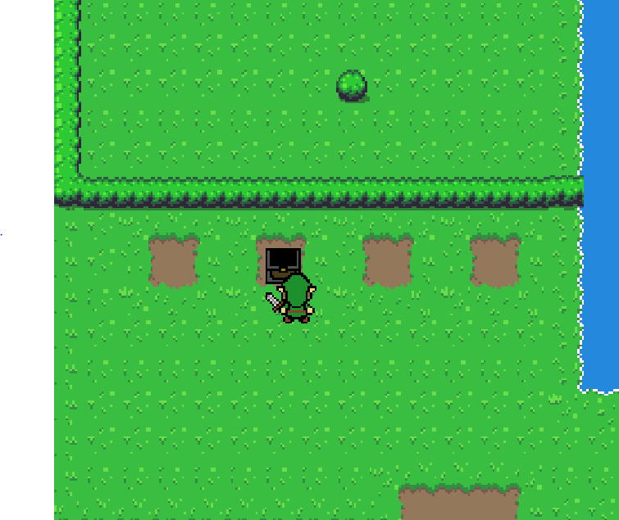As shown in the image, it was important that the prompt became active when the Chest was available, however, once the chest had been interacted with I needed to make sure that the prompt did not show even though the Player was in range; this is because I didn’t want a Player to keep interacting with the chest. The reason why I want the chests to be single-use is because when I eventually add rewards to them I don’t want the Player to keep using them and it is important that the prompt is removed so the Player knows they cannot interact with it.

#### , Validation within Iteration

|  |  |  |
| --- | --- | --- |
| Test/Data | Criteria | Outcome |
| E Prompt | Walk into collider of Chest | E prompt is displayed |
| E prompt | Walk out of collider | E prompt is not displayed |
| Chest’s one-time use | After closing message press “E” key again | Nothing |

#### Evaluation of Iteration

The purpose behind this Iteration is so that I am able to reward the Player for completing levels which gives the game a sense of progression; this meets part of my success criteria which was to include a way of notifying a Player of their progression/achievements. The way that I have planned to have progression is that when I create the Saving system I will save a bool which can then be used to indicate the Player of their progression; this could also be used to limit progression such as requiring 1 area to be completed before the next is available.

## Progress on 22/03/2019

### Iteration 12: Creating the combat system

#### New objects within Iteration

|  |  |  |
| --- | --- | --- |
| Name | Type | Reason |
| Attack Up | Animation | The reason behind creating an upwards attacking animation is that the Player is able to see that they are attacking |
| Attack Down | Animation | The reason behind creating a downwards attacking animation is that the Player is able to see that they are attacking |
| Attack Left | Animation | The reason behind creating a left attacking animation is that the Player is able to see that they are attacking |
| Attack Right | Animation | The reason behind creating a right attacking animation is that the Player is able to see that they are attacking |
| Up 2D Collider | 2D Box Collider | This collider is used to tell whether something is in the attacking range when the Player is moving upwards |
| Down 2D Collider | 2D Box Collider | This collider is used to tell whether something is in the attacking range when the Player is moving downwards |
| Left 2D Collider | 2D Box Collider | This collider is used to tell whether something is in the attacking range when the Player is moving left |
| Right 2D Collider | 2D Box Collider | This collider is used to tell whether something is in the attacking range when the Player is moving right |
| Attack Up Recording | Recording | After having issues of box colliders triggering SceneMovement collisions I decided to look up a way of not triggering them, the way of doing it was to enable the collider when the animation played and then disable it after the animation |
| Attack Down Recording | Recording | After having issues of box colliders triggering SceneMovement collisions I decided to look up a way of not triggering them, the way of doing it was to enable the collider when the animation played and then disable it after the animation |
| Attack Left Recording | Recording | After having issues of box colliders triggering SceneMovement collisions I decided to look up a way of not triggering them, the way of doing it was to enable the collider when the animation played and then disable it after the animation |
| Attack Right Recording | Recording | After having issues of box colliders triggering SceneMovement collisions I decided to look up a way of not triggering them, the way of doing it was to enable the collider when the animation played and then disable it after the animation |
| Slime | Slime Object | Gives a visual representation for something the Player is able to see and attack (at the current state it doesn’t function) |
| Box Collider | 2D Box Collider | This is attached to the slime to be able to act as a trigger which indicates if they have been hit by the Player |
| Box Collider | 2D Box Collider | This is attached to the slime to act as a collider which stops other objects walking into it |

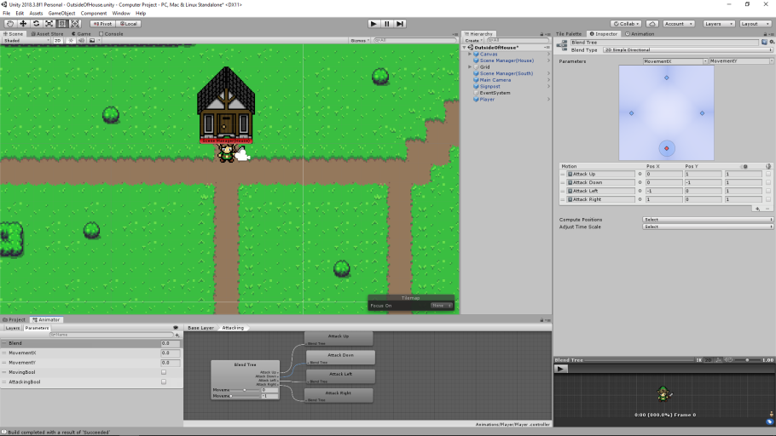During this Iteration of creating the Player attacking system I wanted to see if I was able to track the position that the Player was last moving in 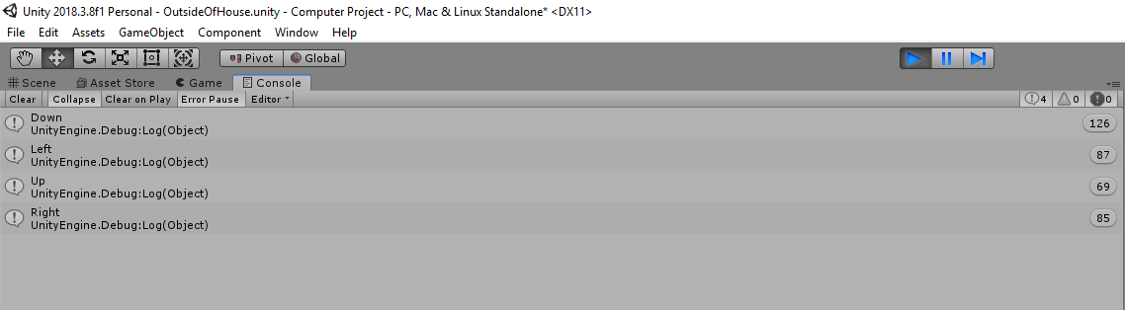 and then be able to access it within the PlayerMovement script. As shown in the screenshot I was able to access the movement and represent the direction using an “If” statement. The function I used **was (“If (MovementX ==1”){Debug.Log”Right”}** I then repeated this for the 4 directions that the Player could possibly move and then tested by moving the Player around.

These lines of code have since been deleted as I found an issue where the colliders attached to the Player, to allow you to attack, also are able to trigger the SceneMovement triggers which mean that the game loops between the “House” and “OutsideOfHouse” scene. Although I could change this by moving the spawn location of the Player I decided that I would remove this way of creating attack colliders as this means that the Player may accidentally walk too close and trigger an object that they did not intend to such as signposts etc.

As I did with the movement animations I made a separate blend tree for the attacking animations so that they trigger when required. For the Blend Tree to work I used the MovementX & MovementY parameters which are given as part of the PlayerMovement. Then for each animation I created conditions which needed to be met for the animation to play. For the “Attack Up” animation to work, X needs to equal 0 and Y needs to equal 1. This means that when the Player is walking upwards and when they press the “Space” button the right animation will play; I’ve repeated this for the different animations so that in all the directions the animator functions as intended.

As I had issues with the box colliders before I searched on the Internet for tips and found out that you are able to change when they are active by recording the animation and then setting them as active and inactive when required; as I needed the collider to be active only during the animation I made the recording so that when it starts, the collider becomes active and at the end of it the collider becomes inactive. It is important that the collider becomes inactive at the end because this means that the collider remains active even if you didn’t attack; this is shown by my testing.

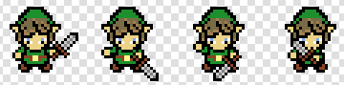During this iteration I needed to create the different sprites for each direction that the Player could move in. I decided to create four different images for each direction so that the animation has a bit of length although it is only 0.2 seconds; if I had more time I would have created more images to make the animation smoother although as I have time restrictions I have decided that this animation will be suitable as the purpose of this is to notify the Player that they are attacking; the game itself isn’t meant to be visually appealing.

#### Analysis of Movement and Attacking Script

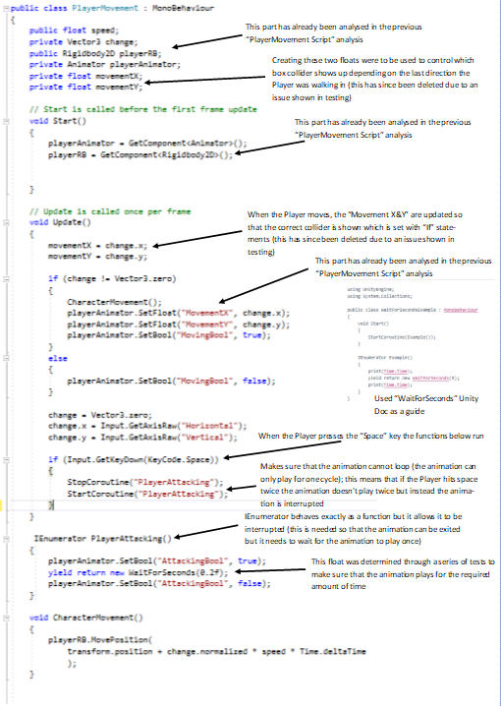

#### Testing within Iteration

|  |  |  |  |
| --- | --- | --- | --- |
| Test | Criteria | Reason | Pass/Fail - Reason |
| Testing the MovementX variable | When the Player moves along the X-axis I want the game to log -1 and 1 | This test is to try and find out if I am able to store the Player’s last movement direction as a variable so that it can be paired up with a hit box | Pass - As explained above with the screenshot I was able to track the direction |
| Testing the MovementY variable | When the Player moves along the Y-axis I want the game to log -1 and 1 | This test is to try and find out if I am able to store the Player’s last movement direction as a variable so that it can be paired up with a hit box | Pass - As explained above with the screenshot I was able to track the direction |
| Testing upwards attack animation | When the Player is facing upwards and presses the “Space” key the animation should play | This is a test to see if the animation plays when required | Pass – When the Player is walking upwards and presses the “Space” key the animation plays |
| Testing the downwards attack animation | When the Player is facing downwards and presses the “Space” key the animation should play | This is a test to see if the animation plays when required | Fail – Instead of the downwards animation playing the upwards animation played  Solution – After trying several fixes I decided to add walking animations to left and right (attacking animations had not been made) this then seemed to solve the issue even though I don’t know the actual issue |
| Testing the downwards attack animation | Same as above | Same as above | Pass – With the fix of having 4 animations for the different directions this then fixed the issue of the wrong animation playing |
| Testing the left attack animation | When the Player is facing left and presses the “Space” key the animation should play | This is a test to see if the animation plays when required | Pass – When the Player is facing left and presses the “Space” key the animation plays |
| Testing the right attack animation | When the Player is facing right and presses the “Space” key the animation should play | This is a test to see if the animation plays when required | Pass – When the Player is facing right and presses the “Space” key the animation plays |
| Testing the animation break “yield return new WaitForSeconds” | I am testing how long the animation should be active before it is disabled | It is important that the animation remains active for the length of the animation so that it doesn’t loop | Fail – The first test of 1 second was too fast and then when I tried 0.5 the code broke  Solution – It sees values as an integer which doesn’t allow 0.5. To fix this issue I added “f” to the end (float) |
| Testing the animation break “yield return new WaitForSeconds” | Same as above | Same as above | Pass – The final value that I got to was 0.2f which doesn’t cut off the animation (the same value could have been found by looking on the animator to see the length, but I wasn’t aware until after) |
| Adding 4 empty objects and collision boxes | I have created a dummy slime() to register if the correct collider is hit | I have set it up so that the last movement direction is always tracked and then created 4 “If” statements to decide which collision box becomes active | Fail – As the collision boxes are always active this meant that they kept triggering other colliders when the player is walking around  Solution – I have decided to completely scrap this idea as an extra collider that is active will lead to more issues when it comes to having a combat system with enemies attacking |
| Testing new method of collision boxes from attacking | The new way of having collision boxes is so that they become active during the animation | After following guides online, I found out that you are able to modify when an object is active whilst recording an animation. For this to work I recorded each direction and at the start of the animation I activated the collision box | Fail – During the test the “Debug.Log(“Hit”)” returned “Hit” suggesting that the recording worked however, when I then went to the console to clear it I realised that it had registered multiple times which means that if damage was being dealt it would be too high  Solution – After looking at the animation I realised that obviously there was nothing to set the collision to inactive… The fix to this was to make the collision box inactive at the end of the animation. |
| Testing new method of collision boxes from attacking | Same as above | After finding the fix to the original issue it was important that there weren’t any more issues | Pass – Having made sure that the collision box becomes active and inactive in each animation the “Hit” did not keep increasing after the animation  Note – From one press of the “Space” key from some positions the “Hit” registered multiple times although this should be fixed when the enemy can move and a knockback occurs |

#### Validation within Iteration

|  |  |  |
| --- | --- | --- |
| Test/Data | Criteria | Outcome |
| Attack animations | “Space” key  “LMB” (Left-mouse button) | Animation plays  Nothing – Although it is quite common I decided to allow only keyboard controls |
| Attacking collider boxes | Facing towards Enemy and press “Space” key | The hit registers |
| Attacking collider boxes | Facing away from the Enemy and press “Space” key | The hit does not register |

#### Evaluation of Iteration

As predicted when designing the game, I thought that this Iteration was going to be the most challenging to create due to the number of components to the script, by following online guides I was able to animate the Player so that they have moving but also attacking animations. One limitation within this Iteration, is due to a lack of time, I did not create diagonal attack and moving animations as creating the current animations took a long time. Even though this should not affect the Player’s experience I think it will be a feature that would need to be further developed.

## Progress on 25/03/2019

### Iteration 13: Creating Enemy Slime

#### New objects within Iteration

|  |  |  |
| --- | --- | --- |
| Name | Type | Reason |
| Slime | Object | This is a visual representation of an enemy which the Player can interact with |
| Animator | Animator | This is used to decide what sprite is being displayed when attached to an object (the slime) |
| EnemyMovement | Script | This is used to control how the object behaves |
| Combat | Script | This is used to control how the object behaves; it focusses on the stats of the Slime and as a result by separating this from “EnemyMovement” this allows me to modify it to suit the object that it is attached to |
| Slime’s Collider | 2D Collider | The reason for having a collider attached to the Slime is so that it cannot walk outside of the area that the Player is able to move in |
| “Idle” animation | Animation | The purpose behind having an idle animation is so that when the enemy isn’t moving they are not just randomly jumping up and down |
| “Moving” animation | Animation | The purpose behind having a specific animation for moving is so that the Player is able to recognise that the enemy is out of range and is moving towards them |
| “Attacking” animation | Animation | The purpose of having an attacking animation is because the “Moving” animation changes the position of the sprite which means that the collider also needed to change based on which sprite was being shown which caused the Player to sometimes be unable to hit the slime and if they were above the Slime then the moving animation caused them to be pushed away due to the collider |
|  |  |  |

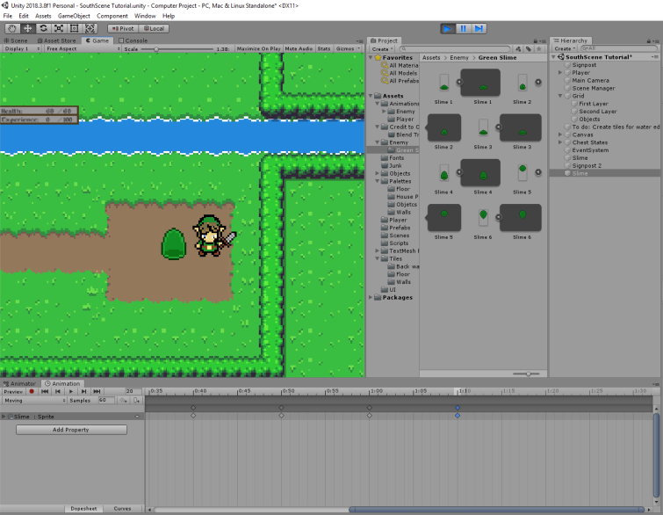

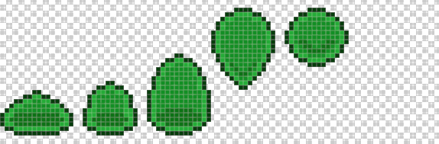This is a screenshot of what the slime looks like when the game is running (this is before it “jumps”) each sprite is shown for a tenth of a second which is why they have limited detail as I didn’t want to spend too much time on the artwork as the Player will likely not see the details unless they focus on it. Now that the animation has been created and linked to the slime I am able to use it as a prefab which means that it keeps any components which are attached to it and I am able to duplicate the object (I haven’t saved it as a prefab as of now as the script is not fully completed)

This is what the multiple sprites look like although this is a zoomed-in view which as a result means that they are pixelated which in the game does not happen as the camera view is further away than this. Although there are only 5 different sprites the animation is longer than ½ a second as I decided to repeat the animation but, on the reverse, as when testing without this it was clear to see how the animation clipped off at the end and looped which although isn’t functionally an issue I thought that it was a quick fix.

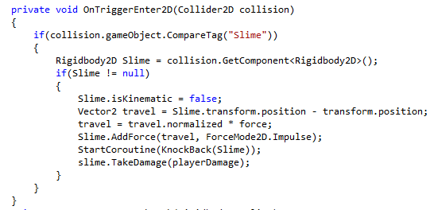When the slime is within range of attack the animations will need to be different as by allowing the Slime to appear as though it jumps means that it will either have a large collision box or that the Player is able to hit the slime when visually they aren’t (slime would need a 16x32 collider which takes up two tiles which is too big of a collision box).

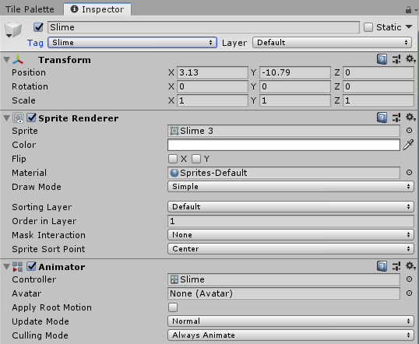Although this isn’t part of either of the scripts that were created within this iteration I made changes to the “PlayerMovement” so that the Player is able to pass on damage. “slime.TakeDamage(playerDamage);” is the line used to pass on information. “slime.TakeDamage” is a reference to another script (“slime” is linked to the script attached to the enemy object) and “TakeDamage” is referencing to a public function within the Combat script with (playerDamage) being an int that is being passed on.

When creating the enemy slime, I realised that if I wanted to have multiple Slimes on the screen at once I would need to alter how the code worked as I relied on getting an object that had a specific name so that the Player was able to target it. Instead of this I decided that I would create a custom tag called “Slime” and then reference to the tag rather than an object name so that I could have multiple Slimes on the screen at once and still be able to attack them.

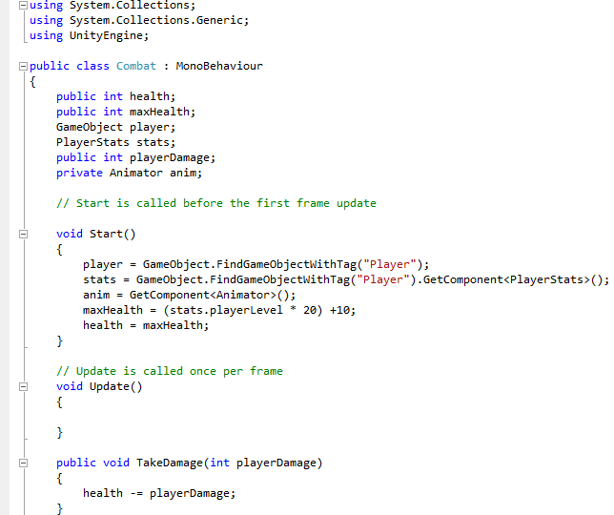

The purpose of this script is to control the combat system and allow the Player to deal damage to enemies. It is important that the Slime is able to access the different scripts attached to the Player as this then allows me to scale the Slime’s stats to the Player which stops the game from becoming too easy as the Player levels up. As the Slime will become a prefab it is also important that every relationship is made within the game is hard-coded as this then stops me needing to create the links in the unity editor which can cause issues if everything isn’t paired up as I have found out numerous times when creating a new scene as I did not hard-code the relationship between the main camera and the Player the scene is unable to run and as it never says the issue it takes a while to be able to find out what the problem is.

#### Testing within Iteration

|  |  |  |  |
| --- | --- | --- | --- |
| Test | Criteria | Reason | Pass/Fail - Reason |
| Testing transition times for sprites | I will change the length of how long a sprite is visible and then watch it | I want to make sure that the animation is smooth, not so slow that the image changes are different but not too fast that it looks bad | Pass – After trying several different lengths I finally found that a tenth of a second was a good speed for each sprite. |
| Testing the box collider on the Slime throughout the animation | I will stand above the slime and then see how it functions | I want to make sure that when the animation is being played the Player is pushed away instead of the slime getting stuck as this could lead to the Player exploiting this issue to stop them attacking. | Pass – When the Player walks into the animation path of the Slime they are pushed out the way which means the Player is unable to stop the Slime from moving |
| Testing Slime Movement | I used the same script that I used on the camera and wanted the slime to be able to follow the Player | It is important that enemies are able to follow the Player as this stops the Player from being able to progress as quick | Fail – The Slime becomes attached to the Player and causes the Player to not be able to move |
| Testing if there is a smooth transition between Idle and Moving | When the Player moves into a distance of “5” from the Slime the Slime should begin to move (should cause animation to change) | The Idle animation means that the Slime isn’t visually moving and as a result I don’t want the Slime to move while playing the idle animation | Fail – The complete idle animation played before the moving one did which caused the Slime to be moving with the idle animation  Solution – On the transition between the two animations |
| Testing the hit collider against the Slime | On the attacking function I have added Debug.Log(“Hit”) which can be used to count the hits | It is important that the hit collider works as intended as this is an issue that would need to be fixed urgently | Fail - Due to the constant movement in the animation sometimes the hits do not register as intended |

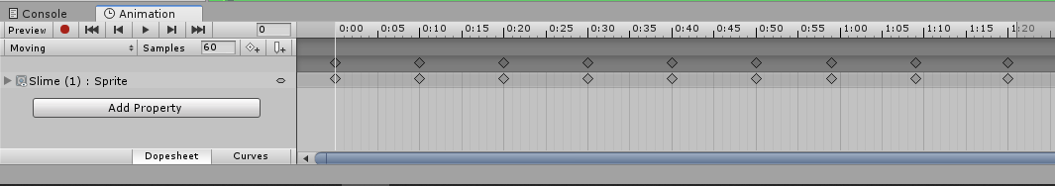When creating the animation for the Slime it was important that I tested the length of the animation because it didn’t want an image to be displayed for too long due to the lack of detail but also, I wanted a smooth transition so that it matched with the movement speed of the Slime.

#### Validation within Iteration

|  |  |  |
| --- | --- | --- |
| Test/Data | Criteria | Outcome |
| Enemy Range | Inside of range  Outside of range | Enemy moves towards Player  Enemy doesn’t move |
| Enemy Attacking Range | Inside of range  Outside of range | Enemy animation changes to “Attacking”  Enemy moves towards Player |

#### Evaluation of Iteration

One of the main components of my success criteria was that the enemies would be able to appropriately scale to the Player’s level; one key issue I had within this Iteration is that I was unable to compare the Slime to the Player within the ”Start” function; this means that the when I checked the Slime’s stats the “Health” was set to 0. I found out that the reason for this is because it needs to compare within the “Update” function. My solution to this was to create a bool which means that the Health is appropriately set but then this is cancelled out which stops the “If” statement being used again.

During this Iteration I also had a large amount of issues with the Enemy AI; even though I used the flowchart as a guide for the script. I initially planned on using colliders to allow the Enemy to attack the Player, however I late realised that using integer values were easier because the Enemy movement relies on getting within 1 of the Player whereas when creating the colliders, I had issues of the Slime pushing the Player out of the way.

## Progress on 30/03/2019

### Iteration 14: Creating the saving System

#### New objects within Iteration

|  |  |  |
| --- | --- | --- |
| Name | Type | Reason |
| Stats | Script | The purpose of this script is so that progression can be saved and loaded when required; this is needed as the scenes don’t transfer information |
| Test Saving | Empty Object | This object had a box collider attached which acted as a trigger and when the Player walked into it the Saving function ran |

#### Pseudocode for Saving and Loading

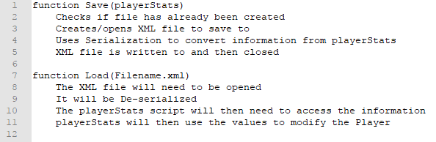The reason for creating the Pseudocode for the Saving and Loading system; is because as I don’t know how to use serialization I will rely on using the Unity forums for the code that needs to be used, as a result using basic Pseudocode will allow me to find the exact section of code that I need.

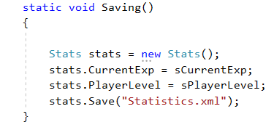This section of code is used to be able to save the stats within “PlayerStats” script by updating the values within “Stats”, when the game increases in size I will need to add further values to be saved which may change where I save the game (I don’t want the “PlayerStats” script to have too many integers).

This is the XML file that is created after running the saving function, currently triggered by the “X” key. If there is time in development I would like to add in a binary formatter for the serializer as this would then stop the user from being able modify the stats to potentially cheat.

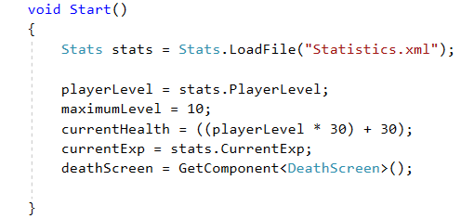This is part of the “PlayerStats” script which is used to be able to retrieve the Player’s stats from the XML file; in this current iteration there are only two values that need to be loaded, however, I presume that when the game gets larger I will need to save bools to track the Player’s progression.

#### Analysis of Stats Saving Script

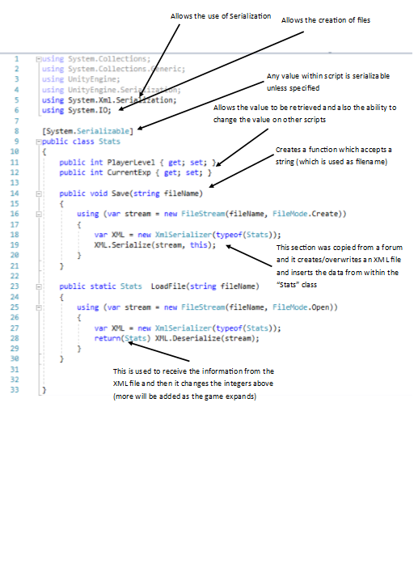

#### Testing within Iteration

|  |  |  |  |
| --- | --- | --- | --- |
| Test | Criteria | Reason | Pass/Fail - Reason |
| Testing if an XML file is created with the correct information | I will play the scene and then see if an XML file is created with the right information | It is important that information is saved as this is the purpose of the serializer | Fail – Even though the XML file was available the values were 0  Solution – Serialization only allows use of a static integer which cannot be used in mathematical operations; so, I added 2 additional integers that were static which were updated every frame with the Current Exp and Player Level |
| Testing if an XML file is created with the correct information | I will play the scene and then see if an XML file is created with the right information | It is important that information is saved as this is the purpose of the serializer | Pass – After the previous changes I was able to get the correct values to be saved into the XML file |
| Testing that the Load function works for the XML file | I will start the game and see if the Player level reflects the level in the XML file | As well as being able to save data it is important that the game can retrieve it and import it | Pass – When the scene loaded I was able to see that the Player was the same level as the level shown in the XML file |

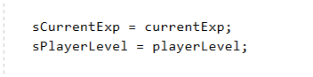During the testing, I had an issue where I wasn’t able to save the Player’s Stats; as shown in the image the reason behind this was because I was only able to serialize a non-static integer. The solution to this was to create static integers which are updated every frame.

“sCurrentExp” and “sPlayerLevel” are the values that are serializable; for them to save I then need to access the values within the saving script called “Stats”.

#### Validation within Iteration

|  |  |  |
| --- | --- | --- |
| Test/Data | Criteria | Outcome |
| Player Level | Saved value of 1  Saved value of 0  Saved value of 1.5 | Player Level displayed as 1  Player Level displayed as 0  Player Level displayed as 0 |
| Current Exp | Saved value of 0  Saved value of -5  Saved value of 61 | Exp displayed 0  Exp displayed -5  Exp displayed 0 – Player Level 2 |

#### Evaluation of Iteration

This Iteration was one of the key components of the game because it then means that I am able to control what can be saved (interactions such as using chests should be saved to stop repeat rewarding); this Iteration also allows me to meet the success criteria to not allow the Player to lose their progress. One issue I found within this Iteration however, is that Unity only allows the serialization of static values; this means that if a variable is used within the script and needs to be saved I will need to create two instances of it. This issue has altered how I am going to design the game because instead of saving Player’s progression throughout a level I will just save whether they have completed it (any puzzles will reset when they exit the scene).

## Progress on 05/04/2019

### Iteration 15: Implementing the Saving and Loading system into the game

#### New objects within Iteration

|  |  |  |
| --- | --- | --- |
| Name | Type | Reason |
| Load Game | Empty Object | The reason why I created an Empty object was so that I was able to link this up with the “Load Game” button and then from within the Menu “Controller” Script I was able to decide when the option was available |
| Controller | Script | This is like the previous Menu “Controller” Script that I used although I needed to slightly alter it for when I had the Saving feature working |

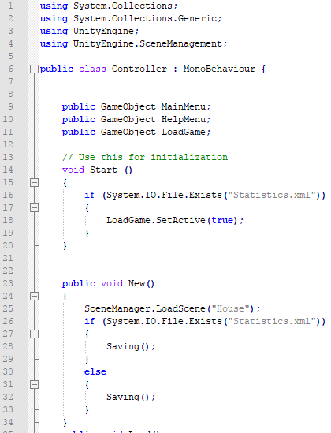This is the “Controller” Script that I created to be able to control the Main Menu; the changes that I made is so that the Saving system would work is that I am able to assign an object to “LoadGame” in the Editor. The purpose of this is because if the Player wants to carry on their progression the game requires an XML file to save it and as a result instead of loading the scene and finding out they lost their progression they can find out on the Menu as the Load option won’t be available.

Another reason for having this feature is because when I was conducting tests, I found out if the XML file was deleted the first scene would crash as it relies on having the XML file. This then meant that I needed to create an XML file during the “New Game” function so that there was always an XML file available.

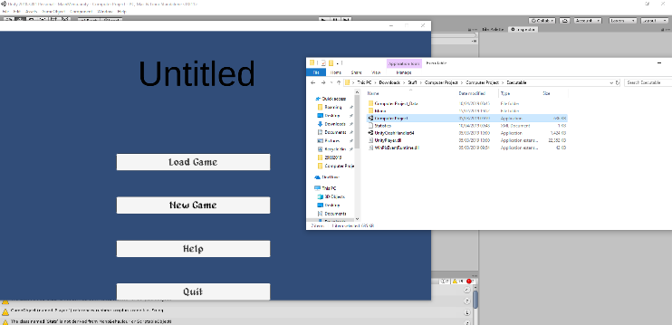Originally, I copied over the Saving function from the “PlayerStats” Script although I later realised that as no data was being inputted the values returned 0 and this then lead to enemies not functioning as required as their Health is compared to the Player’s Level which means it was 0. To fix this issue I edited the Saving function so that: “playerLevel = 1, currentExp = 0” which means when the first scene is loaded everything works as intended.

As can be seen in this screenshot I was able to create an XML file using the “New Game” button; this is necessary as it then allows the rest of the game to be able to run as intended without having crashes because it was referencing an XML file that never existed.

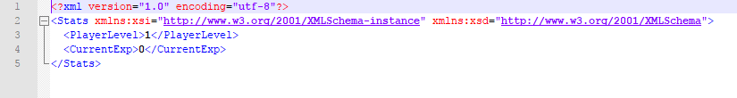This is the XML file that is created with the correct values that were set from the function; as of now there are only two variables that it needs to create from the start however, when it comes to tracking what the Player has interacted with I will need to create a false value for them within this function so that I don’t run into any errors which may be an issue when it comes to naming the variables.

#### Testing within Iteration

|  |  |  |  |
| --- | --- | --- | --- |
| Test | Criteria | Reason | Pass/Fail - Reason |
| Testing that the executable loads the XML file and data can be read and stored | I will start the executable and see if the XML file can be used | It is important that the executable can access the statistics like the editor does | Fail – I realised that the game was accessing the XML file that is made by the editor and then when testing by deleting this I realised that no XML file was available, and the game crashed  Solution – I made it impossible to be able to start the game without an XML file being available |
| Testing that the “Load Game” button is hidden when the XML file is deleted | I will delete the XML file and load up the Executable | It is important that the Player cannot start the game without having an XML file created first as this stops it from crashing | Pass – When the XML file is not available the “Load Game” option is disabled which means the only way of progressing is by clicking on new game which creates an XML file anyway |
| Testing that the “Load Game” button is active when the XML file is available | I will click on “New Game” and exit and then “Load Game” if it is available | I am testing whether the detection function works as intended | Fail – The “Load Game” option is available but when the first scene is loaded the Player’s Level is 0  Solution – Obviously as no Player Level existed to start with the Player’s Level would be 0 so I decided to modify the saving function so that it saves the Player’s Level as 1 and Current Exp as 0 (this is attached to the Main Menu “New Game”) |
| Testing that “New Game” creates a new XML file with “PlayerLevel = 1” and “CurrentExp=0” | I will click on the “New Game” option and then walk out of the house | It is important that on the “New Game” function that correct values are given as the enemies rely on these values for scaling | Pass – The Player has the correct values and the enemies were in proportion to the Player |

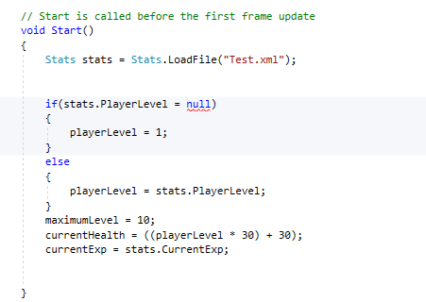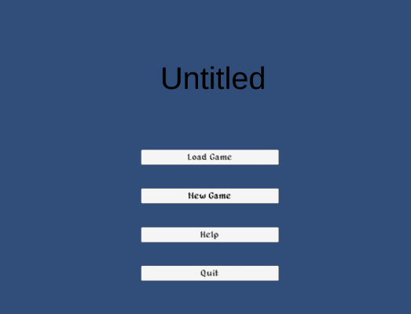This is a screenshot during one of the tests(1-3); the purpose of this test was to determine if an XML file was available, if an XML is available, the load option is set to active; which means the user is able to click this button. The reason behind testing this way is because when I was originally adding the Saving and Loading system into the game I did not have a way of checking/ensuring that an XML file was available which lead to the first scene crashing as soon as it was loaded.

The original plan if there was no executable available was to set default values although as shown in the screenshot I was unable to determine if a value was null or not so I then decided to have a bool which gets saved which decides if the Stats should be loaded or created. Although as shown in the Image below by not having the XML file available before the scene loads it creates and error which when tested within the executable crashes it.

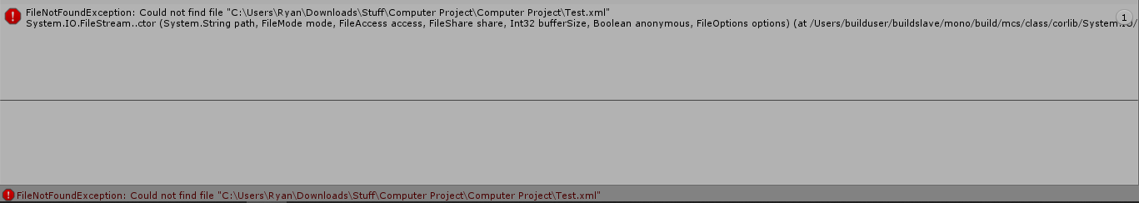This error is because the game tries to open up an XML file before it has been created which as a result causes it to crash; the solution to this test was to not allow the game to be loaded if no XML file was available and only have a “New Game” option.

#### Validation within Iteration

|  |  |  |
| --- | --- | --- |
| Test/Data | Criteria | Outcome |
| New Game – Player Level: 1, Current Exp: 0 | Button Click | Player Level displayed as 1  Current Exp displayed as 0 |
| Load Game – Player Level: 2, Current Exp: 10 | Button Click | Player Level displayed as 2  Current Exp displayed as 10 |

#### Evaluation of Iteration

As part of my success criteria it was important that the Player had the ability to Save, Leave and Resume their game. I was able to create the Loading system so that the Player is able to resume their progress after they have closed the application, however one issue that I had after this is that when the Player has not Played the game before it crashes but I managed to fix this issue by creating an XML file during the “New Game” function. One limitation of this Iteration is that the Player is not able to have multiple saves stored, although multiple saves isn’t a common feature on most PC games I thought that it would be a useful feature; as the loading feature now looks for a file named “Statistics.xml” I am not able to add multiple saved.

Another issue that was caused during this iteration is that I didn’t make the loading function search a specific folder for “Statistics.xml” this means that it is possible that the wrong file may be accessed although it would be very rare that the Player had two instances of “Statistics.xml”.

## Progress on 10/04/2019

### Iteration 16: Creating the Combat System with values

#### New objects within Iteration

|  |  |  |
| --- | --- | --- |
| Name | Type | Reason |
| Combat | Script | Although it isn’t a new object I heavily changed the script to be able to include a combat system |
| EnemyMovement | Script | Although it isn’t a new object I heavily changed the script to be able to include a combat system |
| Death Screen | Canvas | This canvas is used to display the UI when the Player dies; usually I would have used an Empty Object, but I made a new canvas because it was easier to hide the other objects this way |
| Death Screen | Script | This script is used to handle how the Player can interact with the “Death Screen” canvas; the reason why it was not in the “PlayerStats” script is because as the game expands it might have too many values to be saved which aren’t necessary, so it is easier for the “DeathScreen” script to only save vital information |
| Resume Game | Button | The reason for having this button is so that the Player can continue the game after they have died |
| Quit Game | Button | The reason for this button is so that the Player is able to Exit the game without using hardware controls |
| Main Menu | Button | The reason for this button is so that the Player can enter the Main Menu without needing to restart the application |
| Text | Text | This text is just to notify that the Player has been killed; this canvas is loaded as soon as the Player’s health is equal to 0 so the Player might not be aware of their death |
| Top | Collider | This collider is used to determine if the enemy is within attack range of the Player |
| Bottom | Collider | This collider is used to determine if the enemy is within attack range of the Player |
| Left | Collider | This collider is used to determine if the enemy is within attack range of the Player |
| Right | Collider | This collider is used to determine if the enemy is within attack range of the Player |

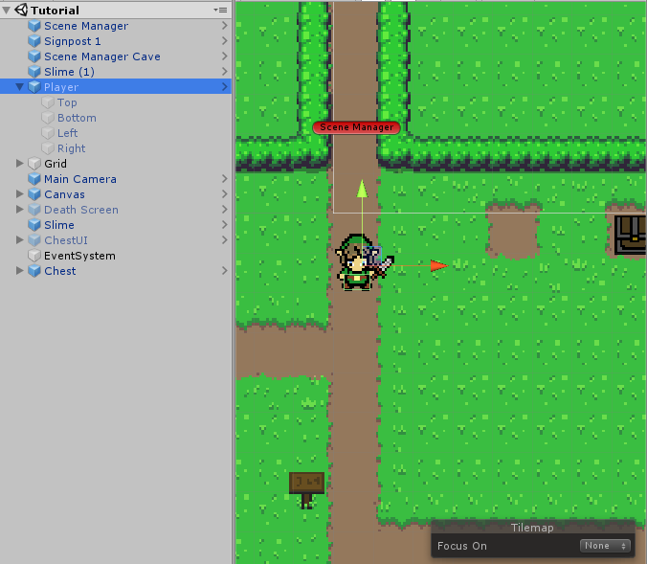To create the combat for the Player I used 4 colliders which I changed to act as triggers; I then attached each of these to the appropriate “Attacking” animation so that when the Player presses the “Space” key the trigger becomes active and then at the end becomes inactive so that the attack function doesn’t constantly play. As shown in testing I previously forgot to change the bottom collider into a trigger which caused issues were the Enemy was knocked back.

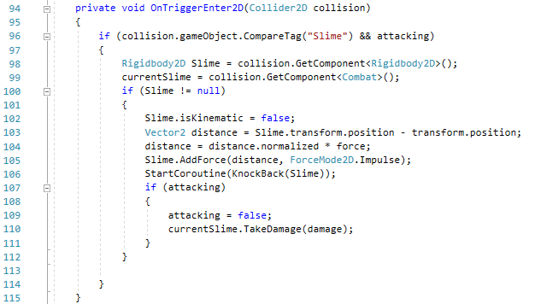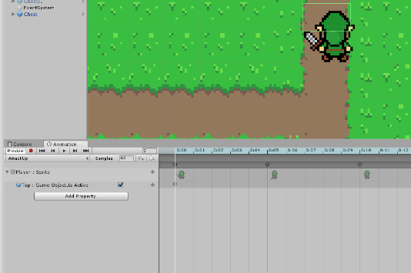When I started creating the script for the Player attacking I realised that the game would be too easy as the Player could quickly spam the “Space” key to kill enemies as there is no delay to attacking. To fix this issue I searched online for a knockback tutorial because this feature is quite common in games as it prolongs combat; after finding a video showing how to create the knockback I added it into my code and I was then able to attack enemies (this image is an updated version of the code)

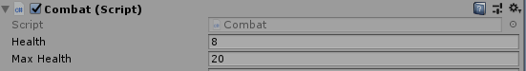After creating the Player’s attacking system I then gave the Slime health to see if I was able to deal damage to the Slime “currentSlime.TakeDamage(damage)” originally (“combat.TakeDamage(damage)”)is a public function which is attached to the Slime that enters the attack trigger; the Player passes on the Integer “damage” which is an integer based on the Player’s current level. As shown within this image I was able to damage the Slime.

The way that I have decided to create my combat system for my enemies is that they will attack based on the distance to the Player instead of having colliders; this means that it is easier to control when they attack as I don’t need to fine-tune the collider to fit into the movement.

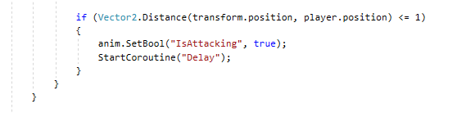As shown in the Image I have attached the Attacking function within the Movement function because the slime will always aim to be within 1 of the Player so this makes it a suitable distance for them to be allowed to attack.

The reason why I made the attacking function have a delay is because when I was originally testing if the Slime could hit the Player; using Debug.Log(“Hit”) I found out that as soon as the Slime was in range the function played which would mean it was unfair for the Player as they wouldn’t have time to react.

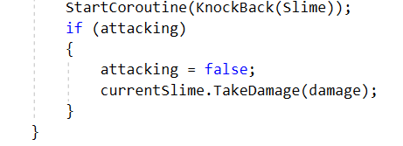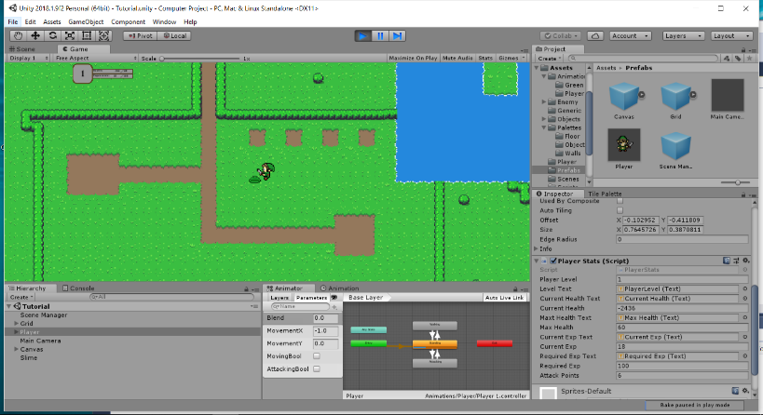For the Enemy attack I decided to use the same knockback script that I did with the Player as this then stops the Slime from being able to repeatedly attack in a short amount of time; however, as shown in the image even though the Knockback did work the attack function ran multiple times which caused the Player to take too much damage. I managed to fix this issue within the testing by adding a bool which breaks the function after it has ran once.

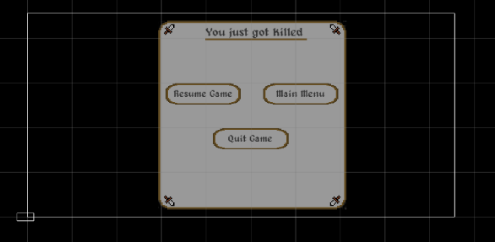This is the section of code that allowed me to control how many times it was possible for the enemy to take damage. This is because the function gets cancelled out by “attacking = false;”

After creating the Combat system, I decided that it was important that both the Player and Slimes were able to be killed when their health equals 0. For the Death Screen to work, I set up a bool called “dead” which is activated when the health equals 0. The Death Screen pauses the game and allows the user to decide what they want to do next. “Resume Game” will load up the “House” scene; “Main Menu” will load up the “Main Menu” and “Quit Game” will exit the application.

#### Analysis of Combat Script

The purpose of this script is to control the variables for the Enemy Slime and decide when the player has dealt enough damage. This script is separate from the movement, so it will be heavily referenced.

#### Analysis of Enemy Movement Script (Part 1 of 2)

#### Analysis of Enemy Movement Script (Part 2 of 2)

This Script is used to control the Enemy Slime and allow them to engage with the Player; initially I was going to create an Enemy script for the different types of Slimes and then modify them as required. However, due to the time restraints I have separated the Slime’s Stats and the AI logic and then if I create other types of Slimes I can simply duplicate the Combat Script and modify the values.

#### Testing within Iteration

|  |  |  |  |
| --- | --- | --- | --- |
| Test | Criteria | Reason | Pass/Fail - Reason |
| Testing top attacking trigger | When the Player is pressing the “Space” key and is within range of the Slime I will see if the hit is registered | It is important that the trigger is able to detect the slime and run the function | Pass – When I pressed the “Space” key the log showed “Hit” |
| Testing bottom attacking trigger | When the Player is pressing the “Space” key and is within range of the Slime I will see if the hit is registered | It is important that the trigger is able to detect the slime and run the function | Fail – When I pressed the “Space” key the Slime was pushed away from the Player  Solution – I forgot to change the box collider into a trigger |
| Testing bottom attacking trigger | When the Player is pressing the “Space” key and is within range of the Slime I will see if the hit is registered | It is important that the trigger is able to detect the slime and run the function | Pass – When I pressed the “Space” key the log showed “Hit” |
| Testing left attacking trigger | When the Player is pressing the “Space” key and is within range of the Slime I will see if the hit is registered | It is important that the trigger is able to detect the slime and run the function | Pass – When I pressed the “Space” key the log showed “Hit” |
| Testing right attacking trigger | When the Player is pressing the “Space” key and is within range of the Slime I will see if the hit is registered | It is important that the trigger is able to detect the slime and run the function | Pass – When I pressed the “Space” key the log showed “Hit” |
| Testing Player Damage | I will hit a slime once and then check the difference between the current and max health | I will test the Player’s damage at different levels to see if it does increase | Fail – The Player dealt too much damage to what was expected  Solution – The function sometimes ran twice which doubled the damage, so I needed to add something in to block the damage |
| Testing Player Damage | I will hit a slime once and then check the difference between the current and max health | After having issues of the attack function running multiple times I decided to add in a bool which stops the attack function playing multiple times | Pass – The damage was the right amount that I expected it to be based on the Player’s Level |
| Testing that the Slime is able to attack the Player | I will move within the Chase Range of the Slime and then watch the log to see if the Player gets hit; shown by Debug.Log(“Hit”) | As the Slime doesn’t have colliders for attacking I needed to check that the ranges for movement matched with the attacking | Fail – The Slime gets into a suitable range, but the function doesn’t play, and the animation is stuck on the “Moving” animation  Solution – The range for the attacking “IF” statement was “position < 1” as the Slime only moves to 1 this meant that it wouldn’t play so I modified it to “position <= 1” |
| Testing that the Slime is able to attack the Player | I will move within the Chase Range of the Slime and then watch the log to see if the Player gets hit; shown by Debug.Log(“Hit”) | It is important that the Slime is able to attack the Player; I am also checking how many times the hit registers as I previously has issues with the Player | Pass – After making the changes the Slime moves towards the Player and then after the delay they attack pushing back the Player; the hit also only registered once which is what was wanted |
| Testing that the Slime scales to the Player correctly | I will look in the editor at the public variables for the Slime | It is important that all the stats scale appropriately to the Player as this means the game has a sense of progression | Fail – After giving the Slime values based on the Player all values come back 0 with no issues in the code  Solution – I found out that values cannot be compared to an object in the “Start” function as the object doesn’t exist so I needed to add in a function that gives the Slimes correct values but doesn’t keep being called as this would give them infinite health |
| Testing that the Slime scales to the Player correctly | I will look in the editor at the public variables for the Slime | It is important that all the stats scale appropriately to the Player as this means the game has a sense of progression | Pass – After the changes made I was able to get the Slime to have it’s stats reflect the Player’s level |
| Testing the difficulty by having multiple Slimes try to attack at once | I have put 3 Slime objects close together to test if they are too difficult in groups | I am testing whether it would be better to include more Slimes in levels or to make them deal more damage to the Player | Fail – After killing one of the Slimes the other ones become invincible and when they are hit they don’t take damage (knockback still works proving that the function is running)  Solution – After more testing I realised that instead of dealing damage to the Slime that is hit the Player deals damage to Slime 1 which is why the other two become invincible, so I needed to change how the Player references the Slime. |
| Testing the difficulty by having multiple Slimes try to attack at once | I have put 3 Slime objects close together to test if they are too difficult in groups | After the previous test resulted in the Slimes not being able to take damage I am testing to see if the solution worked | Pass – After changing how the Player references the Slimes I monitored the Slime that I was hitting to see if the damage was decreasing; I was able to kill all Slimes after this |

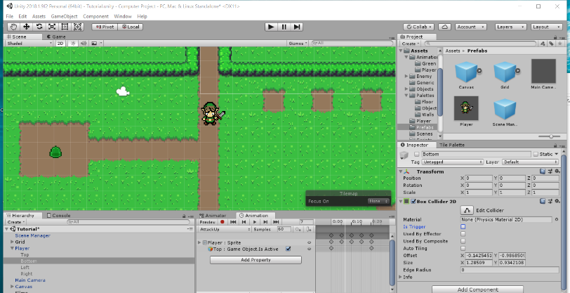As shown in this screenshot when I was testing the collider for the Player attacking I realised that the bottom one was not set as a trigger which lead to me having issues of the Slime being pushed away; to fix this issue I just clicked on the box next to “Is Trigger” and then when I retested the animation the collider became active.

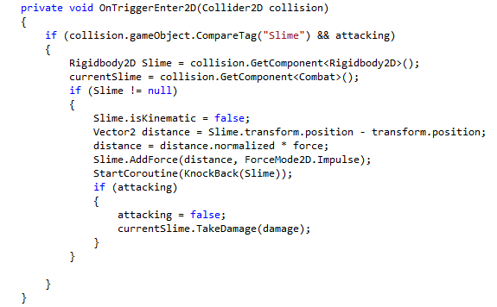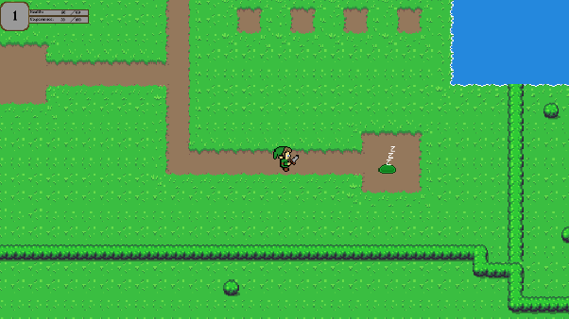Another issue I had when testing the game was that when I killed one of the Slimes the other ones became invincible; I late realised that the reason behind this was because instead of accessing the script of the current Slime to deal damage, it was accessing the script of the first Slime. The solution to this was to modify the script so that the Player accesses the “Combat” script of the Slime that is currently being hit rather than using a “Slime” tag. As shown in the image, after attacking the Slime at the bottom it was the Slime at the top that was killed.

For the fix to work I modified the script so that after there was a collider trigger, the Player gets the “Combat” component of the current Slime and then when it comes to dealing damage, instead of using “combat.TakeDamage(damage)”; “combat” being set at the first update of the script I used “currentSlime.TakeDamage(damage)” which is the “Combat” script of the Slime that has been hit by the collider. Further testing also showed that the “currentSlime” changes after hitting different Slimes.

#### Validation within Iteration

|  |  |  |
| --- | --- | --- |
| Test/Data | Criteria | Outcome |
| Player Health | Player Health is 1  Player Health is 0  Player Health is -1 | Nothing  Death UI is displayed  Death UI is displayed |
| Enemy Health | Enemy Health is 1  Enemy Health is 0  Enemy Health is -1 | Nothing  Object is destroyed  Object is destroyed |
| Player Damage | Damage = (4 + (playerLevel * 2)); | Damage outputted is correct based on Player Level |
| Enemy Damage | enemyDamage = playerValues.playerLevel * 5 + 3; | Damage outputted is correct based on Player Level |

#### Evaluation of Iteration

The purpose of this Iteration was to implement the reference to the Player’s Level for the Slime stats; as part of my main success criteria it was important that the enemies scaled to the Player appropriately. Due to the creation of the AI script this Iteration lead to a lot of issues where I needed to try and fine-tune the relationship between the Enemy and the Player.

One change that I may have made to this Iteration is to use Inheritance when it came to creating the enemies; this is because I could have inherited the “EnemyMovement” script for the “Combat” script so that I didn’t have to attach both scripts to each Slime; although this isn’t an issue for a small-scale game like mine this means that it isn’t efficient as their will be a heavier load on the Processor due to more scripts being ran at the same time.

## Progress on 22/04/2019

### Iteration 17: Creation of the First Level

#### New objects within Iteration

|  |  |  |
| --- | --- | --- |
| Name | Type | Reason |
| Floor | TileMap | The reason for this TileMap is to create a floor in the scene which other objects appear on top of |
| Walls | TileMap | This TileMap is the borders of the level and restricts the Player’s movement using a TileMap Collider 2D |
| Objects | TileMap | This TileMap is for objects that I want to have a collider on but do not want to access it through a script (used for organisation) |
| Chest | Chest Prefab | The Chest Prefab contains the “Chest” script and both states of the Chest |
| Scene Manager | SceneManger Prefab | This Prefab is to create a collider for the Player and also has the “SceneMovement” script attached to it so the Player is able to change scenes |
| ChestUI | Chest UI Prefab | The Chest UI Prefab contains the “ChestUI” script and the interface for the Chest when the Player interacts with it |
| Slime 1 | Slime Prefab | The Slime prefab contains the Slime Objects and both the “Combat” Script and “EnemyMovement” script |
| Slime 2 | Slime Prefab | The Slime prefab contains the Slime Objects and both the “Combat” Script and “EnemyMovement” script |
| Slime 3 | Slime Prefab | The Slime prefab contains the Slime Objects and both the “Combat” Script and “EnemyMovement” script |
| Slime 4 | Slime Prefab | The Slime prefab contains the Slime Objects and both the “Combat” Script and “EnemyMovement” script |
| Player | Player Prefab | The Player Prefab contains the Player Object and both the “PlayerStats” script and the “PlayerMovement” script |
| Main Camera | Main Camera Prefab | The Main Camera prefab contains the Camera Object and the CameraController Script |
| EventSystem | EventSystem | This is needed to allow the user to interact with the UI |
| Normal Hole | Object | This object is a visual representation of where the Player needs to move to, to change scenes |
| Gate | Object | This object is used to block the Player’s progression until they have completed the requirements |
| Left Torch | Empty Object | This Empty Object is used to organise the objects within the scene as some had the same name |
| Right Torch | Empty Object | This Empty Object is used to organise the objects within the scene as some had the same name |
| LitTorch | Object | This object is used to notify the Player of their progression because it appears after two slimes have been killed |
| UnlitTorch | Object | This object is used to notify the Player of their progression |
| LitTorch | Object | This object is used to notify the Player of their progression because it appears after two slimes have been killed |
| UnlitTorch | Object | This object is used to notify the Player of their progression |

#### Analysis of Gate Controller Script

The purpose of this Script is to control the progression of the Player; for the Player to be able to complete the level they must kill the 4 Slimes. As of creating this I have not created a way for the script to be serializable; as a result, when the Player exits the scene and loads it up again their progression is not resumed which may be an issue if the Player dies halfway-through.

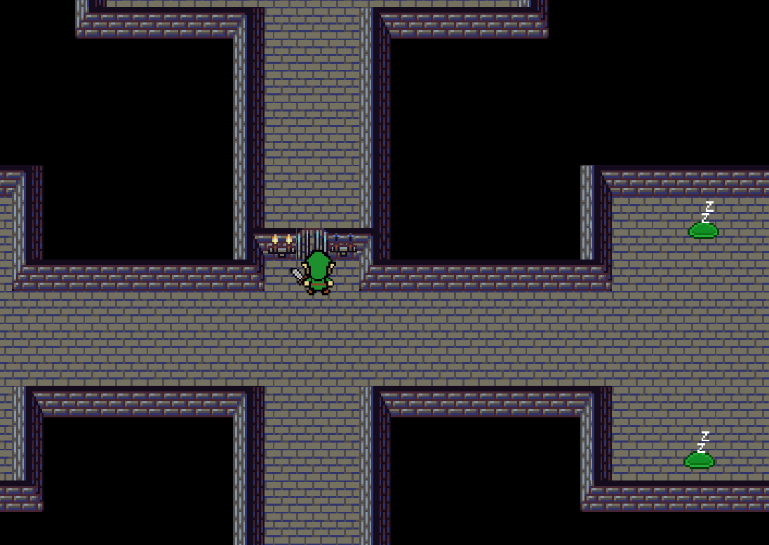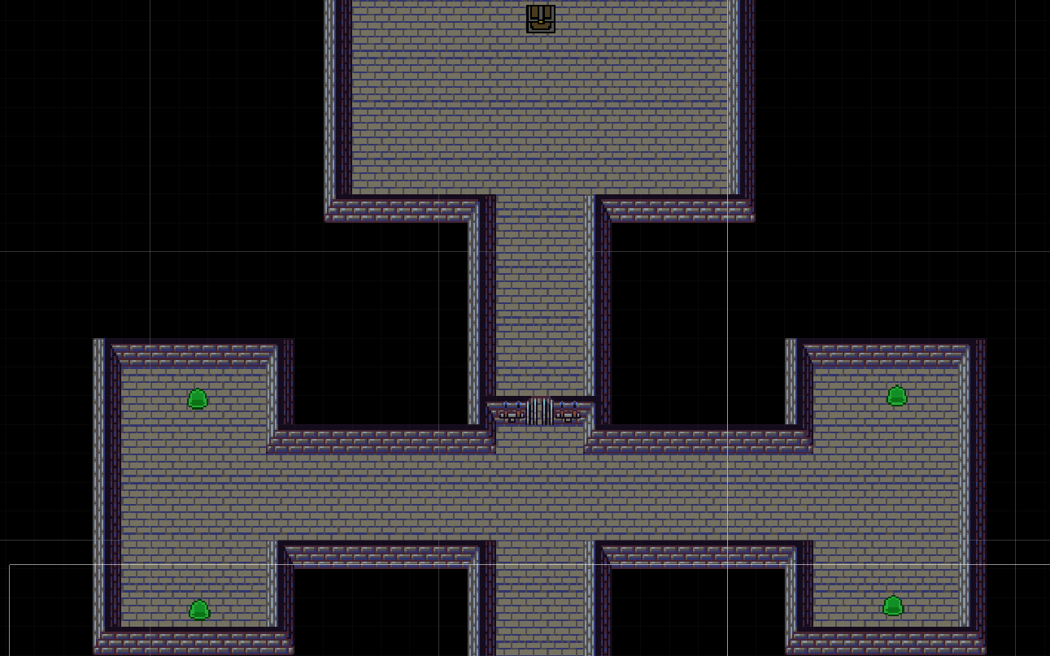This is the initial design for the first Level; when the Player kills the 4 Slimes the gate becomes inactive which as it has a collider attached to it means that the Player is then able to get through. To try and help the user understand how to get past the gate I added torches to the side of it. When 2 Slimes are killed the left torch changes from unlit to lit (unlit torch becomes inactive and lit torch is set to active). When the four Slimes are killed the Slime counter should equal “4”; when the Slimecounter equals “4” the right torch has the same transition and the gate becomes inactive.

As shown on the image to the right after killing the Slimes to the left the left torch becomes active (this should indicate to the Player that they need to kill the other Slimes). When all Slimes are killed the Gate is not visible on the screen which means that the Player can walk straight through.

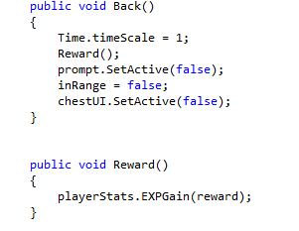After creating the script for the “Dummy chest” I slightly modified the script so that the Player had a purpose for completing the first level (they are rewarded with Ex[). The changes I made was that when the Player clicks on the “Back” button (part of the UI that shows up) within the function the Player is rewarded Exp. “reward” is a public integer so that I am able to modify it within the editor. Eventually the aim is to reward the Player with an item which indicates their progression and then this item is saveable so that the Player knows they have already completed this level.

#### Testing within Iteration

|  |  |  |  |
| --- | --- | --- | --- |
| Test | Criteria | Reason | Pass/Fail - Reason |
| Testing that the left torch changes after the Player has killed two Slimes | I will enter the Scene and kill two Slimes; after this I will go to the middle of the level to check for a change | The reason behind wanting to change what object becomes active is because I want to be able to notify the Player of their progression | Pass – When two Slimes are killed the “Lit Torch” object becomes visible; as well as this the Slime counter integer as part of the Gate Script displayed 2 within the editor. |
| Testing that the left torch changes after the Player has killed four Slimes | I will enter the Scene and kill four Slimes; after this I will go to the middle of the level to check for a change | The reason behind wanting to change what object becomes active is because I want to be able to notify the Player of their progression | Pass – When four Slimes are killed the “Lit Torch” object becomes visible; as well as this the Slime counter integer as part of the Gate Script displayed 4 within the editor. |
| Testing that the “Gate” becomes inactive when the Slimecounter is equal to “4” | I will kill 4 Slimes and then walk into the middle and check if the gate has vanished | It is important that the Gate becomes inactive because this shows the Player that they have completed that area | Pass – When 4 Slimes have been killed the Gate object becomes inactive and the Player is able to walk through; the box collider on the Gate also became inactive |
| Testing that the Chest rewards the Player with “60” Exp | I will walk up to the Chest and press the “E” button after this I will press the “Back” button and then see if the Exp did change | It is important that the Chest is able to access the function within “PlayerStats” and pass on “reward” which is an integer | Pass – When the Chest is interacted with my Level changed from 1 to 2 (currentExp was “40” and requiredExp was “100”) so the Exp reward worked as intended. |

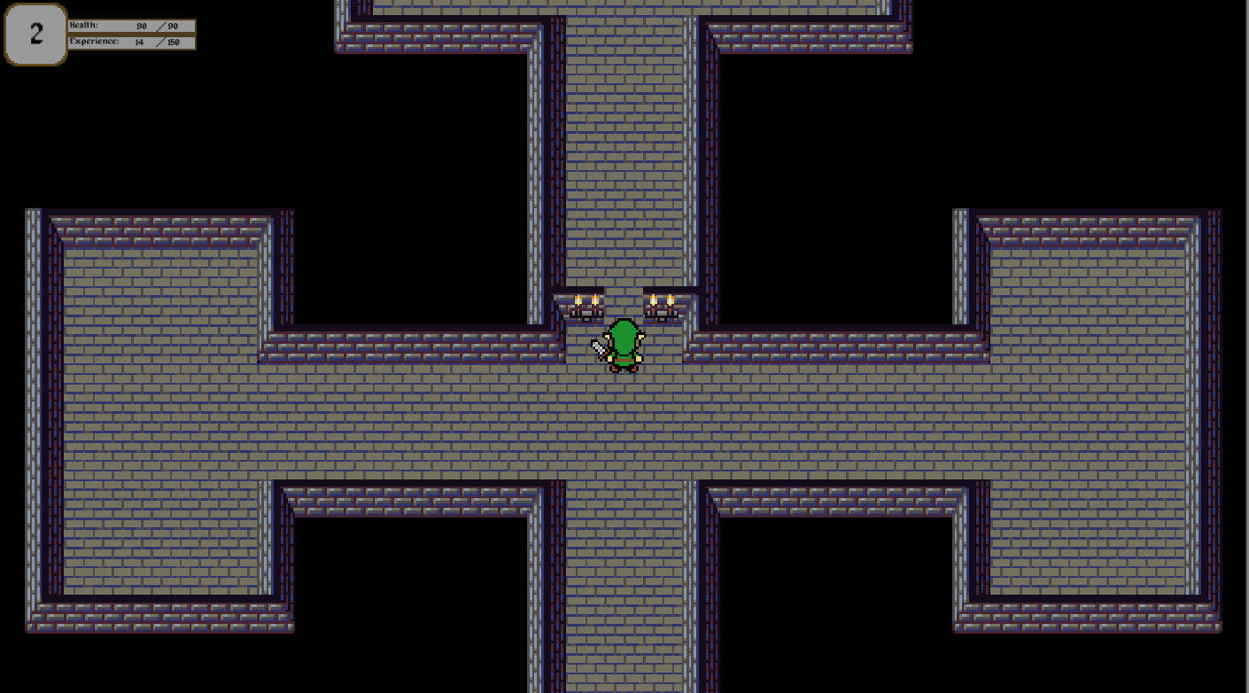As shown in this image, I was testing that when the “Slimecounter” was equal to 4 the gate then became inactive. As is visible, the Gate has become inactive which means that the Player is able to walk through without being blocked by a 2D Collider.

#### Evaluation of Iteration

Due to the time limitations this is the last Iteration that I was able create; the purpose behind this Iteration is so that the Game actually has a level which needs to be completed; due to the fact that this Iteration heavily relied on using Prefabs I didn’t have any issues as the code that was created was based on previous code within the game.

One limitation created during this feature is that I wasn’t able to add a way of tracking the Player’s progression; at the end of this mini-level there is a chest which offers the Player, Exp, as I was unable to create the saving function I failed to meet one of my success criteria’s which was to be able to track the Player’s progression/completion.

# Evaluation

## Player Testing

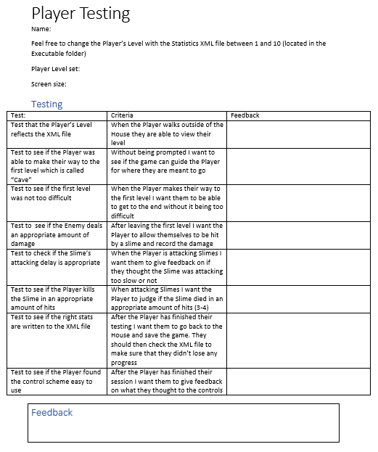

This is the testing document that I gave to testers when they were trying the game so that they could give feedback and offer any changes they would like to be made. I decided that it would be a good idea if I did not offer any information about how they would play the game as this would then determine if I would need to add in more guidance.

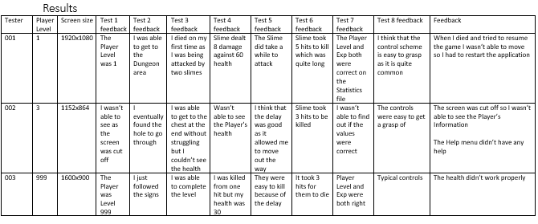

This was the feedback that I have typed up so that it is easier to analyse; overall, I don’t think that there were any major issues. The final tester helped me to see that the Max Level does work on the game although I would have preferred it if the health was 0 so the Player wasn’t able to play if they modified the XML file drastically. However, if this was created for commercial use I would have probably included a binary formatter on the XML file as this would stop me having issues of people being able to skip levels (future levels were meant to have a level requirement).

#### Testing Usability

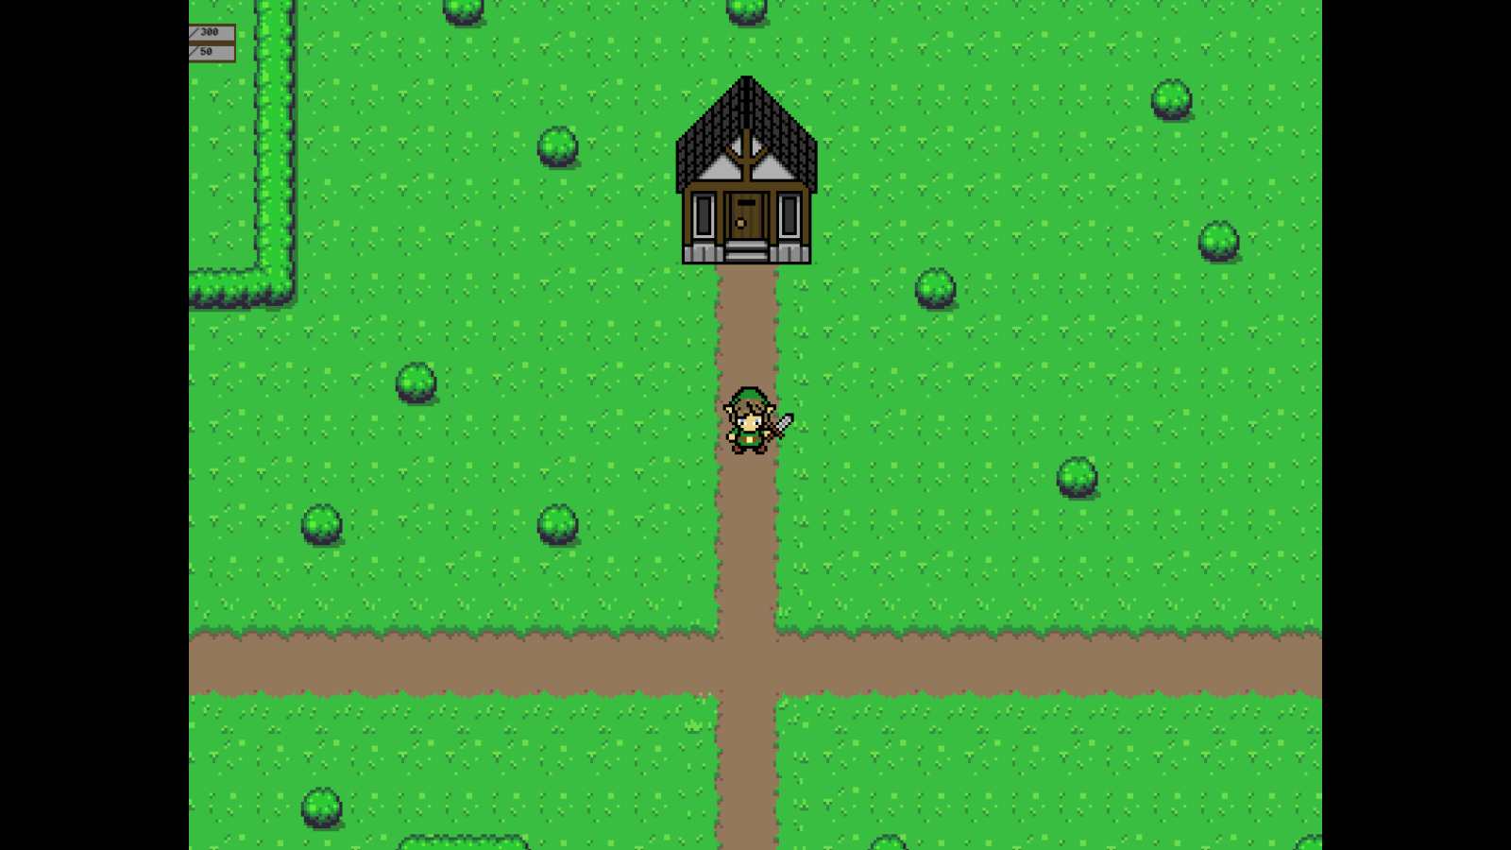Overall, I think that the game was easy to use; the people who tested it have common knowledge of the standard controls and they all said in the feedback that the controls were quite common for a PC. One issue one of the testers had though, was that at”1152x864” screen size the screen did not display correctly. The reason why I wanted to know the selected screen size is because during my personal testing I realised that the Executable did not display the same way as the Editor did and I wanted to make sure that the UI Scaled correctly as I had to alter the position, so it wasn’t cropped out,

This is an image that I did when I was going through the feedback; as the tester said the screen is obviously partially cut which makes the game difficult to play as they will be unaware of their current health which would change their playstyle.

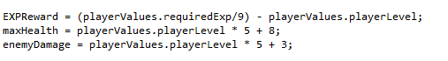As part of the testing I also wanted the testers to track how many hits it took to kill the Slime; this is because I wanted to make sure that it was 2-3, as anymore will make the combat tedious. Based on the feedback, I edited the “maxHealth” so that at lower levels the health was less than previous because the damage will also be low due to how the Player’s damage is based on the Player Level. As there was no other feedback based on the UI or the Player Movement I presumed that the testers thought that this was sufficient and that they had no issues.

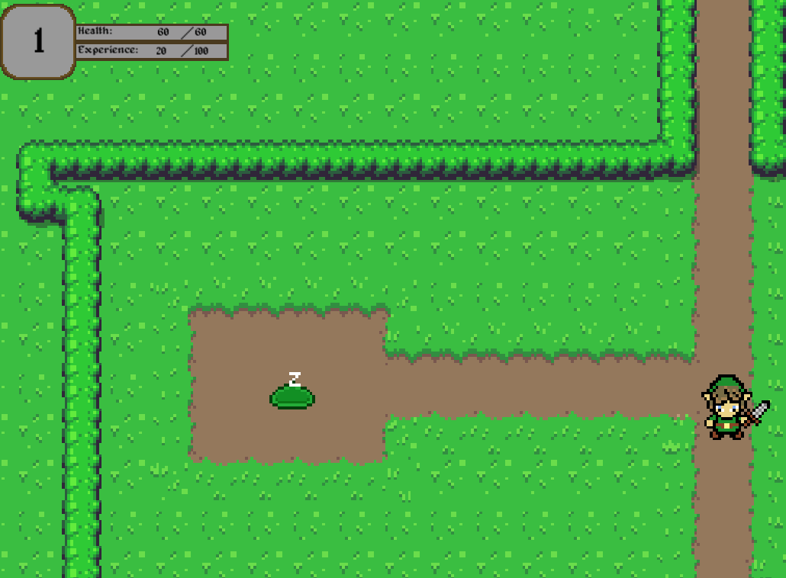One component that was not mentioned during feedback was the way that the Player Level and Player Health were displayed, originally, I intended to use a slider bar for the health as this is a visual aid as Players are able to tell by the colour displayed, what their current Health situation is rather than needing to try and read the value which can draw their focus from the game.

When some peers were also watching the game during development they mentioned that the Player moved too slow; although this is only apparent when moving long-distances between scenes; I think that if the game went through further development I would need to create new moving animations to encorporate the Player to be able to move faster (the current animation suits a low moving speed)

## Final Testing

### Player Movement

|  |  |  |  |
| --- | --- | --- | --- |
| **Test** | **Input/Conditions** | **Outcome** | **Justification** |
| Testing +X.Movement | Using the “D” key that is assigned as positive horizontal | When the “D” key is pressed the Player moves to the right | I have decided that the Player should be able to move in 4-directions |
| Testing the –X.Movement | Using the “A” key that is assigned as negative horizontal | When the “A” key is pressed the Player moves to the left | I have decided that the Player should be able to move in 4-directions |
| Testing the +Y.Movement | Using the “W” key that is assigned as positive vertical | When the “W” key is pressed the Player moves upwards | I have decided that the Player should be able to move in 4-directions |
| Testing the –Y.Movement | Using the “S” key that is assigned as negative vertical | When the “S” key is pressed the Player moves downwards | I have decided that the Player should be able to move in 4-directions |
|  |  |  |  |
| Testing the downwards “Idle” animation | Making sure that the Player is moving downwards and then stop moving | The “Idle” animation plays when the Player stops moving | I wanted a to make sure that the Player had a still animation if they weren’t moving |
| Testing the upwards “Idle” animation | Making sure that the Player is moving upwards and then stop moving | The “Idle” animation plays when the Player stops moving | I wanted a to make sure that the Player had a still animation if they weren’t moving |
| Testing the left “Idle” animation | Making sure that the Player is moving left and then stop moving | The “Idle” animation plays when the Player stops moving | I wanted a to make sure that the Player had a still animation if they weren’t moving |
| Testing the right “Idle” animation | Making sure that the Player is moving right and then stop moving | The “Idle” animation plays when the Player stops moving | I wanted a to make sure that the Player had a still animation if they weren’t moving |
|  |  |  |  |
| Testing the upwards “attack” animation | Using “Space” key when Player’s last movement was upwards | When the “Space” key is pressed the animation plays | It is important that there is a visual prompt that the Player is attacking |
| Testing the downwards “attack” animation | Using “Space” key when Player’s last movement was downwards | When the “Space” key is pressed the animation plays | It is important that there is a visual prompt that the Player is attacking |
| Testing the left “attack” animation | Using “Space” key when Player’s last movement was left | When the “Space” key is pressed the animation plays | It is important that there is a visual prompt that the Player is attacking |
| Testing the right “attack” animation | Using “Space” key when Player’s last movement was right | When the “Space” key is pressed the animation plays | It is important that there is a visual prompt that the Player is attacking |
|  |  |  |  |
| Testing the Player’s Box collider against object above | Move against an object that is above the Player | The Player appears above the object and is blocked from moving | It is important that the Player is blocked from moving as this is the purpose of using colliders it is also important that the Player appears above objects so that they are constantly visible |
| Testing the Player’s Box collider against object below | Move against an object that is below the Player | The Player appears above the object and is blocked from moving | It is important that the Player is blocked from moving as this is the purpose of using colliders it is also important that the Player appears above objects so that they are constantly visible |
| Testing the Player’s Box collider against object to the left | Move against an object that is to the left of the Player | The Player is unable to move any further | It is important that the Player is blocked from moving as this is the purpose of using colliders it is also important that the Player appears above objects so that they are constantly visible |
| Testing the Player’s Box collider against object to the right | Move against an object that is to the right of the Player | The Player is unable to move any further | It is important that the Player is blocked from moving as this is the purpose of using colliders it is also important that the Player appears above objects so that they are constantly visible |
|  |  |  |  |
| Testing that the upwards box collider triggers as part of the upwards “Attack” animation | Using “Space” key when Player’s last movement was upwards | The trigger becomes active and then inactive after 0.3 seconds | It is important that the trigger only remains active for a short amount of time as this tries to stop the function within the collision running multiple times |
| Testing that the upwards box collider triggers as part of the upwards “Attack” animation | Using “Space” key when Player’s last movement was downwards | The trigger becomes active and then inactive after 0.3 seconds | It is important that the trigger only remains active for a short amount of time as this tries to stop the function within the collision running multiple times |
| Testing that the upwards box collider triggers as part of the upwards “Attack” animation | Using “Space” key when Player’s last movement was left | The trigger becomes active and then inactive after 0.3 seconds | It is important that the trigger only remains active for a short amount of time as this tries to stop the function within the collision running multiple times |
| Testing that the upwards box collider triggers as part of the upwards “Attack” animation | Using “Space” key when Player’s last movement was right | The trigger becomes active and then inactive after 0.3 seconds | It is important that the trigger only remains active for a short amount of time as this tries to stop the function within the collision running multiple times |
|  |  |  |  |

### Enemy Movement

|  |  |  |  |
| --- | --- | --- | --- |
| **Test** | **Input/Conditions** | **Outcome** | **Justification** |
| Test that the enemy plays an animation if the Player isn’t in range | I will load the scene but stay out of the range | The “Idle” animation is played | I wanted the Player to know that the Slimes were working |
| Test that the enemy is able to attack the Player | I will walk towards the Slime and see if it is able to attack me | The Slime was able to attack and deal damage | It was important that enemies are able to attack as this is their purpose. |

### Scene Loading

|  |  |  |  |
| --- | --- | --- | --- |
| **Test** | **Input/Conditions** | **Outcome** | **Justification** |
| Testing the Scene Movement Collider in the House | The Player needs to walk into the collider (currently located at the entrance) | When the Player walks towards the collider the scene changes to “Outside of House” | As I have decided not to hard-code the Scenes to the “Scene Movement” script it is important to test that they are paired up as intended |
| Testing the Scene Movement Collider on the outside of the House | The Player needs to walk into the collider (currently located at the entrance) | When the Player walks towards the collider the scene changes to “House” | As I have decided not to hard-code the Scenes to the “Scene Movement” script it is important to test that they are paired up as intended |
| Testing the Scene Movement Collider on the South of “Outside of House” to “Tutorial” | The Player needs to walk into the collider (currently located at the south pathway) | When the Player walks towards the collider the scene changes to “Tutorial” | As I have decided not to hard-code the Scenes to the “Scene Movement” script it is important to test that they are paired up as intended |

### Saving

|  |  |  |  |
| --- | --- | --- | --- |
| **Test** | **Input/Conditions** | **Outcome** | **Justification** |
| Testing that an XML file is created on the “New Game” Button | I will click on the “New Game” button and then exit the application | The XML file is created as intended | It is important that the game can create a basic XML file as the first Scene requires an XML file to work |
| Testing that the XML file is updated between scenes | I will level up and then switch scenes and then alt+f4 | The XML file contained the latest Player Stats | I wanted to make sure that there were no ways that the progression could be lost |

### Main Menu

|  |  |  |  |
| --- | --- | --- | --- |
| **Test** | **Input/Conditions** | **Outcome** | **Justification** |
| Testing the “New Game” button | I will left-click on the button | As intended I wanted the “House” scene to load up | I thought that it would be important that the game had a menu before it started so that the Player could decide when they wanted to start the game. |
| Testing the “Load Game” button | I will left-click on the button | The button loads up a separate scene from the “New Game” option so I could test that I could edit the function | The “Load Game” option needs to vary from the “New Game” as this will need to pass on a value which says that the Player’s stats need to be loaded from storage |
| Testing the “Help” button | I will left-click on the button | Once the “Help” button has been clicked the other buttons go invisible and a block of text is made visible | The reason behind having a “Help” button that controls when the UI is displayed is because this is a cleaner way of being able to present information without needing to add additional scenes to the build |
| Testing the “Back” button | I will left-click on the button | When the “Back” button is clicked the UI changes so that the original menu is displayed | It is important that the Player has a way of going back to the original menu without restarting the game |
| Testing the “Quit Game” option | I will left-click on the button | When the “Quit Game” button is clicked the application should close (doesn’t work within the editor) | It is important that the application has a way of closing as not everyone is aware of window commands although this isn’t an issue as the stakeholders are all Computer Science students who are familiar with PCs |

## Overview against Success Criteria

* Game includes a starting menu
  + The Main Menu is the first scene in the build order which means that when the game loads up this is the first scene that loads up. I think that I have met this criteria as the purpose of it was so that the Player is not loaded straight into the game and that the Player has access to information explaining how to play the game.
* Game includes fixed-point saving
  + The Player is able to enter the House and save the game; the game does actually save between every scene although I don’t want the Player to know this because it means that they should complete the level before exiting the game
* Players must be able to save and leave the game and then be able to resume their progress
  + The Player is able to exit the Executable and then when they open it again they should have a load game option which has the last stats that were saved
* Game must have way of notifying Player of achievements/progression
  + This feature has not yet been added and is a limitation of the solution
* Game should include a level cap for the early build
  + Although a further developed version will not have a level Cap I have decided to add a level cap of 10 to the game as this stops the Player’s Damage from being too high when the Player is attacking weaker enemies
* Must have smooth transitions between scenes
  + This feature is not yet added and is a limitation of the solution
* Player has a health system which changes based on the Player’s Level
  + It is important that the Player’s health increases based on the Player’s Level as this then allows me to base enemy damage on the Player’s Level to make sure that the game doesn’t become too easy. More difficult enemies will be visually different so that the Player is aware that their damage will be different, and I will also be able to scale their damage to the Player’s health
* Enemies must automatically respawn if killed when the Player re-enters the level
  + The way that I am creating the game means that the scenes act independently and as a result, anything that happens within the scene is not saved so when the Player re-enters the scene everything is in the same place. This means that if I do want to change how a scene acts I will need to save a value and then when the scene is loaded it checks the value to decide how something appears E.g. (Chest example: when chest is used “chestUsed = true” and above the chest function “If chestUsed=false{…}” this would then stop the chest from being used again as the function cannot run)
* Shouldn’t be any issues of losing progression/game breaking
  + There are no ways that the XML file can be deleted unless by the user themselves which isn’t a concern for me when developing the game

## Overview against In-game Success Criteria

* Game must contain a Main Menu
  + When the Executable is loaded up the first screen is the Main Menu; it was important that I included a Menu screen as this is a good way of allowing the User to navigate the different options.
* Player needs to be able to load their saved game
  + If an XML file is available for the user, they are then able to load their game; this is done by copying over the current values for the Player Level and Player Exp.
* Needs to have a guide/tutorial
  + This criteria is partially met as there are in-game prompts to guide the Player on what they need to do; however as far as a simple guide explaining the different components of the game, I did not include this as the development was not fully completed.
* Needs to contain an in-game menu
  + Although there is an in-game menu which allows the User to Save their game etc. I did not attach it to the Player object; this means that the Player is only able to access the Menu from the House. I did plan to do this because as I had no way of saving the Player’s progression(saving what object had been interacted with/destroyed) I thought it would be easier for the Player to complete the level before trying to save.
* Enemies should level up proportionally to the Player
  + The way that I intended to design the game was that there was going to be multiple types of enemies (visually different) which would indicate to the Player that they might move differently or have different damage; as a result I wanted to make sure that even though the Player may level up, the enemy difficultly remained the same and then as the Player progressed through the game they would meet enemies that were harder to kill.
* There must be a clean transition between areas
  + Originally I was going to rely on not needing to save what the Player had interacted with (writing/reading a file slows down the application) to make sure that the transitions between areas were smooth (I wanted it to feel like one big map); however, I had issues were I wasn’t able to save the Player’s Position due to Unity not enabling serialization of a Vector. This means that when a Player leaves and enters a scene, the Player’s Position is not saved. This is most apparent in “OutsideOfHouse” because when the Player leaves the “Tutorial” scene to enter “OutsideOfHouse” they appear near the top of the scene instead of the bottom which is obvious to the Player that the scene has just been loaded.
* The Game should have the option to pause
  + When I was designing how I intended to create the game, I originally wanted the Player to be able to press a Keyboard Key when they wanted to pause the game; although this would have been easy to implement I decided that the only time I would allow the game to pause is if the Player needed to interact with the UI (Signposts, Chest, Saving UI etc.) as there is no need to pause the game at other times. From my research I found out that it is mainly games for handheld devices that allow the Player to pause the game, usually because of their “pick up and play nature”.

## Limitations of Solution

### Player Combat System

Due to the way that I designed the Player Combat System, the Player is easily able to spam the “Space” key to kill enemies; although I made sure that I didn’t have the “Attacking” animation queue up, I did not have a cooldown between attacks and as a result the Player is able to manipulate the way that the enemies work and quickly kill them off without being damaged(Enemies will always move straight towards a Player before trying to attack).

In future development, I would have changed the “Attacking” function so that like with the enemies, it runs through a “Delay” and then attacks; this would then stop the Player from being able to spam the “Space” key and add difficulty to the game as the Player would need to be concerned with their decision of when to attack.

### Game’s Progression

Due to the time limitations that I met I was not able to add in collectable items/rewards like I first intended; the way that I originally wanted to create the game was to have multiple levels (all locked behind a level requirement) and then when the Player had completed that level I would have a bool saved; this bool would then determine whether an object would be set to active or not (a pixelated tick on the signpost UI). As of the current version of the game, the Player is able to level up but there is no defined goal and as a result it does not meet my desired goal which was to create a game that was used to entertain the Player as the game quickly becomes stagnant.

In future development, I would have liked to add the features that I had initially planned on creating as this then means that the game would be able to function as required. Although I would be able to quickly add in an indicator for the Player’s progression, it would be meaningless without having multiple levels, so the Player knows which one has been completed.

### Transition between Scenes

One of my Success Criteria’s was that I wanted to include seamless/smooth transitions between the different scenes throughout the game; the aim was to make it seem like one big map instead of the Player knowing that a new area was loaded in when they got to a certain point (like the games that I had researched). However, since Unity does not allow serialization of Vectors(the axis of an object), I was unable to be able to save the Player’s Position between scenes. Online forums explained that you are able to access the different axis as separate integers (static integers are serializable) although as I had a lack of understanding on this I was not able to implement it into the game.

In future development, I would like to be able to learn how to access the different variables within the Vector to then serialize them; after this I would be able to save the Player’s position when they left the scene so that they can be accessed again when the scene was loaded. By implementing this feature, changing scenes should lead to having a smooth transition, there may be a small stutter between the scene changes due to the need for the “PlayerStats” to be saved to be saved to the XML file.

### Game did not include Puzzles as originally planned

Originally, I intended on having puzzles in the game (inspired by the puzzles from game series such as “Zelda”) however, as I was unable to create an actual full level there was no chance of adding puzzles into the game which as one of the main components of the game it would be an emphasis for future development.

In future development, I would create additional levels so that I was able to add in puzzles to the game so that it met what I original planned; as the levels are self-encapsulated this means that it would be easy to add in new levels as I would create a new scene and the link it up with the “OutsideOfHouse” scene.

## Maintenance

If the game was to be released for commercial intentions I would need to be able to update it so that it would keep Players engaged for a longer amount of time; as well as this, maintenance would involve trying to fix any issues that were not brought up in the personal testing from me or when I allowed peers to test it.

### Adding additional levels

One form of maintenance that the game would need, is releases of new levels; this is because after adding in the levels from future development there would eventually be a point where the Player would have nothing left to do and the addition of new content will maintain the Players interest.

### Fixing minor issues

One issue that I have encountered within my game is that when the Player is knocked back by 1 Slime into another the delay for attacking does not appear to work; this has resulted in the Player instantly being killed like in previous iterations when I did not have the “KnockBack” Coroutine. For the current state of the game I decided that I would separate the enemies so that this bug wouldn’t occur as the Player would only be able to attack 1 at a time rather than being attacked by two slimes.

# Bibliography

Bush assets: ArMM1998 – OpenGameArt.org

Dungeon/Cave assets: DawnBringer – OpenGameArt.org

Font asset: pix3m – OpenGameArt.org

Main Menu Background – Wallup.net